Product information 46/2016

BMW 2 Series F22 M240i
BMW 2 Series F22, 09/2015 - M240i(x) 3.0l 250 kW (B58B30)
REMUS Cat-back-system
- 100% stainless steel
- Powerful sound
- Performance and torque increase
- Light weight construction

+ 15,5 PS
+ 14,4 Nm

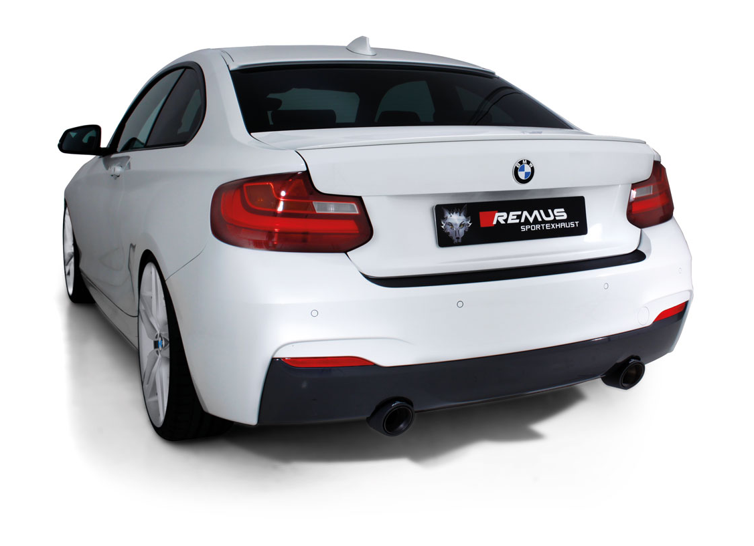

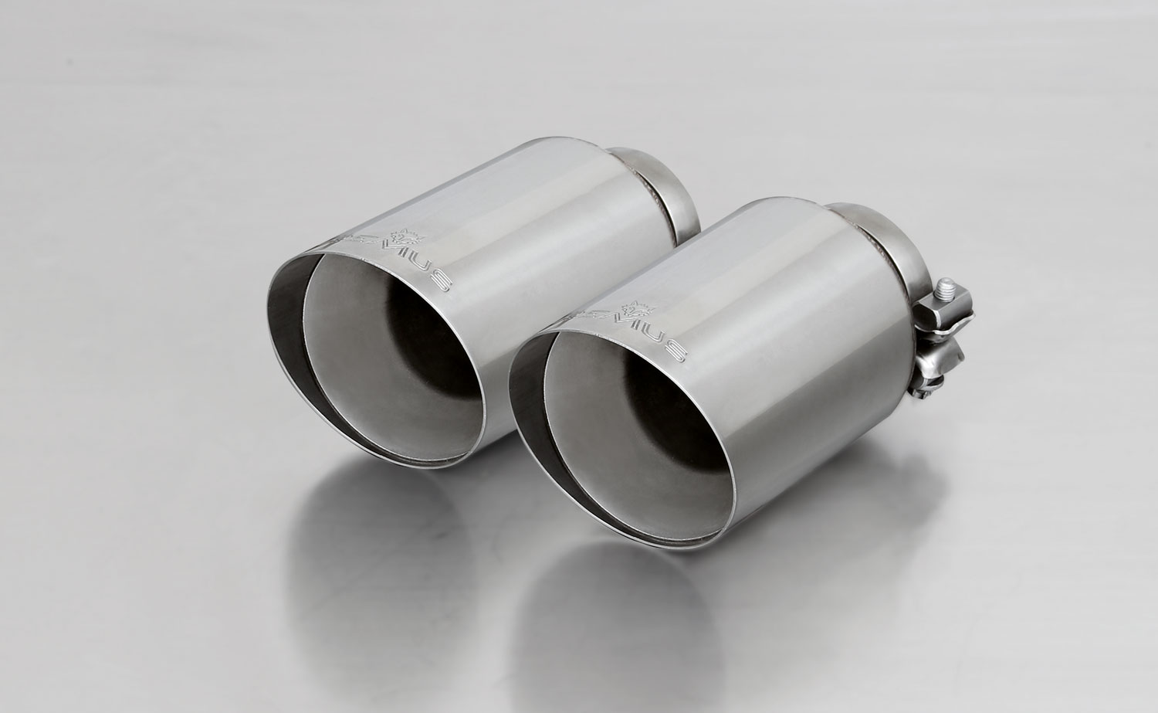
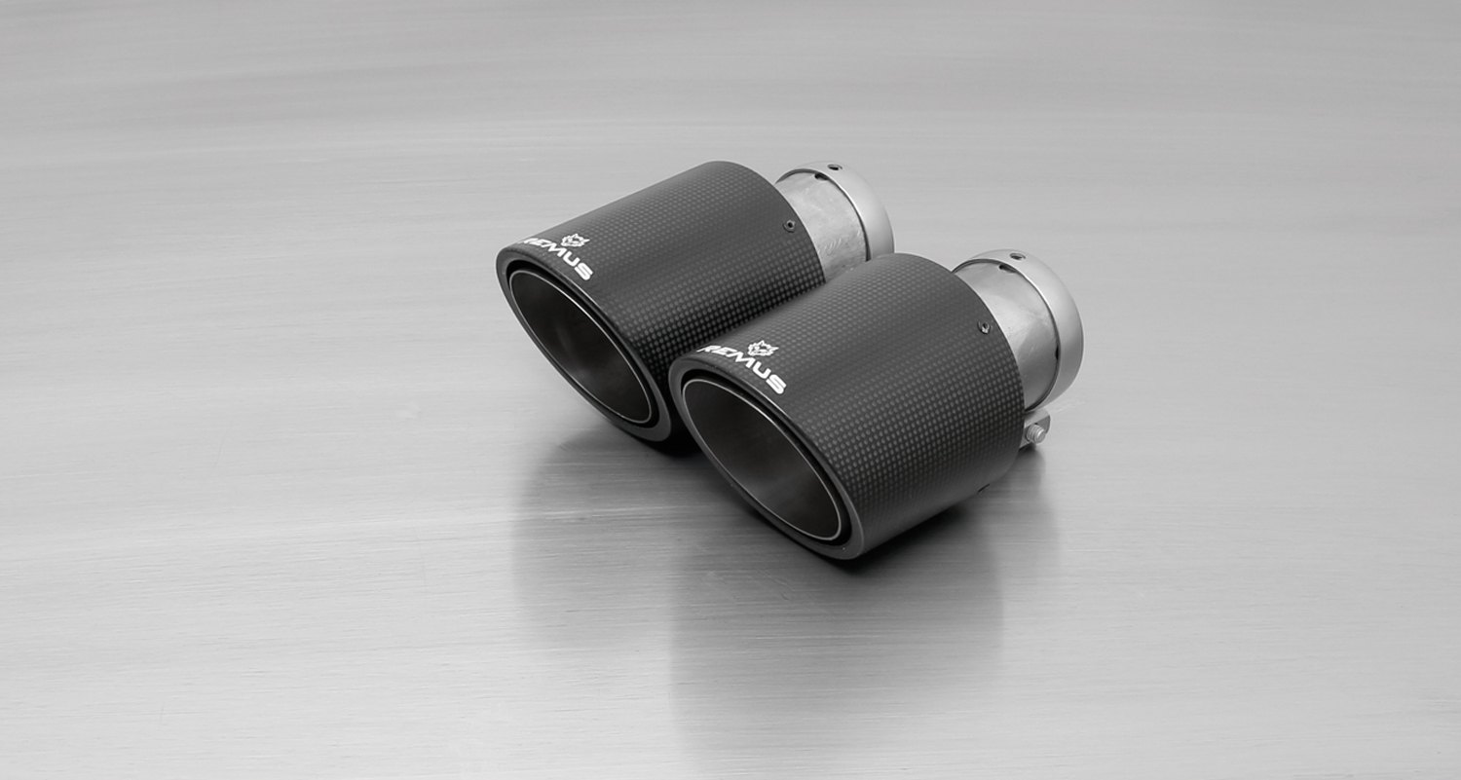
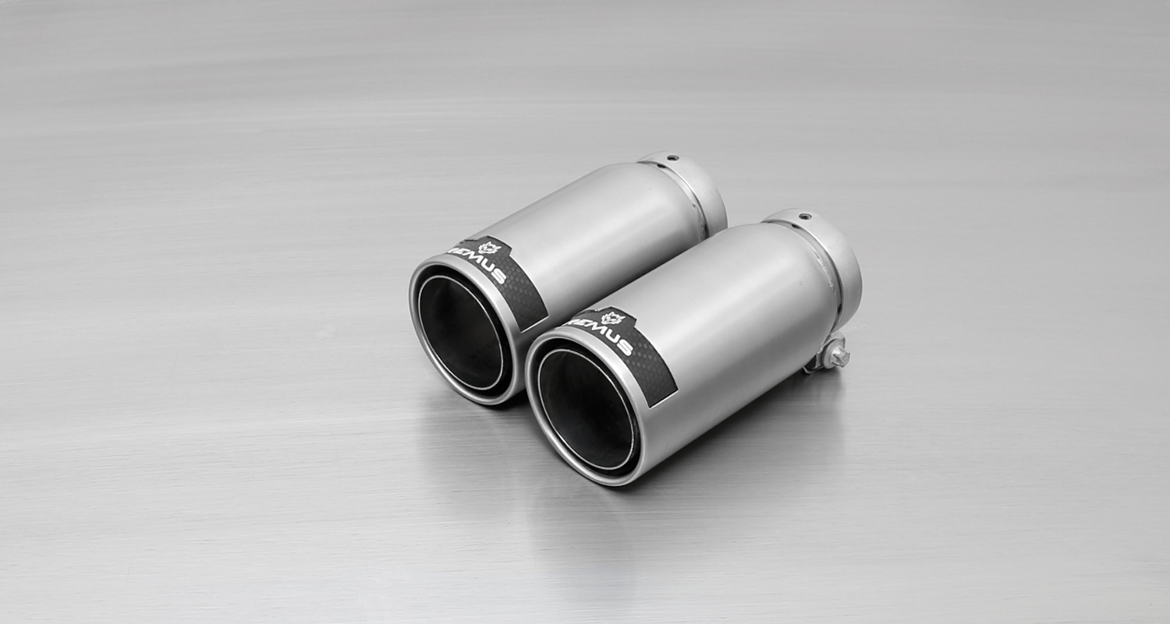
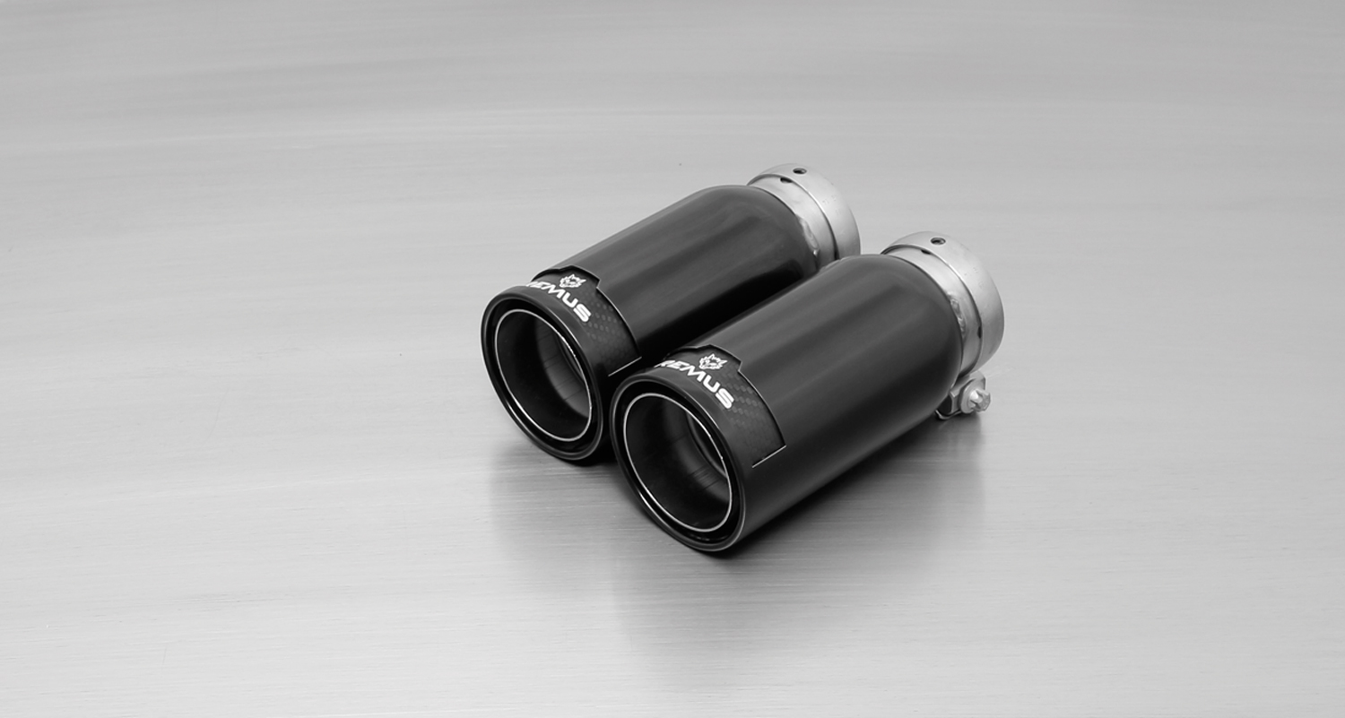
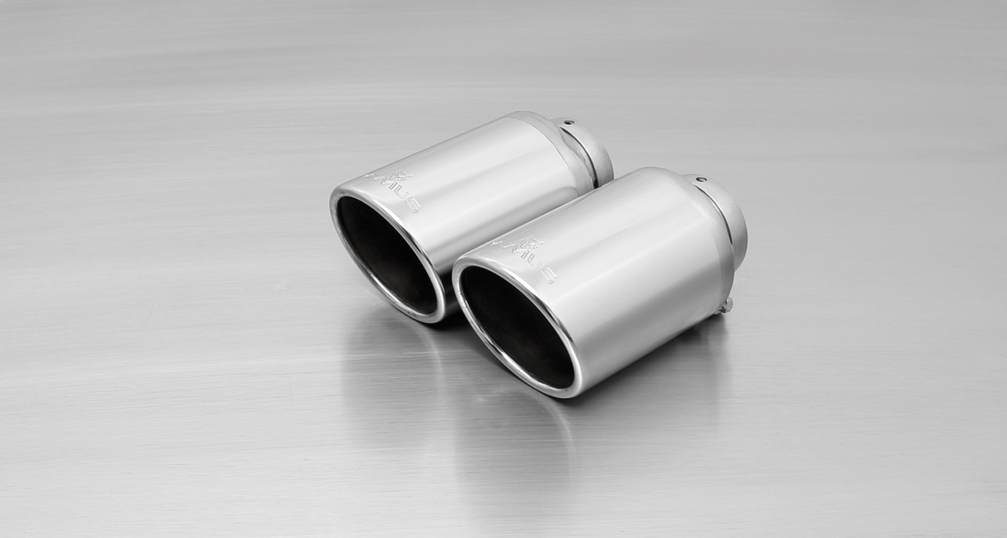
#70SG: tail pipes Ø 102 mm
angled, straight cut, chromed

#98C: tail pipes Ø 98 mm
Street Race, polished

#70S: tail pipes Ø 102 mm
angled, chromed

#70CS: Carbon tail pipes Ø 84 mm
angled, Titanium internals

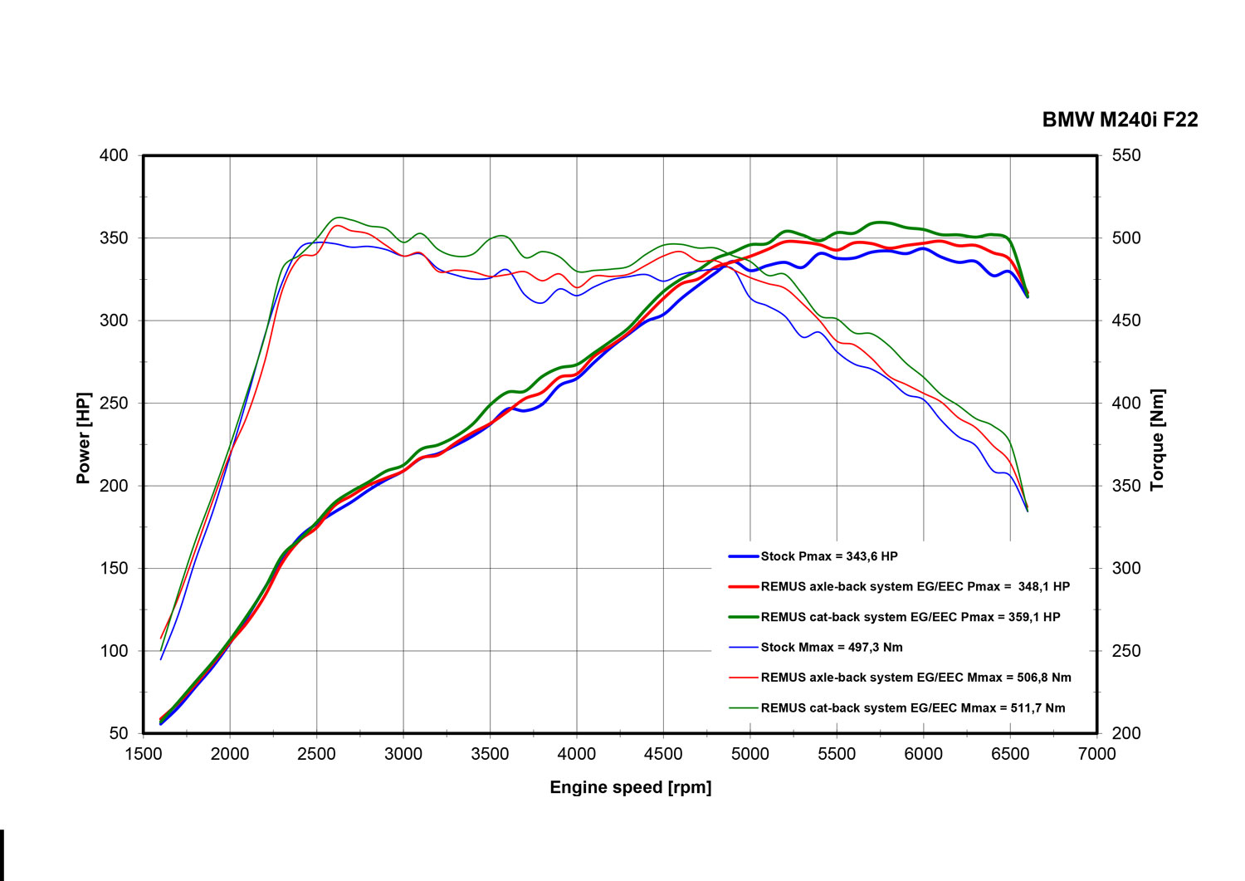
#98CB: tail pipes Ø 98 mm
Street Race Black Chrome

Car and engine specification
BMW 2 Series F22, 09/2015=>
M240i(x) 3.0l 250 kW (B58B30)
Part no. | Description | € RRP price excl. VAT
088015 1100 | Stainless steel RACING downpipe with sport catalytic convertor (200 CPSI), without homologation | 1.050,--
089016 0000 | Stainless steel RACING front section instead of original front silencer,  without homologation  Original tube Ø 80 mm, REMUS tubes 2x Ø 60 mm into 1x Ø 84 mm | 470,--
089016 0300 | Stainless steel resonated front section instead of original front silencer,  incl. EC homologation  Original tube Ø 80 mm, REMUS tubes 2x Ø 60 mm into 1x Ø 84 mm | 590,--
089016 1500 | Stainless steel sport exhaust centered for L/R system (without tail pipes)  with integrated valve, incl. EC homologation  Original tube Ø 80 mm, REMUS tubes Ø 84 mm  The activation of the valve is carried out using the original actuator via the vehicle onboard electronics. | 625,--
choose from following tail pipe package:
0026 70SG | Stainless steel tail pipe set 2 tail pipes Ø 102 mm angled, straight cut, chromed, with adjustable spherical clamp connection | 148,--
0026 70S | Stainless steel tail pipe set 2 tail pipes Ø 102 mm angled, rolled edge, chromed, with adjustable spherical clamp connection | 170,--
0026 70CS | Carbon tail pipe set 2 tail pipes Ø 102 mm angled, Titanium internals, with adjustable spherical clamp connection | 420,--
0026 98C | Stainless steel tail pipe set 2 tail pipes Ø 98 mm Street Race, straight, carbon insert, with adjustable spherical clamp connection | 222,--
0026 98CB | Stainless steel tail pipe set 2 tail pipes Ø 98 mm Street Race Black Chrome, straight, carbon insert, with adjustable spherical clamp connection | 246,--
INFOBOX:
- Axle-back-system L/R: 089016 1500 + tail pipe set! The original exhaust must be cut! No rear skirt modifications required!
- Cat-back-system L/R: 089016 0300 resp. 089016 0000 (Racing) + 089016 1500 + tail pipe set! No vehicle modifications required!
- Turbo-back-system L/R: 088015 1100 (Racing) + 089016 0300 resp. 089016 0000 (Racing) + 089016 1500 + tail pipe set! No vehicle modifications required!

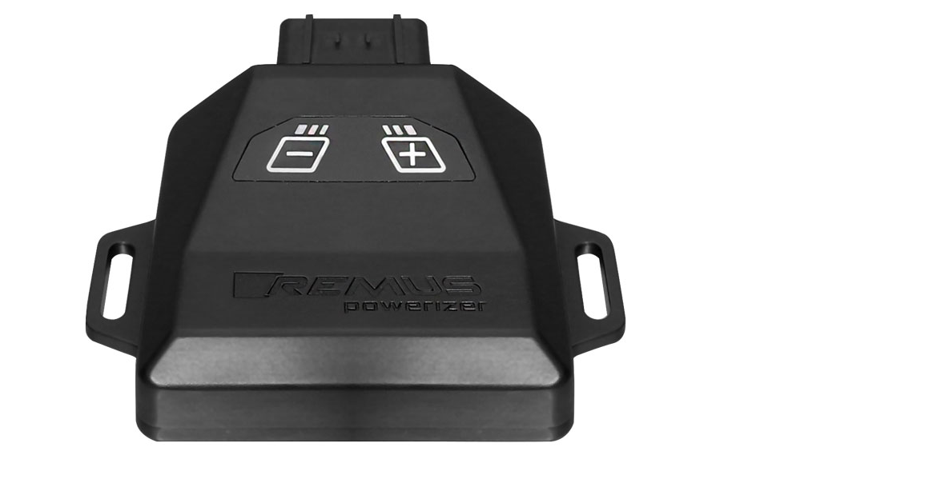
REMUS Powerizer
More power, more economy and more fun!
The electronics of the REMUS Powerizer enhances in real time
the engine management parameters. The engine mapping
is optimized in excess of 1000 times per second and ensures for a
considerable and noticeable power increase. The engine safety parameters and management remains totally original to ensure that individual engine components are not overstrained. Furthermore, the original mapping software remains totally untouched.
Due to the plug & play concept, the REMUS Powerizer is simple to install and can be easily removed or decommissioned using the supplied blind connector. Due to the torque increase, the engine has more power at lower RPM which leads to a reduction in fuel consumption. The power increase of the engine can be fine-tuned by means of seven preset levels. The REMUS Powerizer is available for over 3000 petrol and diesel powered cars.

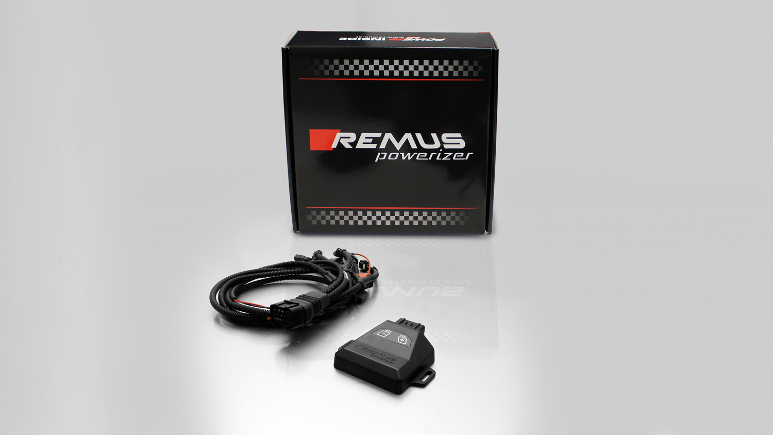

- Up to 25% more power
- Up to 20% more torque
- Easy installation and removal (plug & play)
- Up to 1l/100 km fuel saving
- No modifications on the ECU
- 7 preset power levels

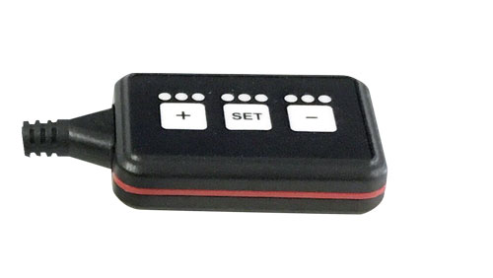
REMUS Responder

Improved throttle response, more dynamic!

Der REMUS ResponderThe REMUS Responder improves throttle response by means
of modifying the accelerator pedal output signal.

No more throttle delay and reduced lag during automatic shifting makes driving
with the REMUS Responder more fun. The Responder attaches between the
OEM pedal sensor and the OEM connector, ready to use in seconds due to plug & play technology.

Sophisticated adjustable programming profiles can lead to improved fuel consumption and
more efficiency. The four individual user selectable and adjustable performance settings
allow drivers to select according to their own preferences. The REMUS Responder totally eliminates the delay in modern electronic accelerator pedals!

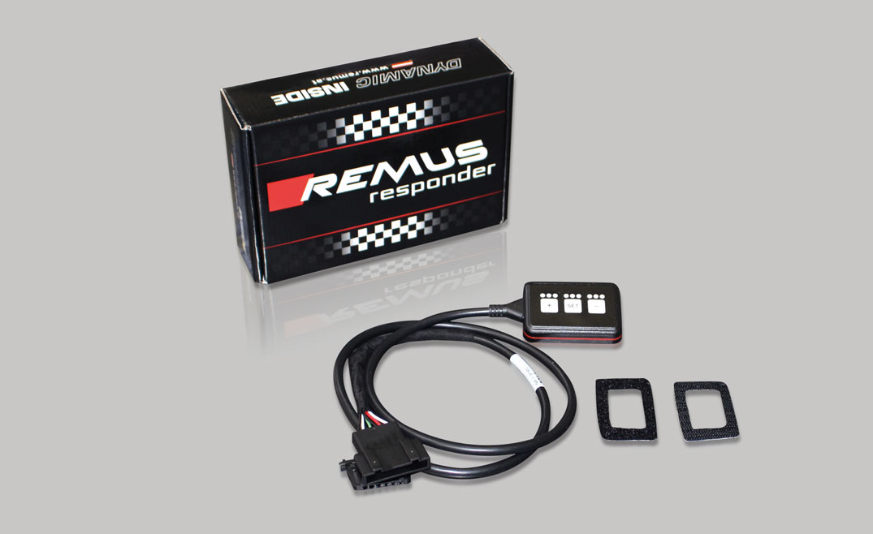

- Improved throttle response, reduced lag during gear changes
- Quicker reaction times, more dynamic without changing engine parameters
- 4 individual user selectable and adjustable performance settings
- Vehicle specific programming using OEM quality connectors
- Simple plug & play installation and easily removed without leaving traces

