Product information 44/2016

BMW 335i / 435i downpipe
restriction
BMW 3 Series F30 Limousine / F31 Touring, from 2012 - 335i 3.0l 225 kW (N55B30)
REMUS RACING downpipe
- 100% stainless steel
- Powerful sound
- Performance and torque increase
- Light weight construction

+ 7,7 PS
+ 7,0 Nm

BMW 4 Series F32 Coupe/ F36 Gran Coupe, from 2013 - 435i 3.0l 225 kW (N55B30)

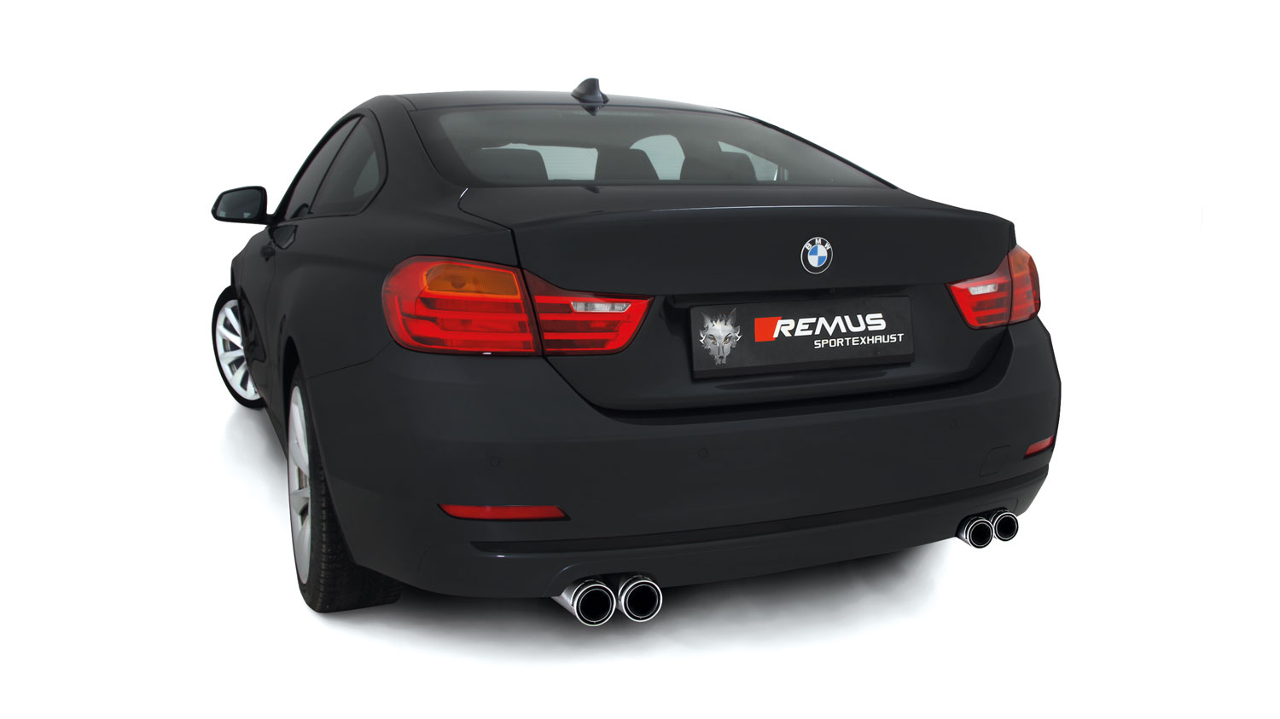

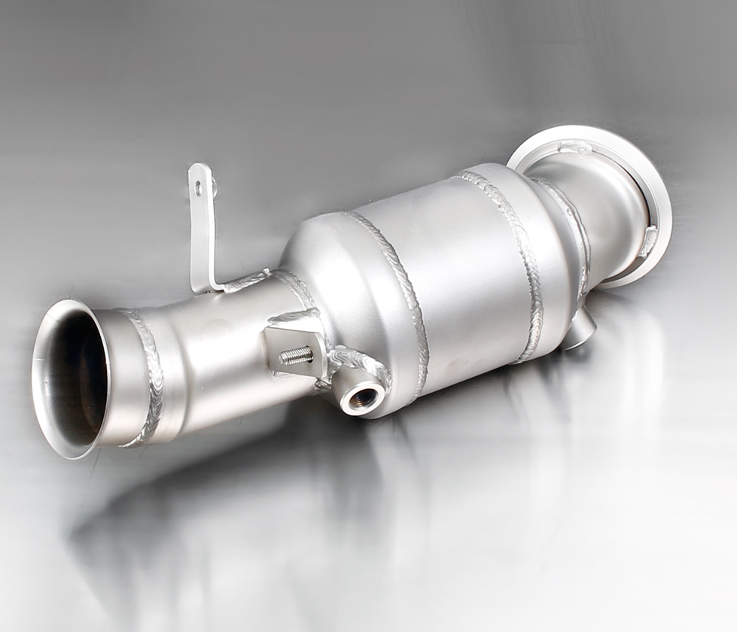
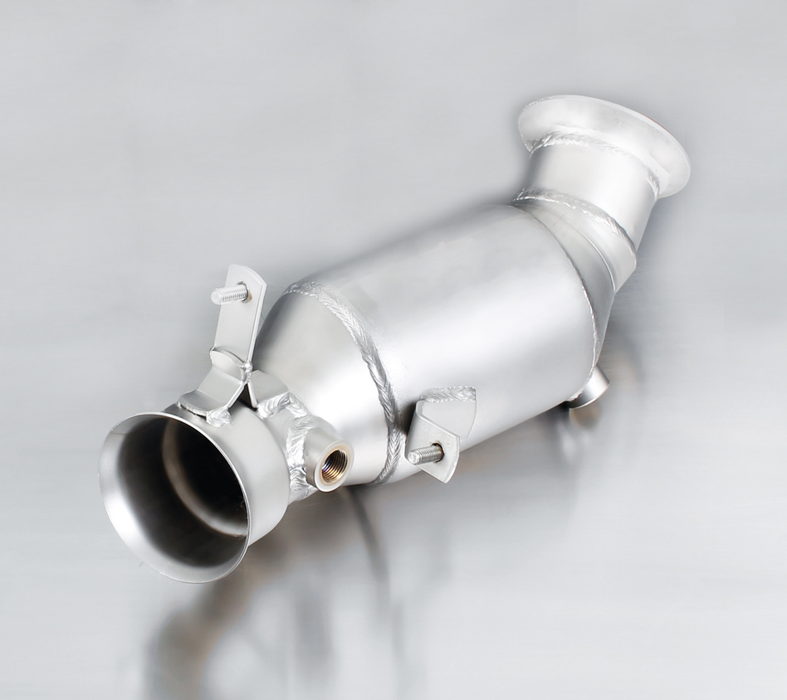

088014 1100
086512 1100

Car and engine specification
BMW 3 Series F30 Sedan / F31 Touring, 2012=> <=7/2014
335i 3.0l 225 kW (N55B30)
BMW 4 Series F32 Coupe/ F36 Gran Coupe, 2013=> <=7/2014
435i 3.0l 225 kW (N55B30)
Part no. | Description | € RRP price excl. VAT
086512 1100 | Stainless steel RACING downpipe with sport catalytic convertor (200 CPSI), NOT for xDrive models, without homologation, only for models until 7/2014 | 989,--
INFOBOX:
- 086512 1100: Only for models until 7/2014!
- When installing REMUS down-pipes with and without the racing catalytic convertors, which are only suitable for closed road driving, it is important to note that ECU tuning is required to ensure that the engine runs and performs efficiently and to ensure that the CEL does not come on.

Car and engine specification
BMW 3 Series F30 Sedan / F31 Touring, 7/2014=>
335i 3.0l 225 kW (N55B30)
BMW 4 Series F32 Coupe/ F36 Gran Coupe, 7/2014=>
435i 3.0l 225 kW (N55B30)
Part no. | Description | € RRP price excl. VAT
088014 1100 | Stainless steel RACING downpipe with sport catalytic convertor (200 CPSI), NOT for xDrive models, without homologation, only for models up from 7/2014 | 961,--
INFOBOX:
- 088014 1100: Only for models up from 7/2014!
- When installing REMUS down-pipes with and without the racing catalytic convertors, which are only suitable for closed road driving, it is important to note that ECU tuning is required to ensure that the engine runs and performs efficiently and to ensure that the CEL does not come on.
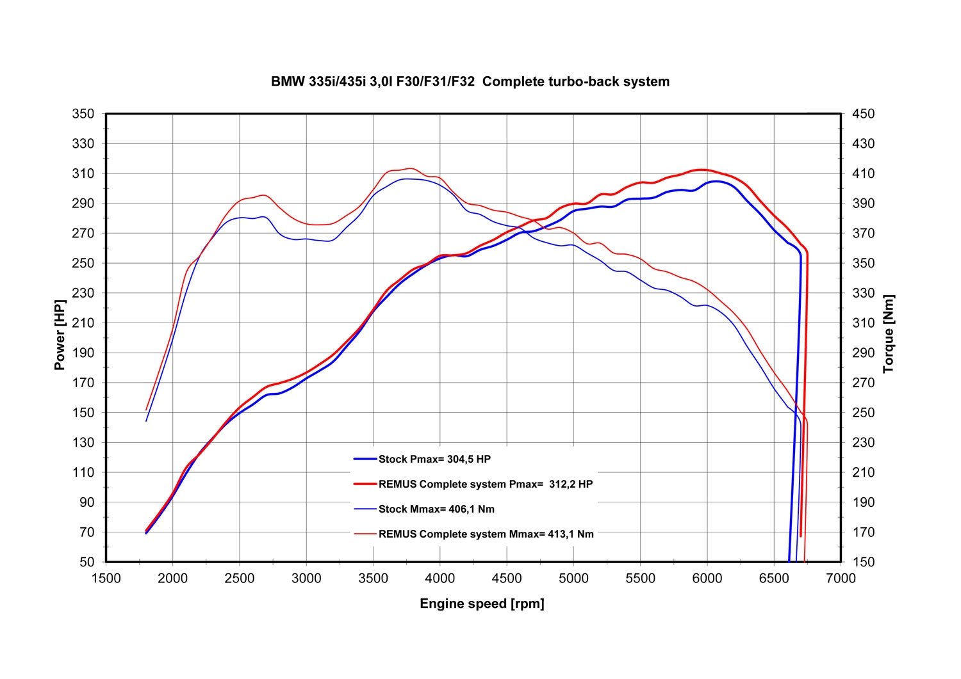

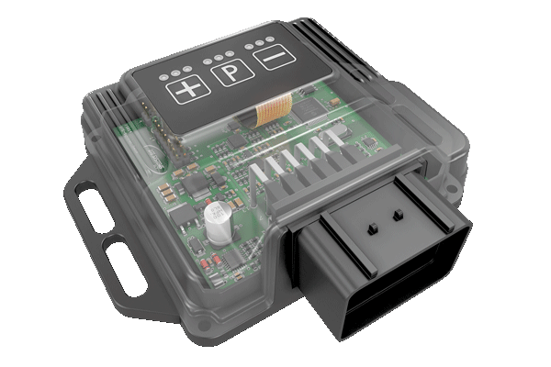
REMUS Powerizer
More power, more economy and more fun!
The electronics of the REMUS Powerizer enhances in real time
the engine management parameter. The engine mapping
is optimized in excess of 1000 times per second and ensures for a
considerable and noticeable power increase. The engine safety parameters and management remains totally original to ensure that individual engine components are not overstrained. Furthermore, the original mapping software remains totally untouched.
Due to the Plug & Play concept, the REMUS Powerizer is simple to install and can be easily removed or decommissioned using the supplied blind connector. Due to the torque increase, the engine has more power at lower RPM which leads to a reduction in fuel consumption. The power increase of the engine can be adjusted according to different driving styles by means of a „maximum power setting“, „eco fuel saving mode“ or a combination of both. The REMUS Powerizer is available for over 3000 petrol and diesel powered cars.

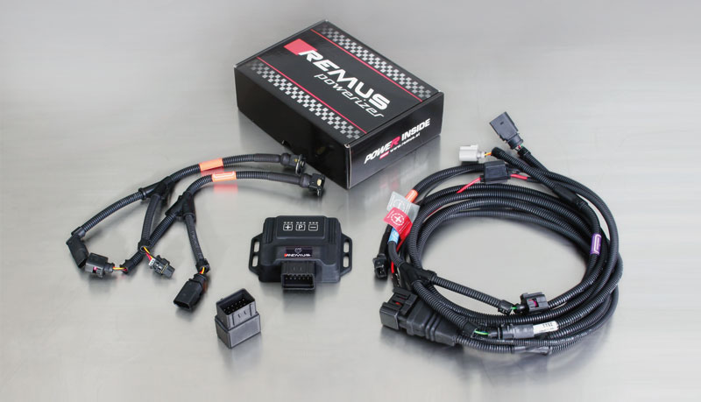

- Up to 25% more power
- Up to 20% more torque
- Easy installation and removal (Plug & Play)
- Up to 1l/100 km fuel saving
- 3 preset programs (RACE/SPORT/ECO) with individual power adjustment

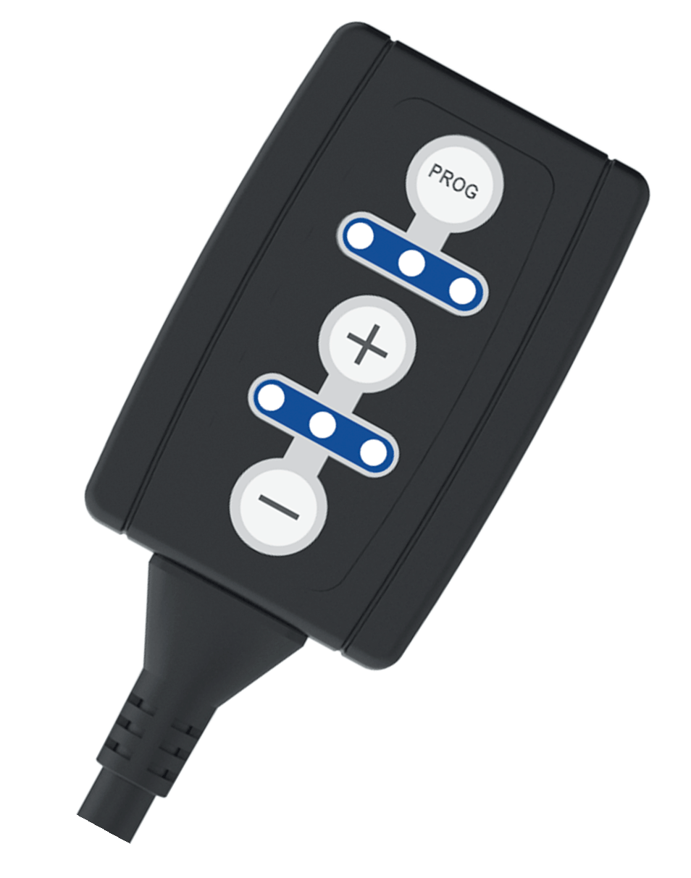
REMUS Responder

Improved throttle response, more dynamic!

The REMUS Responder improves throttle response by means
of modifying the accelerator pedal output signal.
No more throttle delay and reduced lag during automatic shifting makes driving
with the REMUS Responder more fun. The Responder attaches between the
OEM pedal sensor and the OEM connector, ready to use in seconds due to plug & play technology.
Sophisticated adjustable programming profiles can lead to improved fuel consumption and
more efficiency. The 4 individual user selectable and adjustable performance settings
allow drivers to select according to their own preferences. The REMUS Responder totally eliminates the delay in modern electronic accelerator pedals!

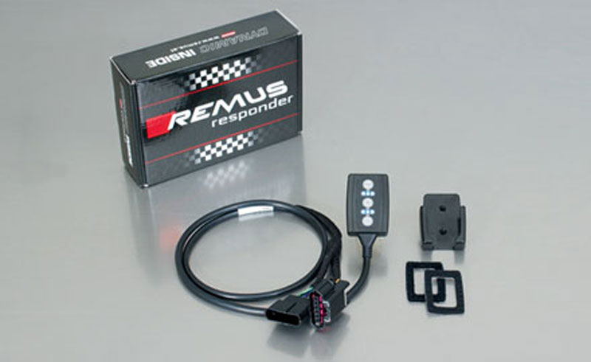

- Improved throttle response, reduced lag during gear changes
- Quicker reaction times, more dynamic without changing engine parameters
- 4 individual user selectable and adjustable performance settings
- Vehicle specific programming using OEM quality connectors
- Simple plug & play installation and easily removed without leaving traces

