Product information 40/2016

AUDI R8, type 4S

R8, type 4S, from 2015 - V10 plus 5.2l FSI 449 kW
REMUS RACING sport exhaust
- 100% stainless steel
- Aggressive racing sound
- Performance and torque increase
- Light weight construction

- 17,8 kg
+ 8,1 Nm

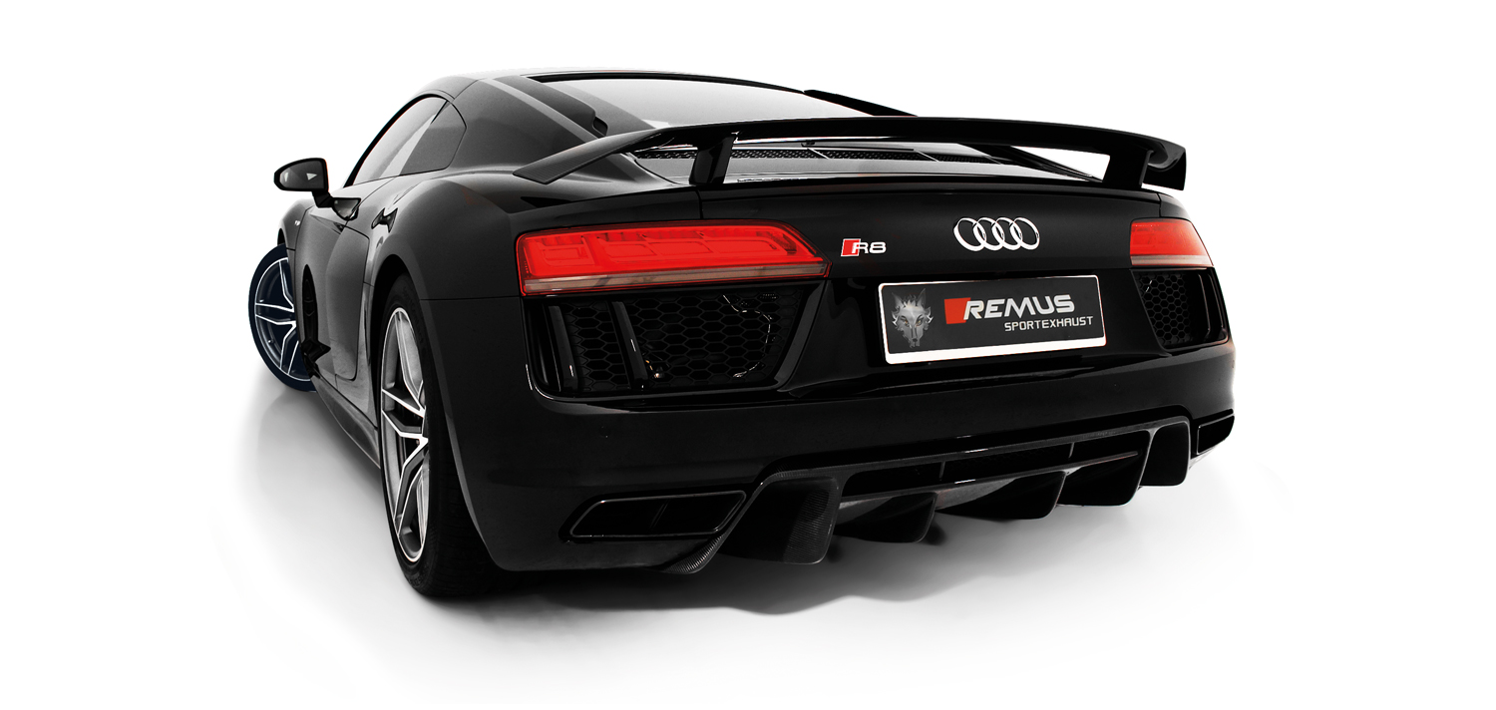

Car and engine specification
AUDI R8, type 4S, 2015=>
V10 plus 5.2l FSI 449 kW
Part no. | Description | € RRP price excl. VAT
049315 1500 | Stainless steel RACING sport exhaust centered,  suitable for the original exhaust outlets, with 2 vacuum operated valves, without homologation  Original tube Ø 76 mm - REMUS tube Ø 76 mm | 2.050,--
INFOBOX:
- The valves are vacuum controlled via the onboard electronics.
- No cutting of the original exhaust system required!
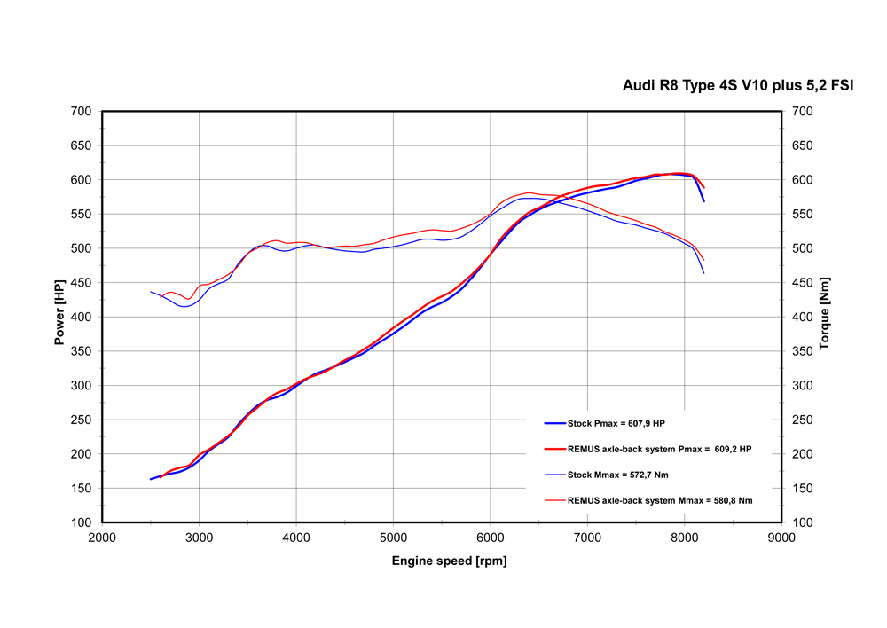

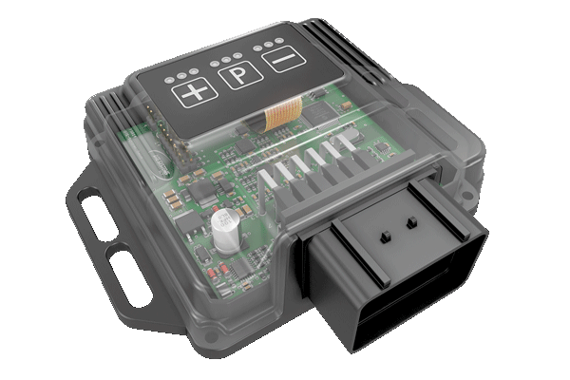
REMUS Powerizer
More power, more economy and more fun!
The electronics of the REMUS Powerizer enhances in real time
the engine management parameter. The engine mapping
is optimized in excess of 1000 times per second and ensures for a
considerable and noticeable power increase. The engine safety parameters and management remains totally original to ensure that individual engine components are not overstrained. Furthermore, the original mapping software remains totally untouched.
Due to the Plug & Play concept, the REMUS Powerizer is simple to install and can be easily removed or decommissioned using the supplied blind connector. Due to the torque increase, the engine has more power at lower RPM which leads to a reduction in fuel consumption. The power increase of the engine can be adjusted according to different driving styles by means of a „maximum power setting“, „eco fuel saving mode“ or a combination of both. The REMUS Powerizer is available for over 3000 petrol and diesel powered cars.

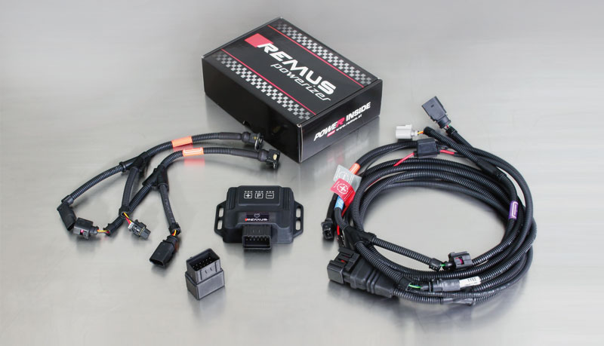

- Up to 25% more power
- Up to 20% more torque
- Easy installation and removal (Plug & Play)
- Up to 1l/100 km fuel saving
- 3 preset programs (RACE/SPORT/ECO) with individual power adjustment

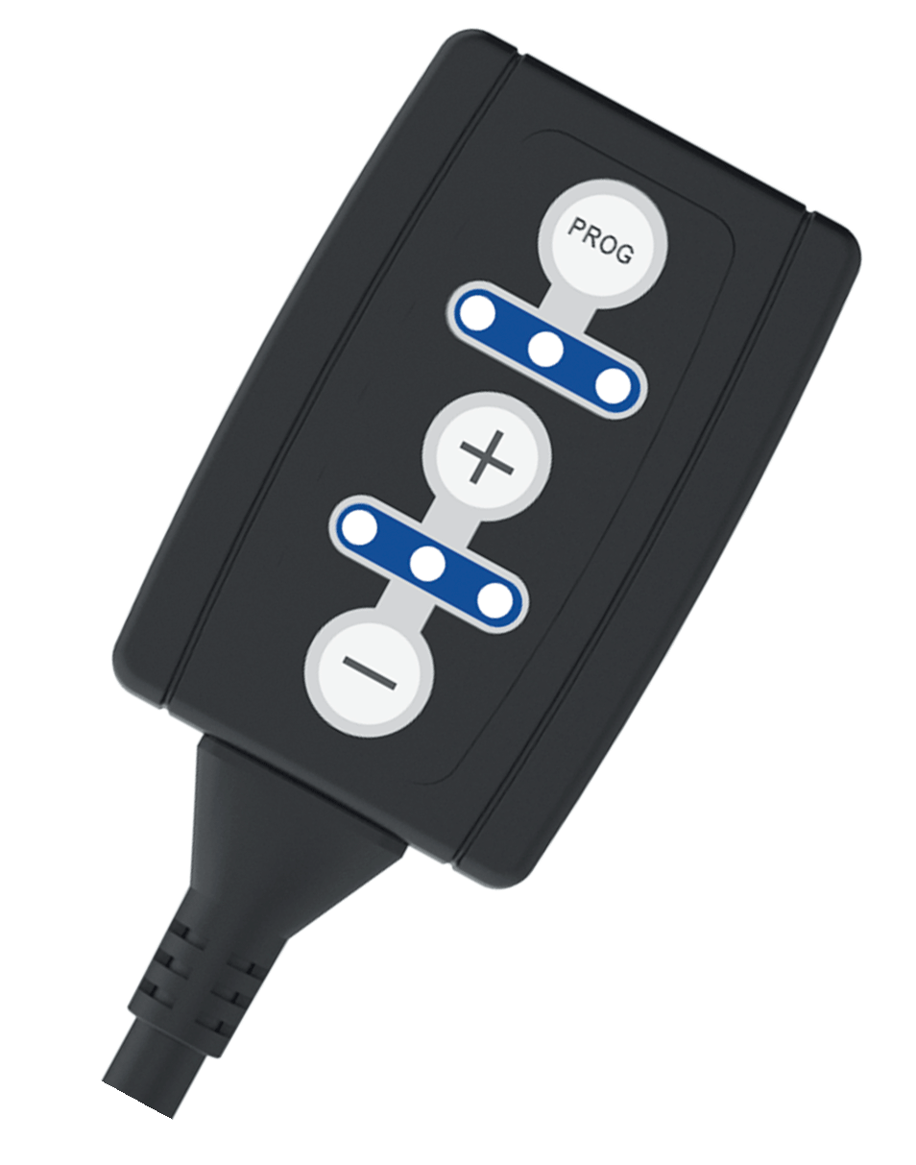
REMUS Responder

Improved throttle response, more dynamic!

Der REMUS ResponderThe REMUS Responder improves throttle response by means
of modifying the accelerator pedal output signal.
No more throttle delay and reduced lag during automatic shifting makes driving
with the REMUS Responder more fun. The Responder attaches between the
OEM pedal sensor and the OEM connector, ready to use in seconds due to plug & play technology.
Sophisticated adjustable programming profiles can lead to improved fuel consumption and
more efficiency. The 4 individual user selectable and adjustable performance settings
allow drivers to select according to their own preferences. The REMUS Responder totally eliminates the delay in modern electronic accelerator pedals!

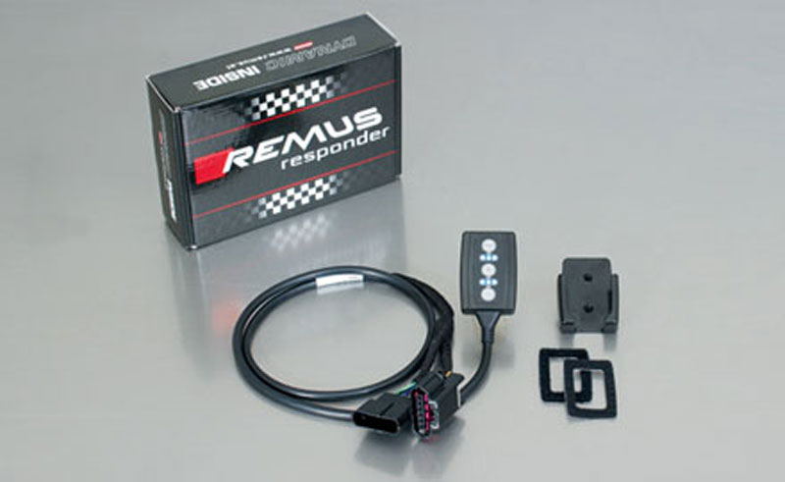

- Improved throttle response, reduced lag during gear changes
- Quicker reaction times, more dynamic without changing engine parameters
- 4 individual user selectable and adjustable performance settings
- Vehicle specific programming using OEM quality connectors
- Simple plug & play installation and easily removed without leaving traces

