REMUS product information 35-2016 2016-09-09

HONDA Civic Type R, type FK2, 2015=>

Dear REMUS partner,

We are pleased to inform you that we have extended the application range of our

REMUS cat-back system left/right with carbon or chromed tail pipes for

HONDA Civic Type R, type FK2, 2015=>

It would be a pleasure for us to receive your order.

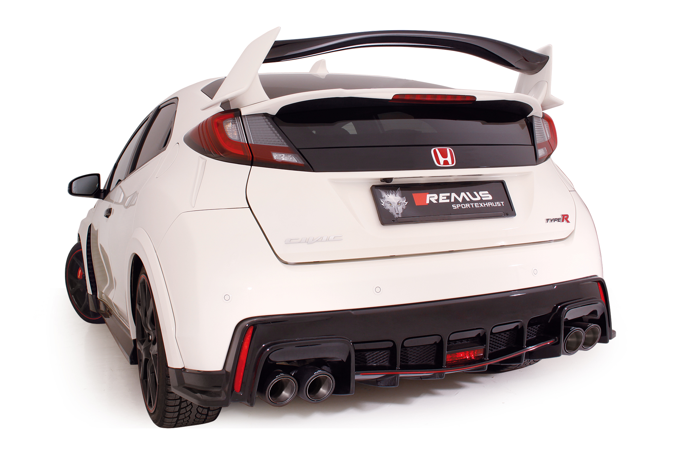
Stay tuned!

Your REMUS Team
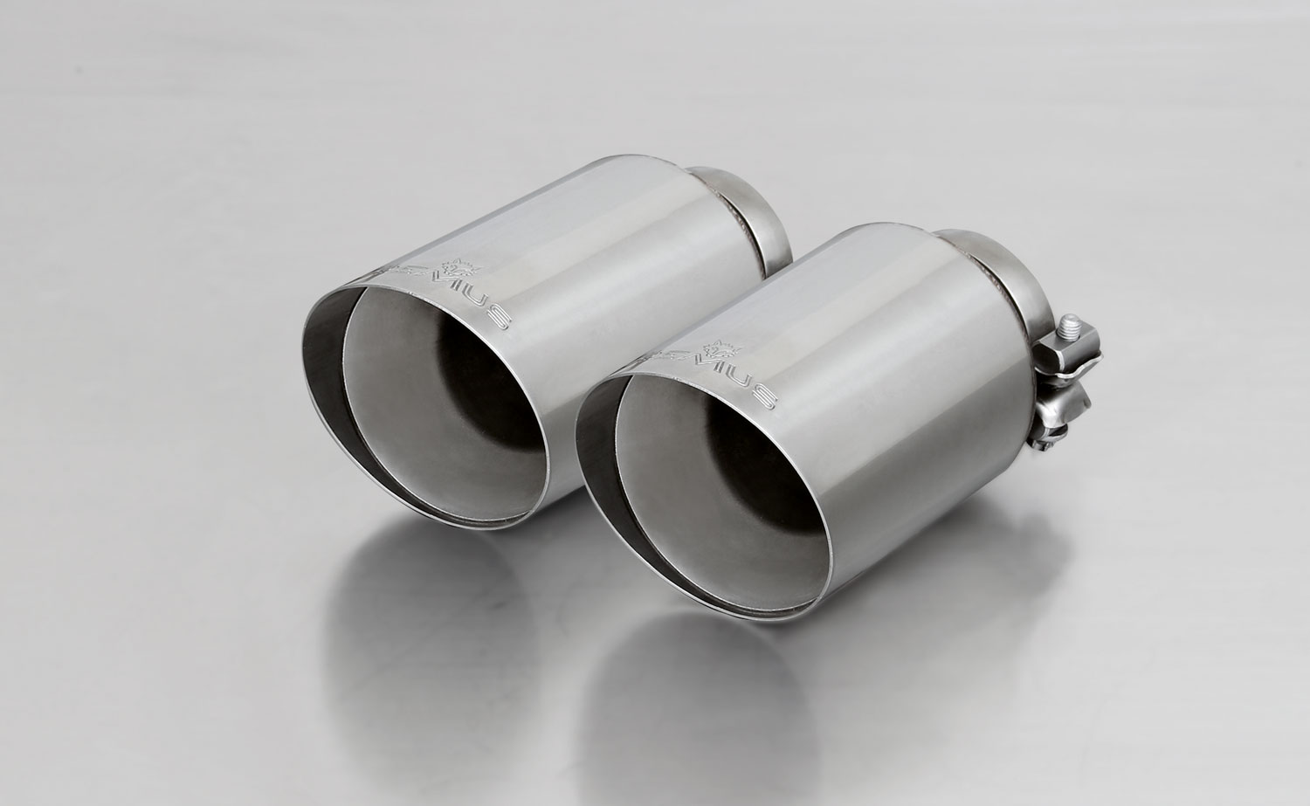
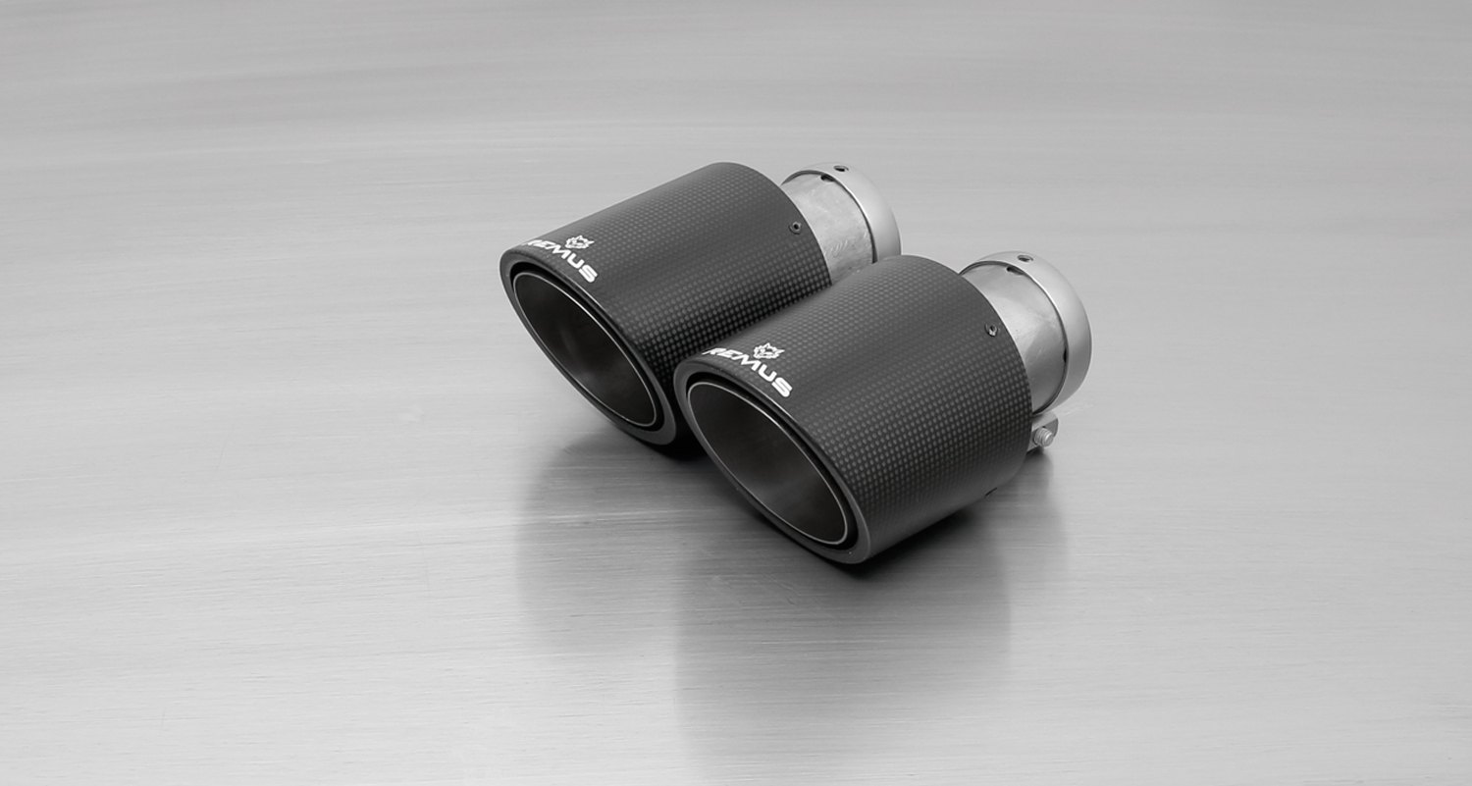
#70CS: Carbon tail pipes Ø 102 mm angled, Titanium internals

#70SG: tail pipes Ø 102 mm angled,
Straight cut, chromed
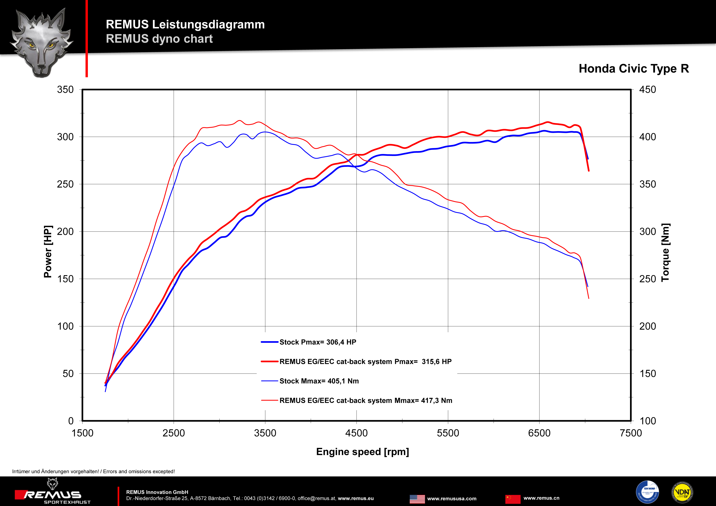

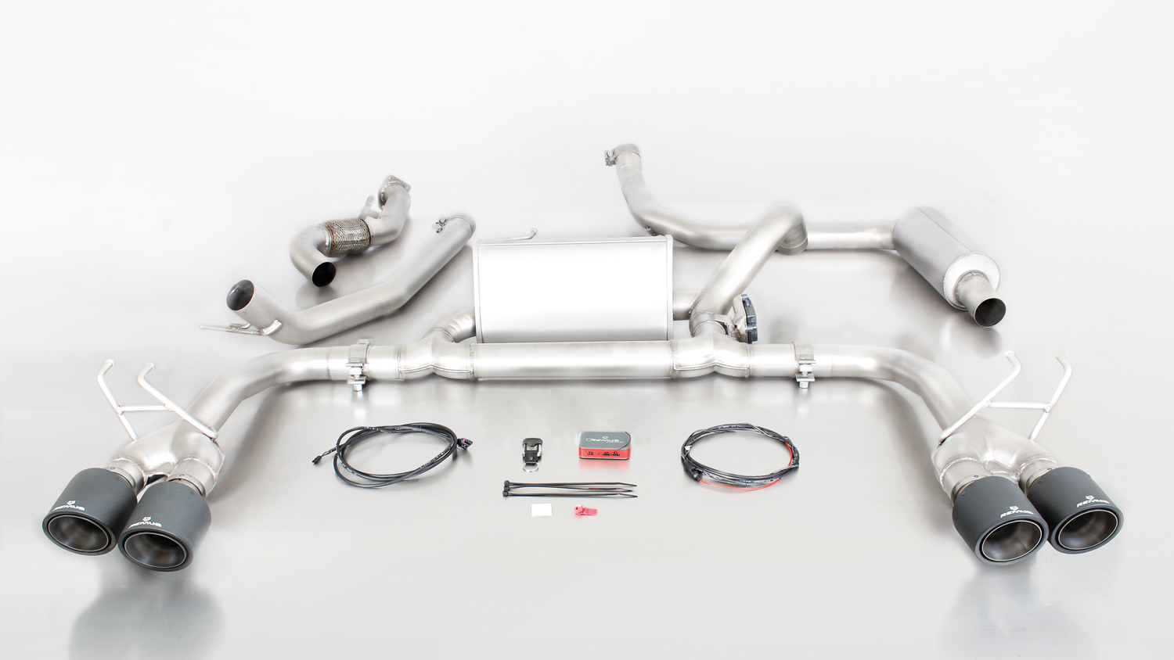
256315 0300 + 256315 1500 + 0446 70CS

Car and engine specification
HONDA Civic Type R, type FK2, 5 door, 2015=>
2.0l VTEC Turbo / Turbo GT 228 kW (K20C1)
Part no. | Description | € RRP price excl. VAT
256315 0300 | Stainless steel resonated section for left hand drive, incl. EEC homologation  tube Ø 70 mm | 340,--
256215 0300 | Stainless steel resonated section for right-hand drive, incl. EEC homologation  tube Ø 70 mm | 340,--
256015 1500 | Stainless sport exhaust centered for left/right system with integrated valve, with EEC homologation  Original tube Ø 60 mm  REMUS tube Ø 70 mm | 930,--
choose from following tail pipe package:
0446 70SG | Tail pipe set L/R consisting of 4 tail pipes Ø 102 mm angled, straight cut, chromed, (length 145 mm) with adjustable spherical clamp connection | 280,--
0446 70CS | Tail pipe set L/R consisting of 4 Carbon tail pipes Ø 102 mm angled (length 145 mm), Titanium internals, with adjustable spherical clamp connection | 740,--
INFOBOX:
- 256315 0300 (left hand drive) respectively 256215 0300 (right-hand drive) + 256315 1500 + and tail pipe set only fit as a complete system!
- No vehicle modifications are required!
- Cat-Back-Anlage: 256315 0300 (left hand drive) respectively 256215 0300 (right-hand drive) + 256315 1500 + and tail pipe set. No vehicle modifications are required!
- It is not permissible to activate the valve on public roads as per the EU transport authority. The activation of the valve is carried out using the supplied remote control key fob, sound
controller and electrical actuator which allows the valve to be operated in 4 different positions.
- 256015 1500 replaces 256315 0300 (left hand drive) respectively 256215 0300 (right-hand drive) + 256315 1500.

Under http://www.remus.eu/powerizer/ and http://www.remus.eu/remusresponder you will find the entire product range, prices and installation instructions.

REMUS RESPONDER:
Improved throttle response, more dynamic!
The REMUS Responder improves throttle response by means of modifying the accelerator pedal output signal. No more throttle delay and reduced lag during automatic shifting makes driving with the REMUS Responder more fun. The Responder attaches between the OEM pedal sensor and the OEM connector, ready to use in seconds due to plug & play technology. Sophisticated adjustable programming profiles can lead to improved fuel consumption and more efficiency. The 4 individual user selectable and adjustable performance settings allow drivers to select according to their own preferences.
The REMUS Responder totally eliminates the delay in modern electronic accelerator pedals!
