REMUS product information 28-2016

FORD Focus III ST Facelift, type DYB, 2015=>

Dear REMUS Partner,

We are pleased to inform you that we have completed our next development
REMUS cat-back system for the
FORD Focus III ST Facelift, type DYB, 2015=>

It would be a pleasure for us to receive your orders.

Stay tuned!
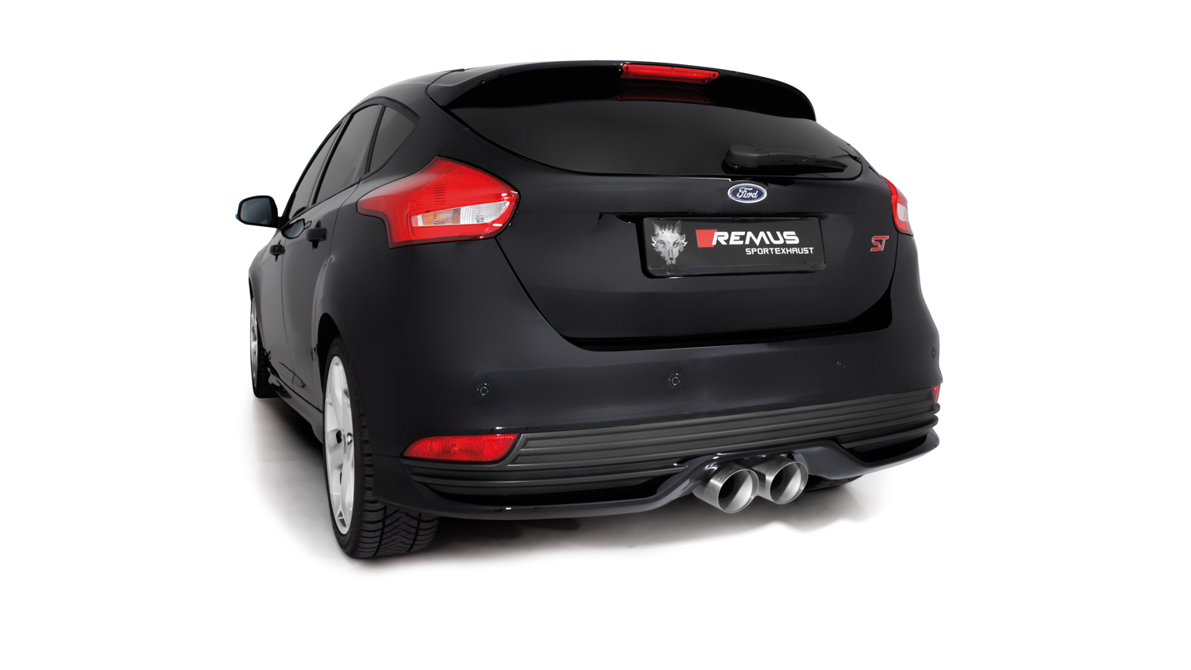
Your REMUS Team

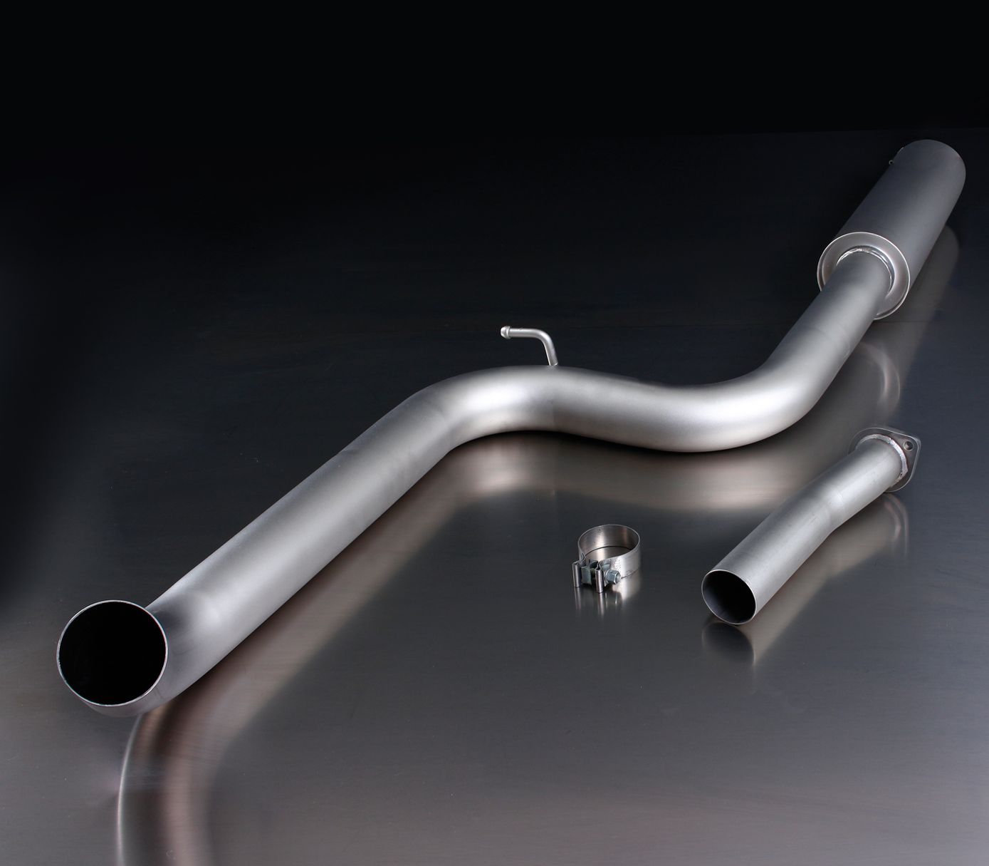
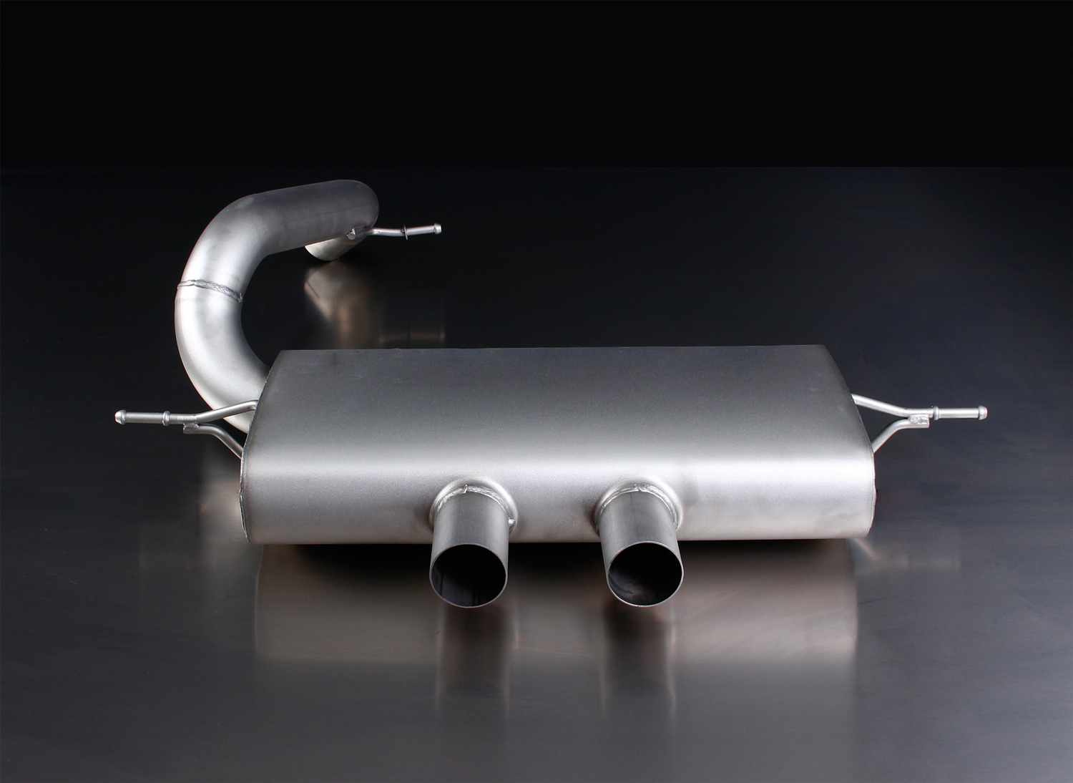
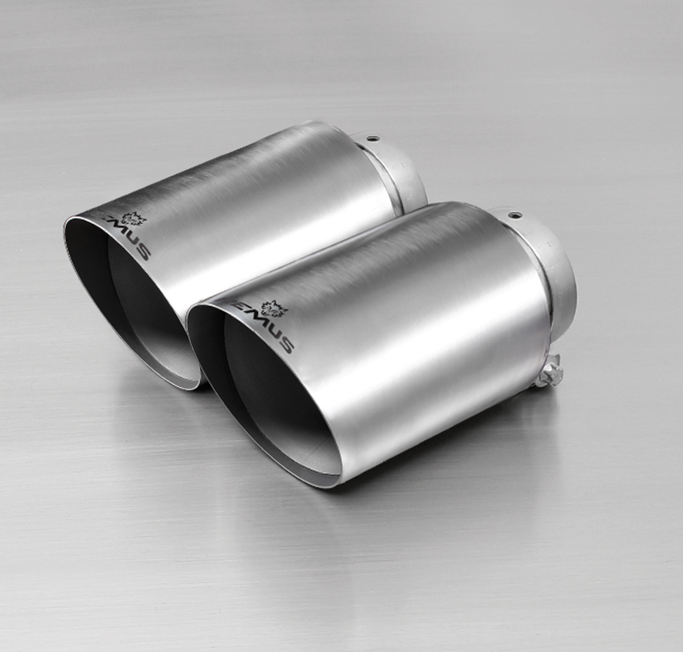
205512 5500

205012 0300

0026 80S

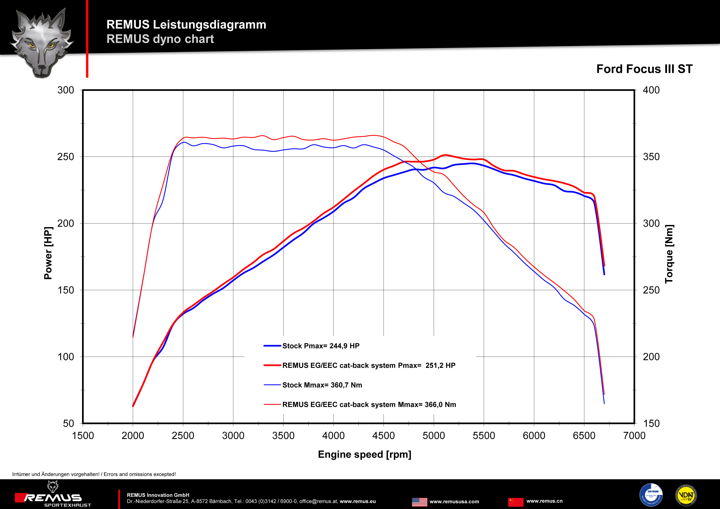

Car and engine specification
FORD Focus III ST, type DYB, 2012=>
2.0l EcoBoost 184 kW (R9DA)
FORD Focus III ST Facelift, type DYB, 2015=>
2.0l EcoBoost 184 kW (R9DA)
Part no. | Description | € RRP price excl. VAT
Optional: stainless steel RACING tube resp. RACING front section, without homologation
205012 0000 | Stainless steel cat-back RACING non-resonated front, without homologation  Original tube Ø 55/60 mm  REMUS tube Ø 70 mm | 156,--
205012 0300 | Stainless steel cat-back RACING resonated front section, without homologation  Original tube Ø 55/60 mm  REMUS tube Ø 70 mm | 263,--
Stainless steel cat-back-system incl. EEC homologation
205512 0300 | Stainless steel resonated cat-back front section, incl. EEC homologation  Original tube Ø 55/60 mm  REMUS tube Ø 70 mm | 285,--
205512 5500 | Stainless steel sport exhaust centered (without tail pipes), incl. EEC homologation  Original tube Ø 55/60 mm  REMUS tube Ø 70 mm | 360,--
0026 80S | Stainless steel tail pipe set 2 tail pipes Ø 115 mm angled, chromed, with adjustable spherical clamp connection | 180,--
INFOBOX:
- Cat-back-system: 205512 0300 + 205512 5500 + tail pipe set! No vehicle modifications required!
- RACING cat-back-system: 205012 0000 bzw 205012 0300 + 205512 5500 + tail pipe set! No vehicle modifications required!
- Part number 205012 1580S will be replaced by 205512 5500 + tail pipe set!

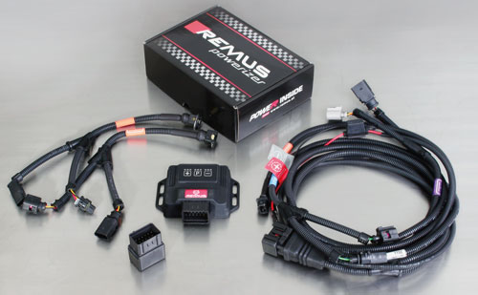

Under http://www.remus.eu/powerizer/ and http://www.remus.eu/remusresponder you will find the entire product range, prices and installation instructions.

REMUS Powerizer: More power, more economy and more fun.
- Up to 25 % more power
- Up to 20 % more torque
- Up to 1l/100 km fuel saving
- Fully adjustable power increase
- Simple DIY installation (Plug & Play)
REMUS POWERIZER: The performance figures represent the maximum achievable values. The actual performance output depends on the original tolerances of each engine. REMUS delivers the POWERIZER with the best possible setting for your vehicle type. You can adjust the performance according to your requirements as per the POWERIZER instructions

Legal references

1. Completion and registration of chip tuning in the car documents
Due to chip tuning, the operating license of the vehicle will terminate if the installation and registration of the POWERIZER is not carried out or immediately reported to an official approved testing facility. Please consider that driving a vehicle without the required operating license will cause legal penalties.

2. Vehicle insurance must be informed upon installing a POWERIZER
The installation of the POWERIZER can have influence on the insurance policy of your vehicle. You must inform the insurance company if you install a POWERIZER in your vehicle.

3. Effect of chip tuning on warranty and guarantee claims
a) When installing a POWERIZER, you will lose all guarantee claims regarding the engine against the vehicle manufacturer.
b) Installing a POWERIZER, can have influence on warranty claims against the seller of the vehicle.
c) REMUS excludes any claims regarding compensation for damages on the engine and drivetrain.

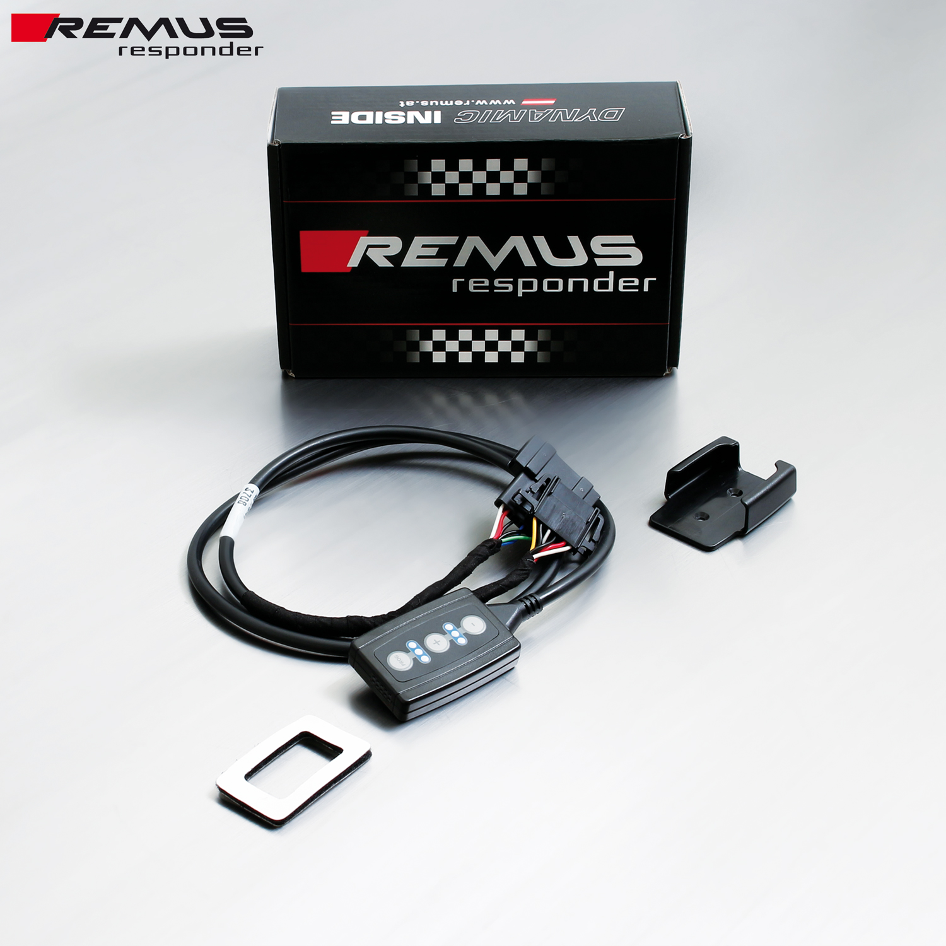

Under http://www.remus.eu/powerizer/ and http://www.remus.eu/remusresponder you will find the entire product range, prices and installation instructions.
REMUS RESPONDER:
Improved throttle response, more dynamic!
The REMUS Responder improves throttle response by means of modifying the accelerator pedal output signal. No more throttle delay and reduced lag during automatic shifting makes driving with the REMUS Responder more fun. The Responder attaches between the OEM pedal sensor and the OEM connector, ready to use in seconds due to plug & play technology. Sophisticated adjustable programming profiles can lead to improved fuel consumption and more efficiency. The 4 individual user selectable and adjustable performance settings allow drivers to select according to their own preferences.
The REMUS Responder totally eliminates the delay in modern electronic accelerator pedals!

