REMUS product information 26-2016

MAZDA MX-5, type ND, 2015=>

Dear REMUS Partner,

We are pleased to inform you that we have completed our next development:
REMUS RACING secondary cat replacement tube, resonated front section and sport exhaust left/right with selectable tail pipes for the MAZDA MX-5, type ND, 2015=>.

It would be a pleasure for us to receive your order.

Stay tuned!
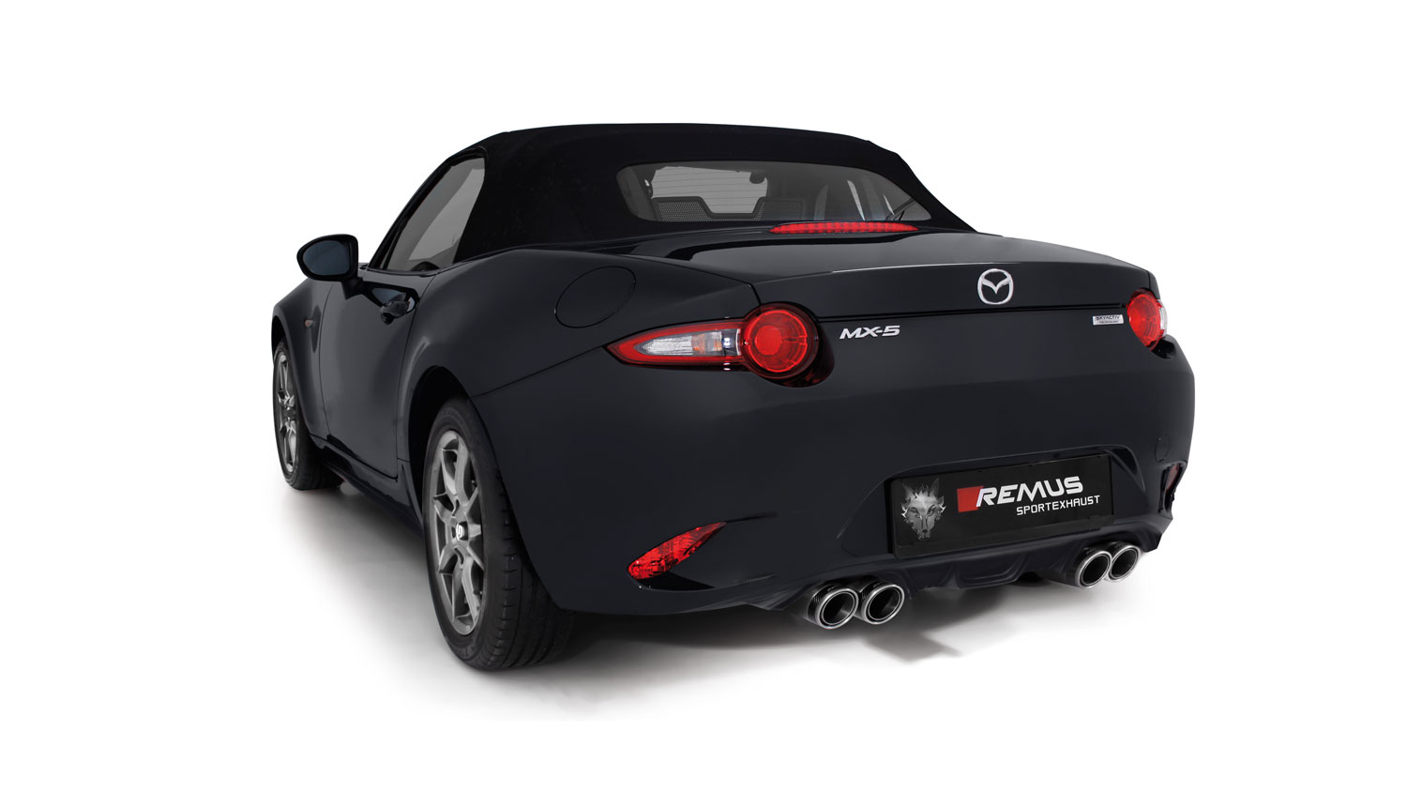
Your REMUS Team

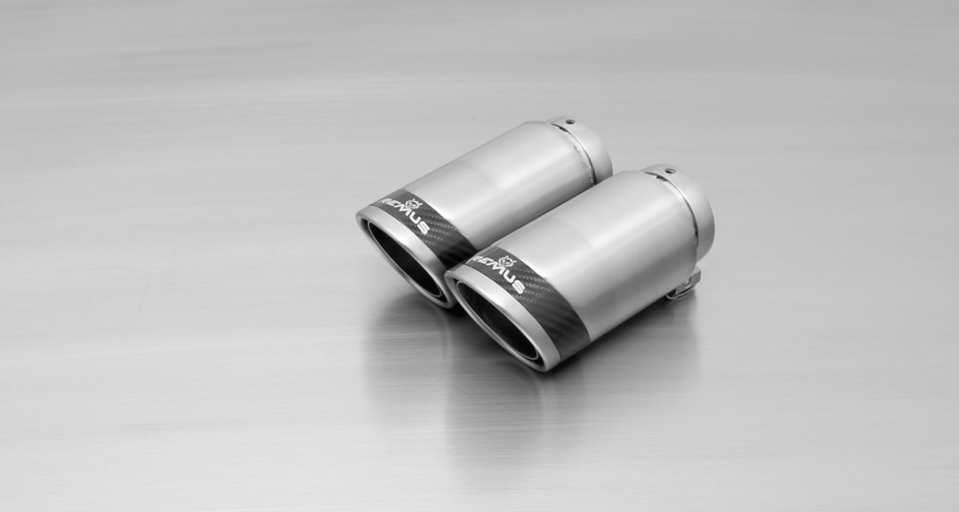
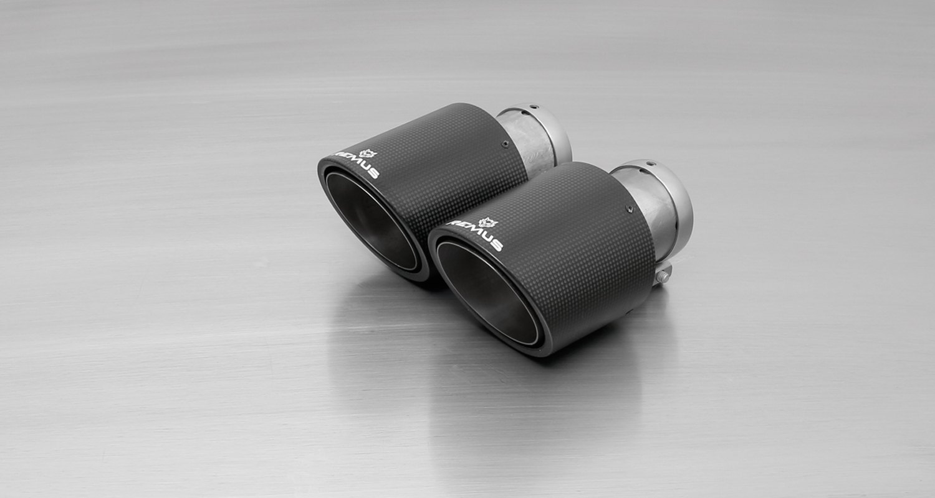
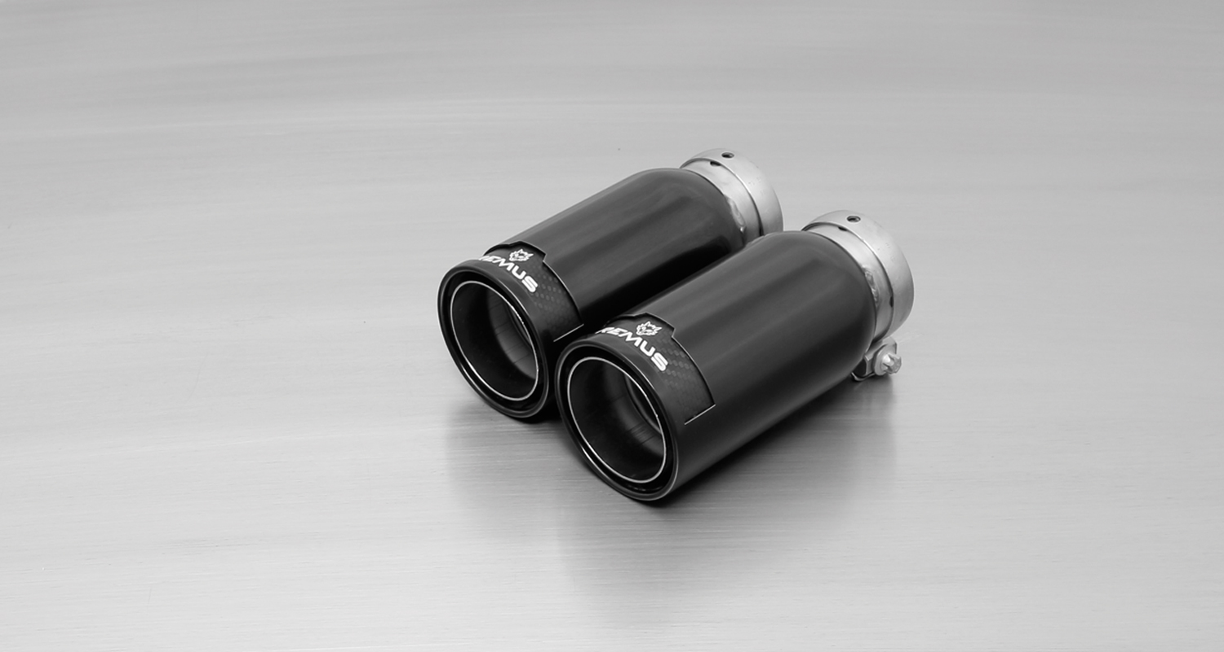
#83CS: tail pipes Ø 84 mm
Carbon Race, polished
#83CTS: Carbon-tail pipes
Ø 84 mm angled, Titanium internals

#83CB: tail pipes Ø 84 mm
Street Race Black Chrome

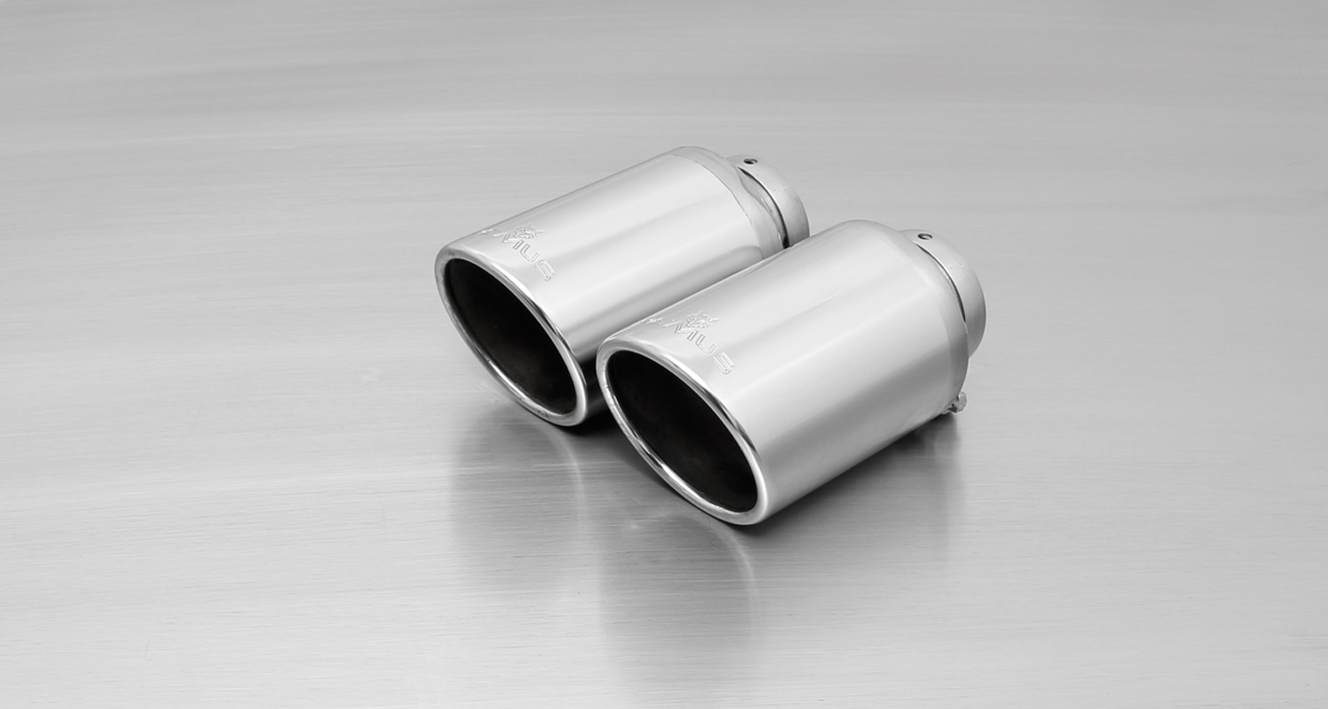
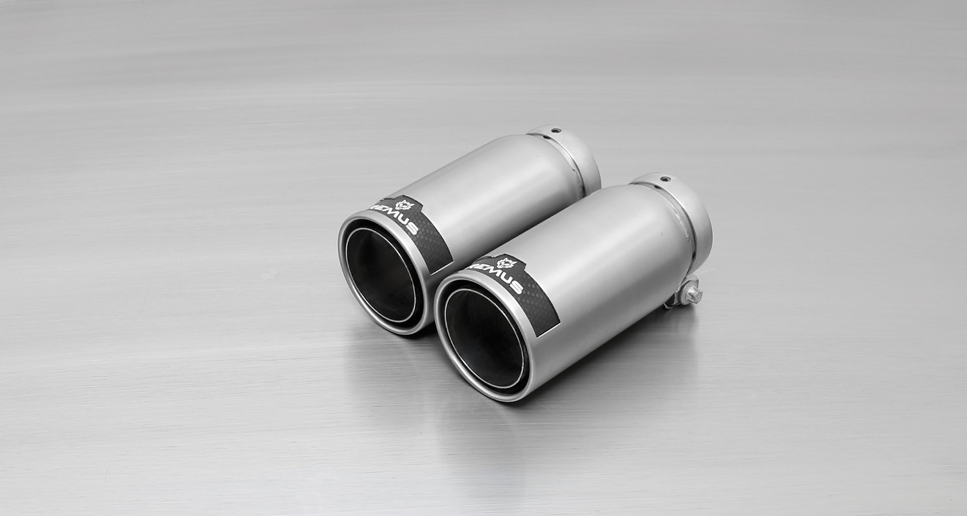
#55S: tail pipes Ø 84 mm
angled, chromed

#83C: tail pipes Ø 84 mm
Street Race, polished

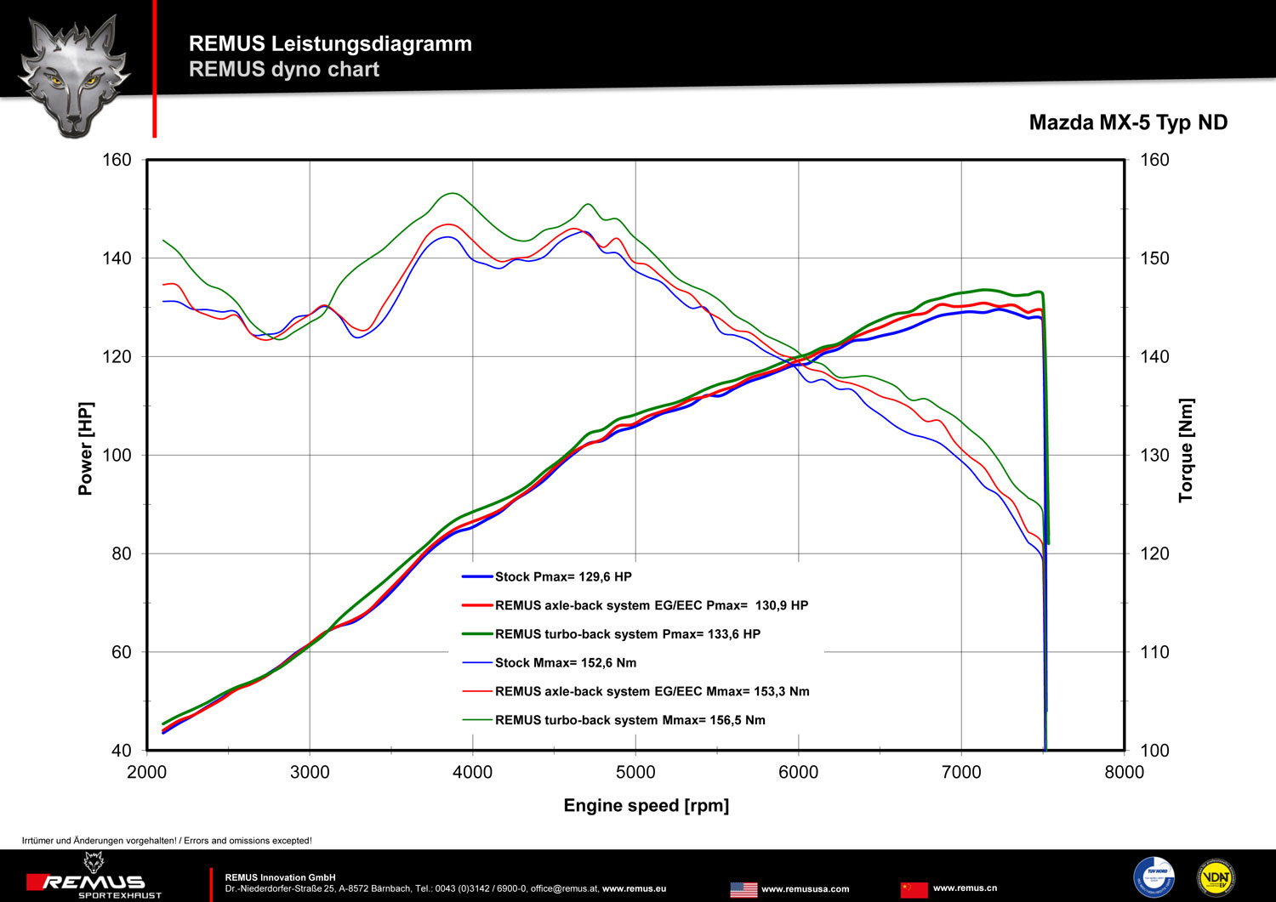

Car and engine specification
MAZDA MX-5, type ND, 2015=>
1.5l Skyactive G-130 96 kW; 2.0l Skyactive G-160 (iELOOP) 118 kW
Part no. | Description | € RRP price excl. VAT
456016 1200 | Stainless steel RACING secondary catalyst replacement tube, without homologation  Original tube Ø 54 mm  REMUS tube Ø 60 mm | 130,--
456016 0300 | Stainless steel resonated cat-back front section, incl. EEC homologation  Original tube Ø 54 mm  REMUS tube Ø 60 mm | 240,--
456016 1500 | Stainless steel sport exhaust centered for L/R system (without tail pipes) incl. EEC homologation  Original tube Ø 54 mm  REMUS tube Ø 60 mm | 360,--
choose from following tail pipe package:
0046 55S | Stainless steel tail pipe set L/R consisting of 4 tail pipes Ø 84 mm angled, chromed, with adjustable spherical clamp connection | 300,--
0046 83C | Stainless steel tail pipe set L/R consisting of 4 tail pipes Ø 84 mm Street Race, with adjustable spherical clamp connection | 340,--
0046 83CS | Stainless steel tail pipe set L/R consisting of 4 tail pipes Ø 84 mm Carbon Race, with adjustable spherical clamp connection | 360,--
0046 83CB | Stainless steel tail pipe set L/R consisting of 4 tail pipes Ø 84 mm Street Race Black Chrome, with adjustable spherical clamp connection | 388,--
0046 83CTS | Stainless steel tail pipe set L/R consisting of 4 Carbon tail pipes Ø 84 mm angled, Titanium internals, with adjustable spherical clamp connection | 680,--
INFOBOX:
- Axle-back-system: 456016 1500 + tail pipe set! No cutting of the original exhaust system required! The right side skirt outlet must be cut as per the enclosed template!
- Cat-back-system: 456016 0300 + 456016 1500 + tail pipe set! The original exhaust must be cut! The right side skirt outlet must be cut as per the enclosed template!
- Racing cat-back-system: 456016 1200 + 456016 0300 + 456016 1500 + tail pipe set! No cutting of the original exhaust system required! The right side skirt outlet must be cut as per the enclosed template!

