Product information 25/2017

AUDI RS5 Quattro
AUDI RS5 Quattro Coupe, B8 type F5, from 06/2017
2.9l V6 Biturbo 331 kW (DECA)

*

*

REMUS Cat-back-system
- 100% stainless steel
- Powerful sound
- Performance and torque increase
- Light weight construction

+ 10,2 HP
+ 11,4 Nm

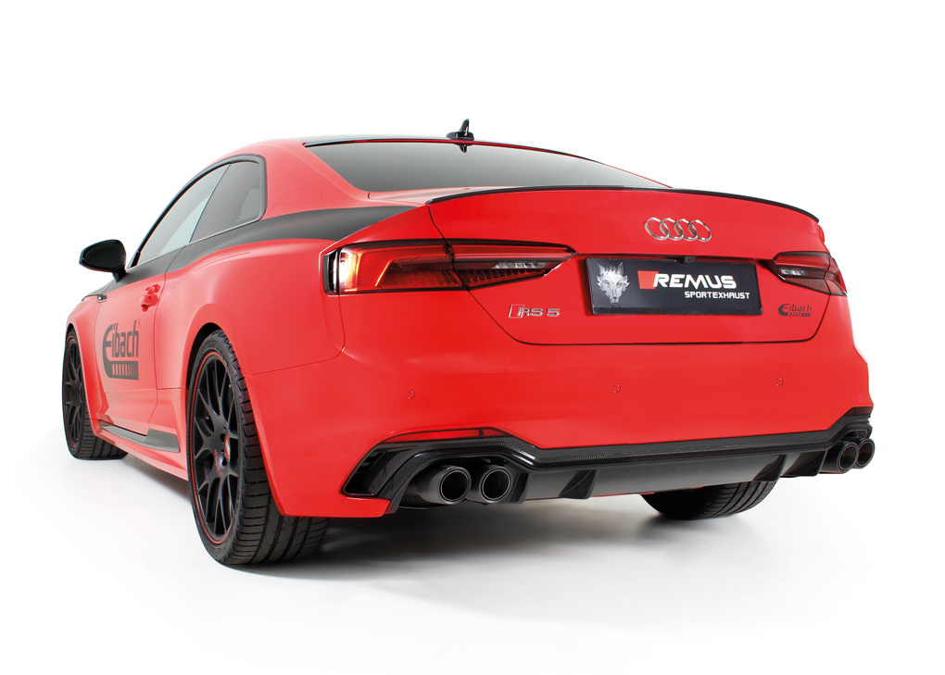
*at 6300 rpm

Car and engine specification
AUDI RS5 Quattro Coupe, B8 type F5, 06/2017=>
2.9l V6 Biturbo 331 kW (DECA)
INFOBOX:
- Cat-back-system (from secondary, underbody catalytic converter):048017 0000 + 048017 0500LR +tail pipe set! No vehicle modifications required!
- Cat-back-system (from main catalytic converter): 048017 1200 (Racing) + 048017 0000 + 048017 0500LR + tail pipe set! No vehicle modifications required!
- The use of racing products and products which do not have EC approval is generally not permitted on public roads.
Part no. | Description | € RRP price excl. VAT
048017 1200 | Stainless steel RACING cat replacement pipe instead of secondary (underbody) catalytic converter, without homologation  Original tube Ø 65 mm, REMUS tube Ø 70 mm | 360,--
048017 0000 | Stainless steel non-resonated, secondary cat-back section (deletes front silencer), incl. EC homologation  Original tube Ø 65 mm, REMUS tube Ø 70 mm | 350,--
048017 0500LR | Stainless steel sport exhaust left and right (without tail pipes)  with integrated valves, incl. EC homologation  Original tube Ø 65 mm, REMUS tube Ø 70 mm  The activation of the valves is carried out using the original actuators via the vehicle onboard electronics. | 1.250,--
Choose from following tail pipe package:
0046 55S | Stainless steel tail pipe set 4 tail pipes Ø 84 mm angled, rolled edge, chromed, with adjustable spherical clamp connection | 320,--
0046 83C | Stainless steel tail pipe set 4 tail pipes Ø 84 mm Street Race, straight, carbon insert, with adjustable spherical clamp connection | 392,--
0046 83CS | Stainless steel tail pipe set 4 tail pipes Ø 84 mm Carbon Race, angled, carbon ring, with adjustable spherical clamp connection | 408,--
0046 83CB | Stainless steel tail pipe set 4 tail pipes Ø 84 mm Street Race Black Chrome, straight, carbon insert, with adjustable spherical clamp connection | 440,--
0046 83CTS | Carbon tail pipe set 4 tail pipes Ø 84 mm angled, Titanium internals, with adjustable spherical clamp connection | 780,--

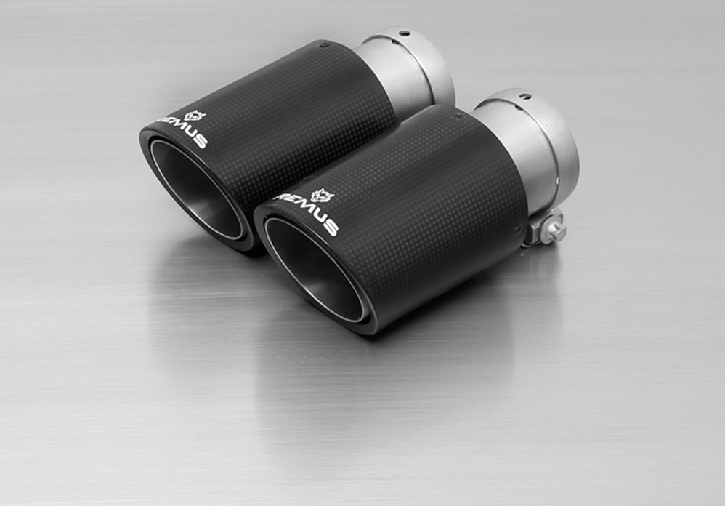
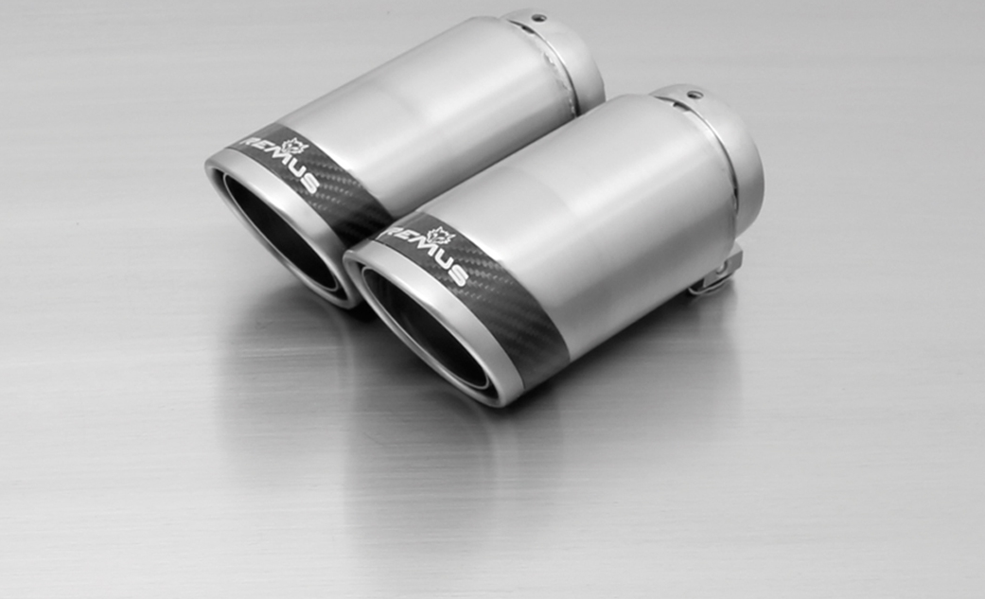
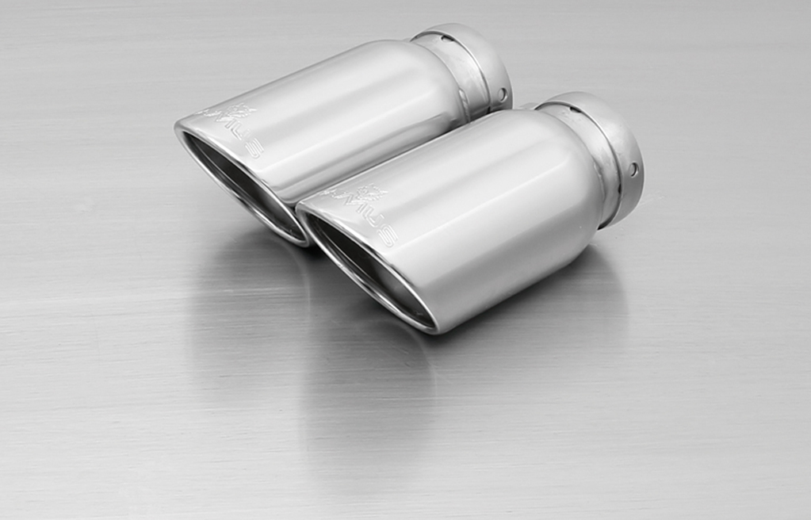

#55S: tail pipes Ø 84 mm
angled, chromed
#83CS: tail pipe Ø 84 mm Carbon Race, angled, polished

#83CTS: Carbon-tail pipes Ø 84 mm angled, Titanium internals

#83CB: tail pipes Ø 84 mm
Street Race Black Chrome

#83C: tail pipes Ø 84 mm
Street Race, polished

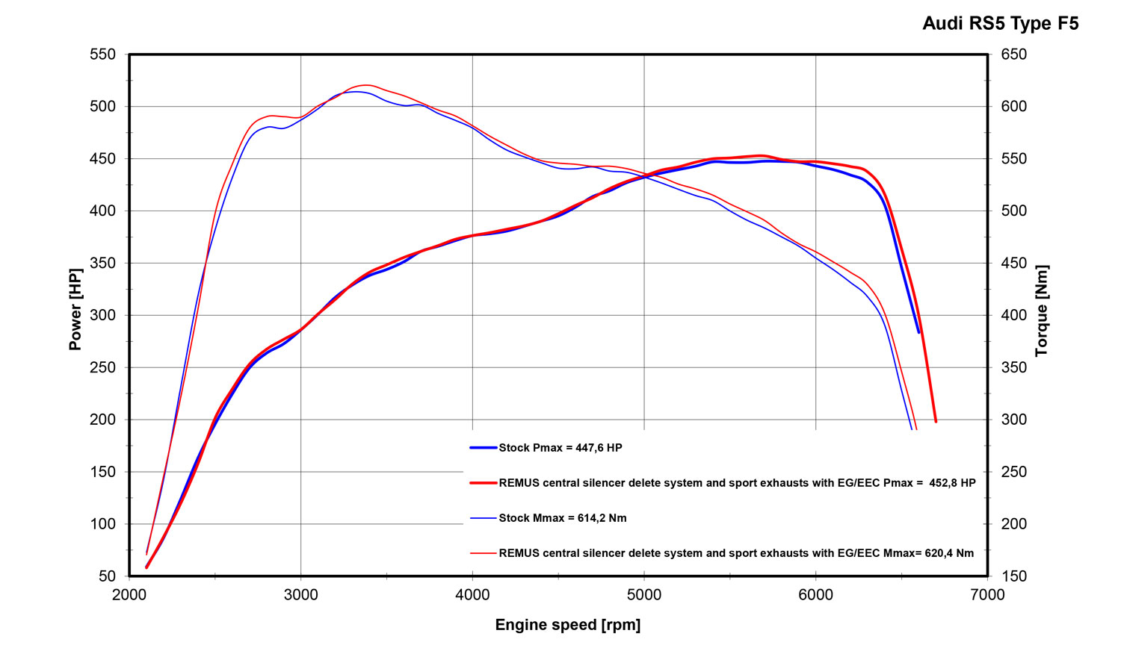

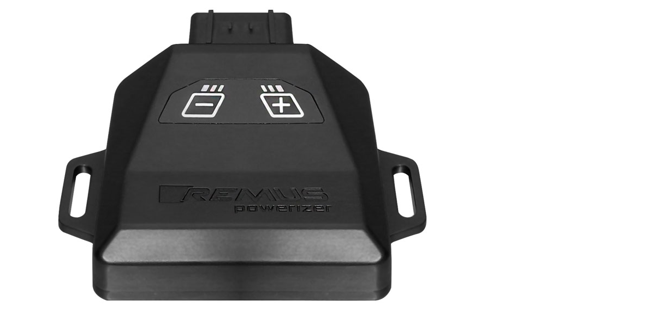
REMUS Powerizer
More power, more torque means more fun!
The perfectly matched electronics and advanced technology of the
REMUS Powerizer enhances Engine ECU mapping is optimized in
excess of 1000 times per second and ensures for a considerable and
noticeable power increase. The engine safety parameters (Check engine light) and engine management remains totally untouched to ensure that individual engine components are not overstrained.
Because of the plug & play concept, the REMUS Powerizer is installed in the engine compartment and connected to sensors such as intake manifold pressure sensor, boost pressure sensor, camshaft position sensor or fuel injection sensor. In real time, the incoming signals are processed, optimized and transmitted to the additional control unit. The Powerizer can be easily removed or decommissioned at any time using the supplied blind connector.
Due to the torque increase, the engine has more power at lower RPM which can lead to a reduction in fuel consumption. The power increase of the engine can easily be fine-tuned by means of seven preset levels via the keypad. The REMUS Powerizer is available for over 3300 petrol and diesel powered cars.
Furthermore, the latest Powerizer is also available for all vehicle engines with SENT technology. This newly developed multi-protocol technology combines analog and digital motor control the same time captures important analog signals of the engine management system which leads to increased engine performance. The capability to tune vehicles with SENT technology is an absolute highlight of the latest Powerizer.

- Up to 30% more power
- Up to 20% more torque
- Easy installation and removal (plug & play)
- Up to 1l/100 km fuel saving
- No vehicle modifications required
- 7 preset power levels

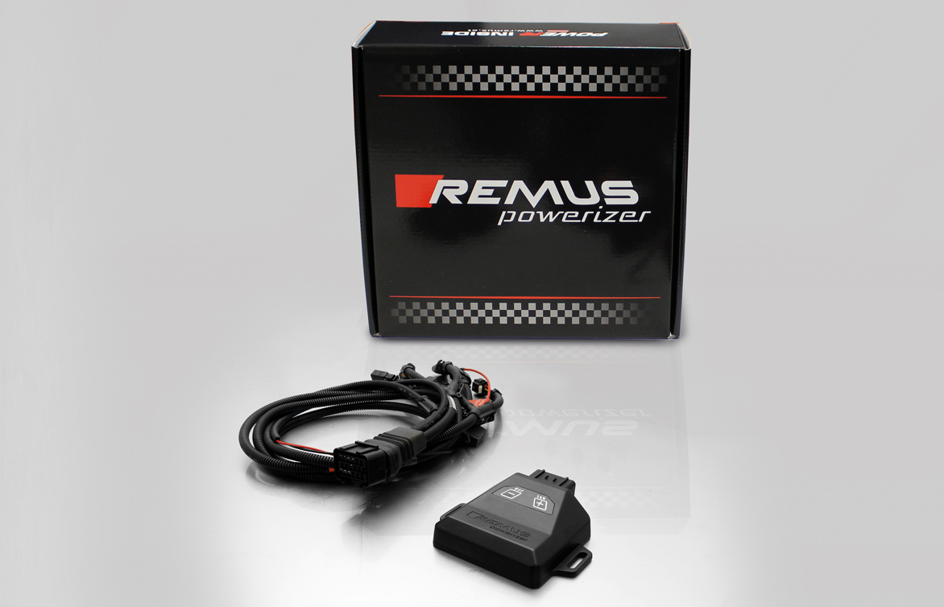

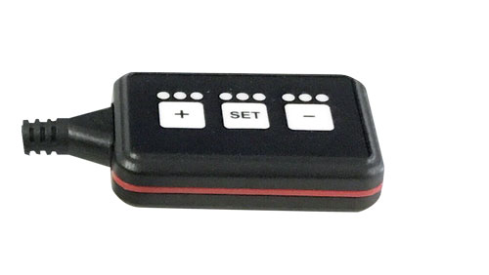
REMUS Responder

Improved throttle response for more driving dynamic!

The REMUS Responder improves throttle response and is the best power boost for
many electronically managed gas pedals. Results of up to 10% better acceleration are not uncommon and no annoying throttle delay and lag during take-off or in between manual / automatic shifts makes driving with the REMUS Responder much more dynamic.

The REMUS Responder attaches between the OEM gas pedal sensor and the OEM wiring loom and is ready to use in minutes due to plug & play technology.

The fully adjustable Responder settings can be adjusted in 20 different stages. The individual user-selectable and adjustable performance settings allow drivers to select according to their own preferences & road conditions.

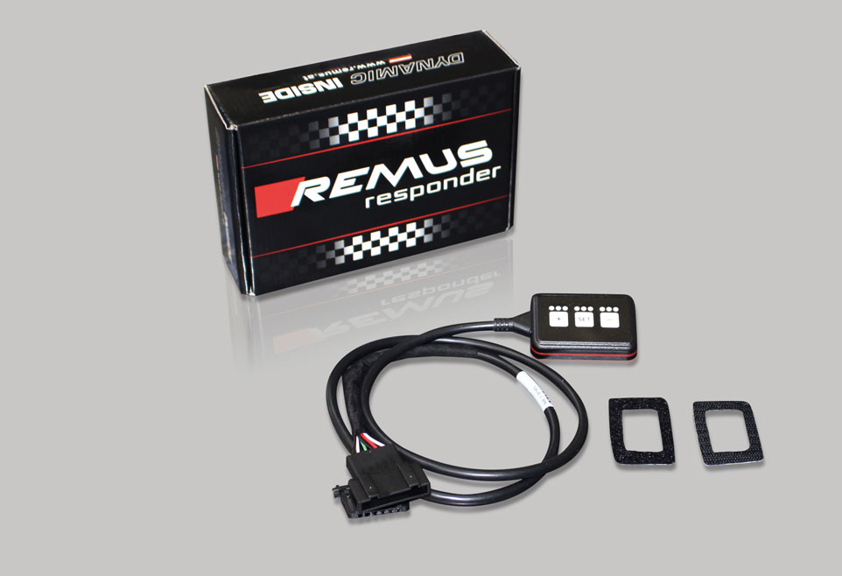

- Improves throttle response and lag during take-off and gear changes
- Quicker reaction times, more driving dynamic
- 20 individual user selectable performance settings
- Vehicle specific programming using OEM quality connectors
- Simple plug & play installation and removal without leaving traces

