REMUS product information 24-2016

VW Scirocco III Facelift, type 13, 2015=>

Deaer REMUS Partner,

We are pleased to inform you that we have completed our next development:
REMUS sport exhausts for the VW Scirocco III Facelift, type 13, 2015=>.
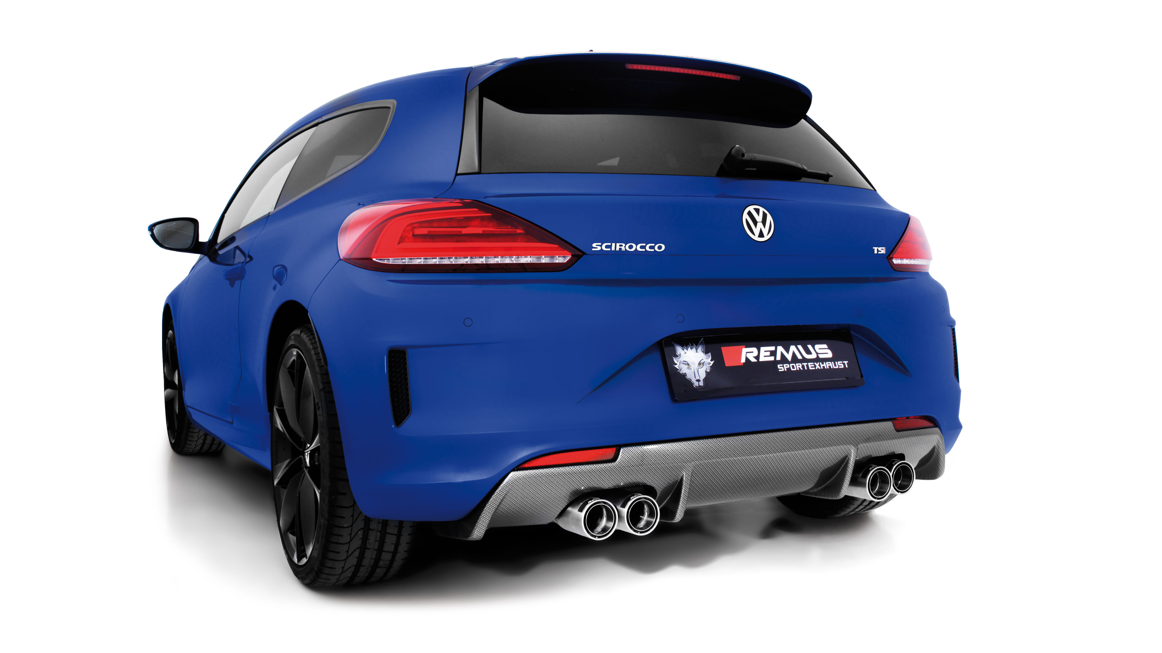
It would be a pleasure for us to receive your order.

Stay tuned!
Your REMUS Team

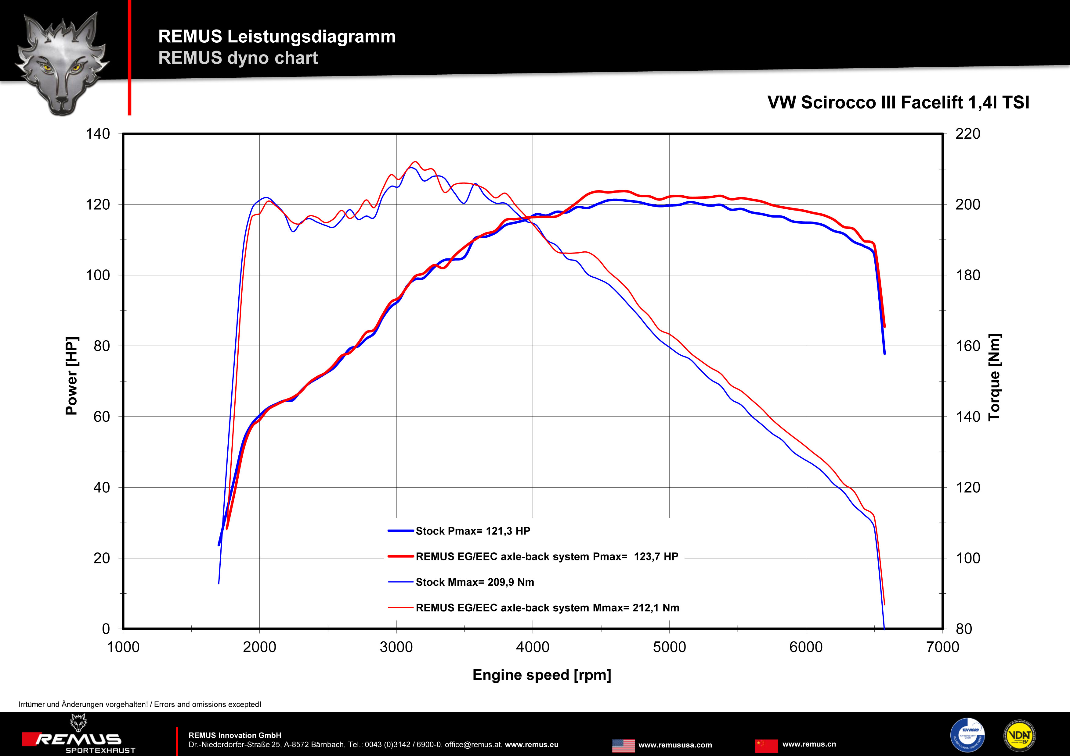

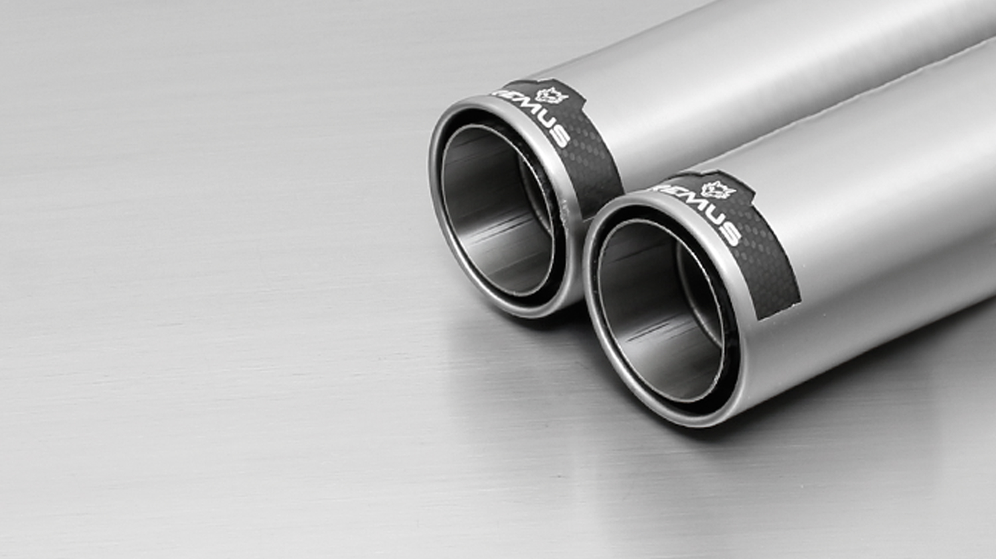
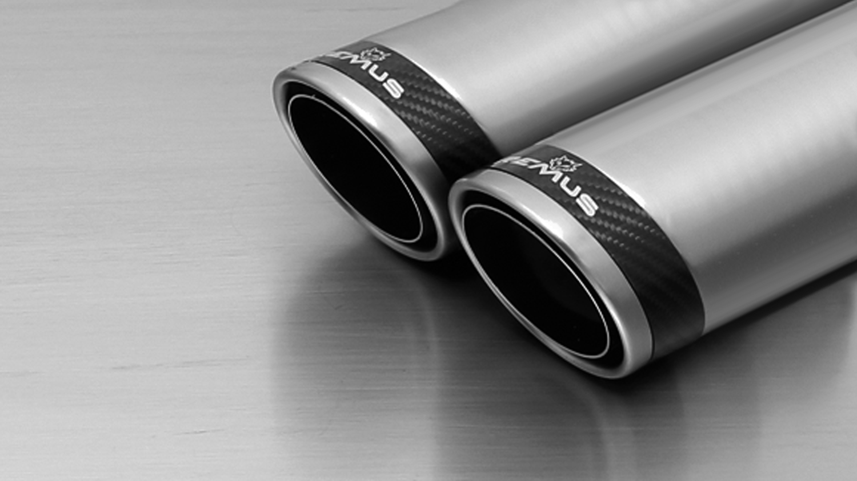

#84CS: tail pipes Ø 84 mm Carbon Race, polished

#84C: tail pipes Ø 84 mm Street Race, polished

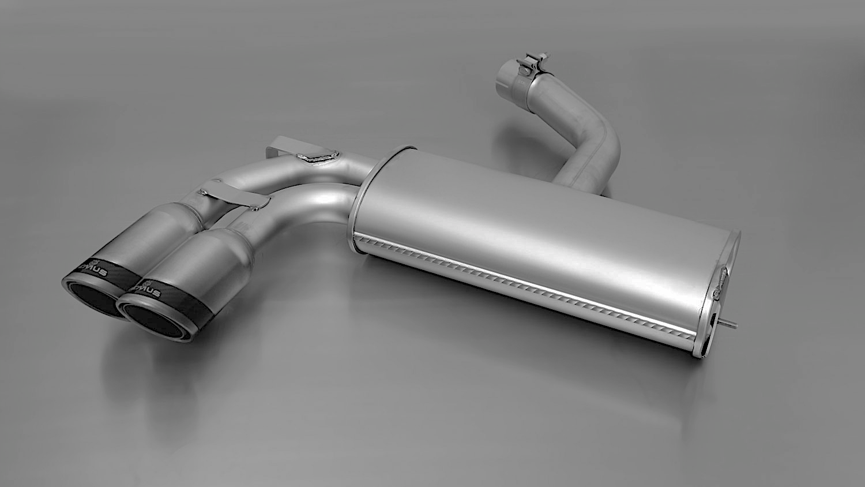

952608 0584CS

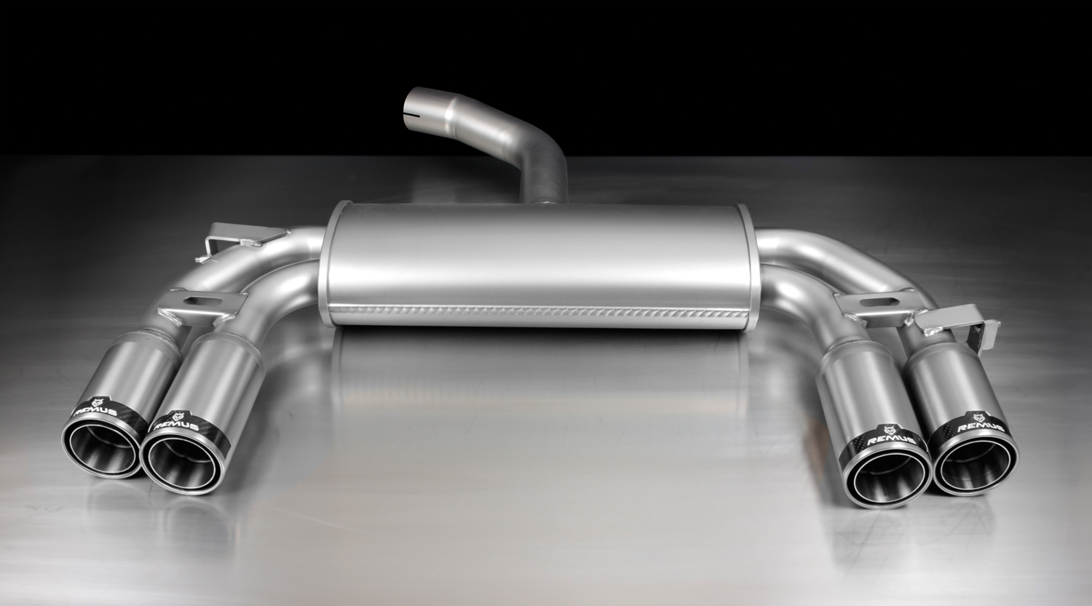
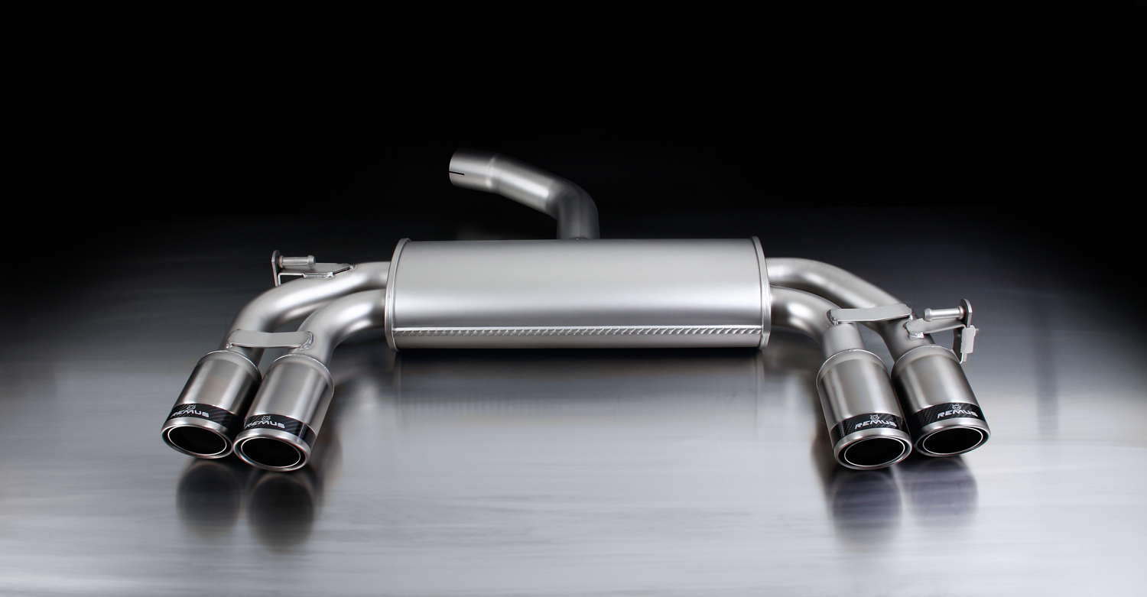

951404 HES

955108 1584CS

955108 1584C

Car and engine specification
VW Scirocco III, type 13, 2008=>
1.4l TSI 90 kW; 1.4l TSI 118 kW; 2.0l TSI 147 kW; 2.0l TSI 155 kW; 2.0l TDI 103 kW
VW Scirocco III Facelift, only suitable for R-Line, type 13, 2015=>
1.4l TSI 92 kW; 2.0l TSI 132 kW
Part no. | Description | € RRP price excl. VAT
Optional REMUS cat-back resonated front section
955108 0300 | Stainless steel resonated front section, only for 2.0l TSI 147 kW, incl. EEC homologation | 263,--
Axle-back-system left:
952608 0584CS | Stainless steel sport exhaust with 2 tail pipes Ø 84 mm Carbon Race, incl. EEC homologation | 499,--
Axle-back-system left/right:
955108 1584C | Stainless steel sport exhaust with L/R each 2 tail pipes Ø 84 mm Street Race, incl. EEC homologation | 637,--
955108 1584CS | Stainless steel sport exhaust with L/R each 2 tail pipes Ø 84 mm Carbon Race, incl. EEC homologation | 658,--
Optional REMUS rear diffusor:
951404 HES | ABS rear diffusor left/right, carbon optic | 191,--
INFOBOX:
- Axle-back-system left and left/right: 952608 0584CS resp. 955108 1584C(S). The original exhaust will need to be cut at the manufacturer marked cutting point! The right side skirt outlet must be trimmed as per the enclosed template! L/R-system also suitable for “Rieger” rear diffusor!
- Axle-back-system left/right with REMUS rear diffusor: 955108 1584C(S) + 951401 HES. The original exhaust will need to be cut at the manufacturer marked cutting point!
- Cat-back-system left and left/right (only for 2.0l TSI 147 kW): 955108 0300 + 952608 0584CS resp. 955108 1584C(S). No cutting of the original exhaust system required! The right side skirt outlet must be trimmed as per the enclosed template! L/R-system also suitable for “Rieger” rear diffusor!
- Cat-back-system left/right with REMUS rear diffusor (only for 2.0l TSI 147 kW): 955108 0300 + 955108 1584C(S) + 952401 HES. No cutting of the original exhaust system and skirt required!

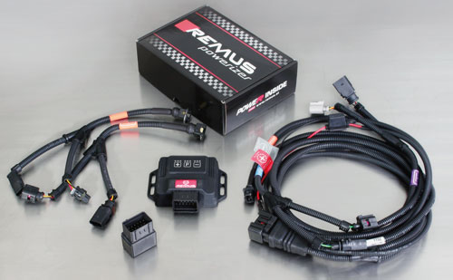

Under http://www.remus.eu/powerizer/ and http://www.remus.eu/remusresponder you will find the entire product range, prices and installation instructions.

REMUS Powerizer: More power, more economy and more fun.
- Up to 25 % more power
- Up to 20 % more torque
- Up to 1l/100 km fuel saving
- Fully adjustable power increase
- Simple DIY installation (Plug & Play)
REMUS POWERIZER: The performance figures represent the maximum achievable values. The actual performance output depends on the original tolerances of each engine. REMUS delivers the POWERIZER with the best possible setting for your vehicle type. You can adjust the performance according to your requirements as per the POWERIZER instructions

Legal references

1. Completion and registration of chip tuning in the car documents
Due to chip tuning, the operating license of the vehicle will terminate if the installation and registration of the POWERIZER is not carried out or immediately reported to an official approved testing facility. Please consider that driving a vehicle without the required operating license will cause legal penalties.

2. Vehicle insurance must be informed upon installing a POWERIZER
The installation of the POWERIZER can have influence on the insurance policy of your vehicle. You must inform the insurance company if you install a POWERIZER in your vehicle.

3. Effect of chip tuning on warranty and guarantee claims
a) When installing a POWERIZER, you will lose all guarantee claims regarding the engine against the vehicle manufacturer.
b) Installing a POWERIZER, can have influence on warranty claims against the seller of the vehicle.
c) REMUS excludes any claims regarding compensation for damages on the engine and drivetrain.

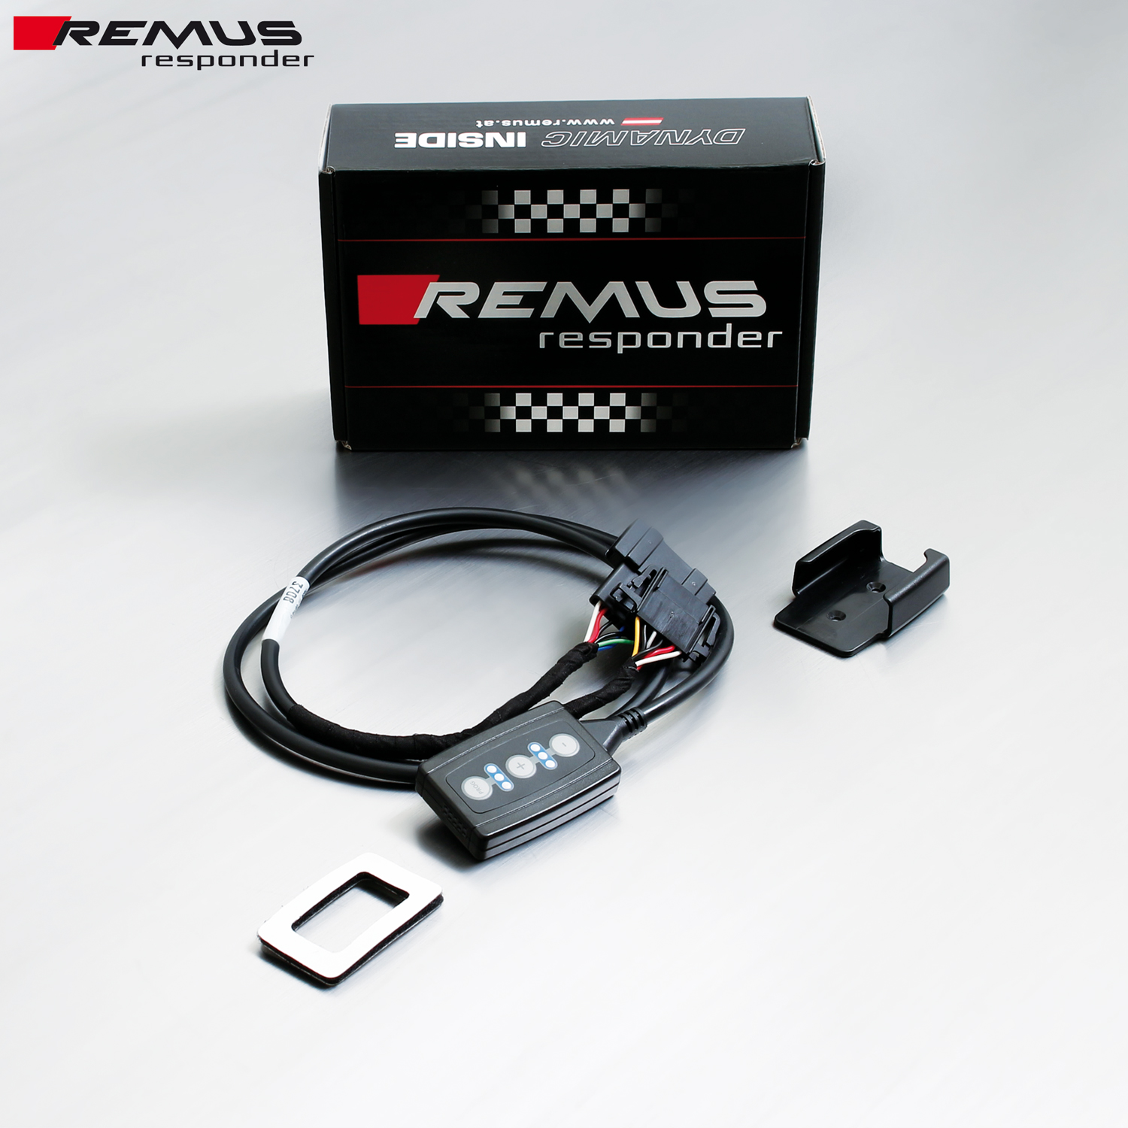

Under http://www.remus.eu/powerizer/ and http://www.remus.eu/remusresponder you will find the entire product range, prices and installation instructions.

REMUS RESPONDER:
Improved throttle response, more dynamic!
The REMUS Responder improves throttle response by means of modifying the accelerator pedal output signal. No more throttle delay and reduced lag during automatic shifting makes driving with the REMUS Responder more fun. The Responder attaches between the OEM pedal sensor and the OEM connector, ready to use in seconds due to plug & play technology. Sophisticated adjustable programming profiles can lead to improved fuel consumption and more efficiency. The 4 individual user selectable and adjustable performance settings allow drivers to select according to their own preferences.
The REMUS Responder totally eliminates the delay in modern electronic accelerator pedals!

