REMUS product information 21-2016

SKODA Octavia III RS/vRS sedan & station wagon, 2013=>

Dear REMUS Partner,

We are pleased to inform you that we have completed our next development:
REMUS sport exhaust with integrated valves for the
SKODA Octavia III RS/vRS sedan & station wagon, type 5E, 2013=>

It would be a pleasure for us to receive your orders.

Stay tuned!
Your REMUS Team

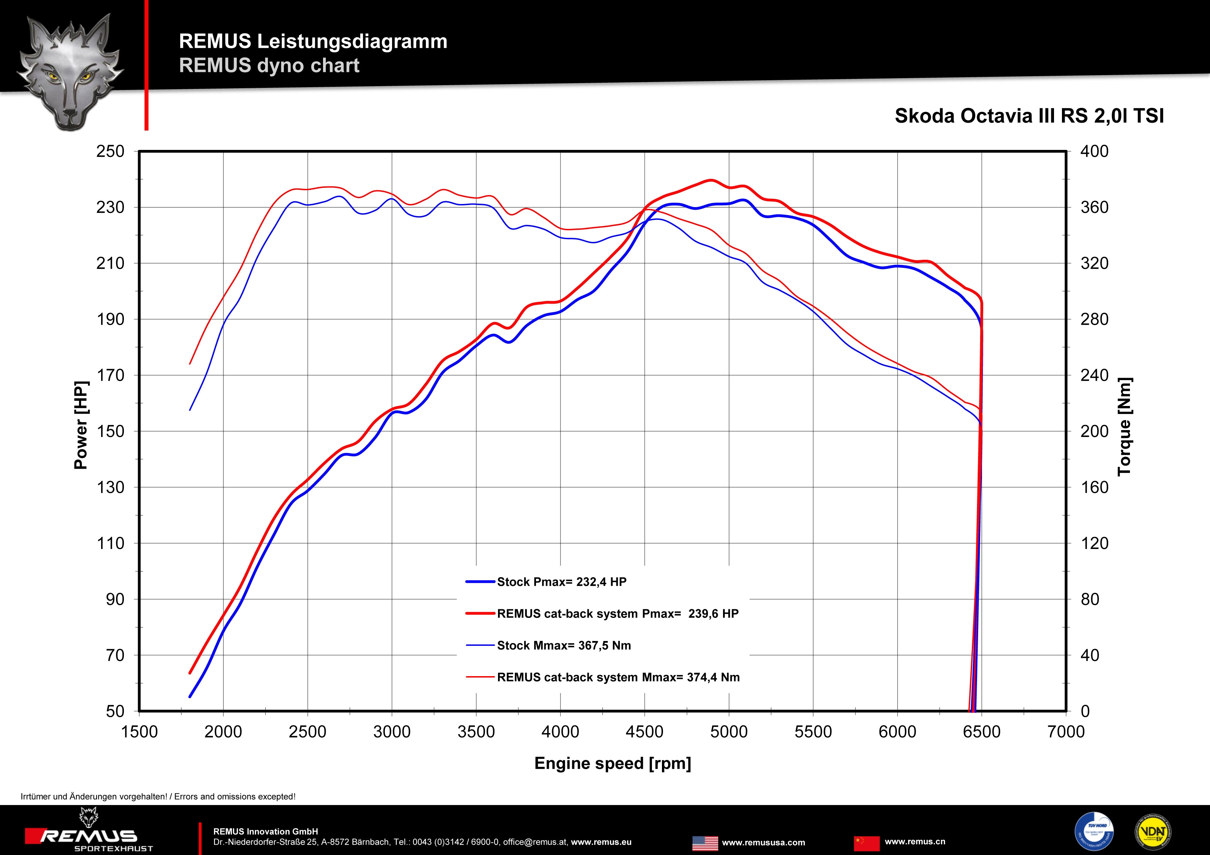

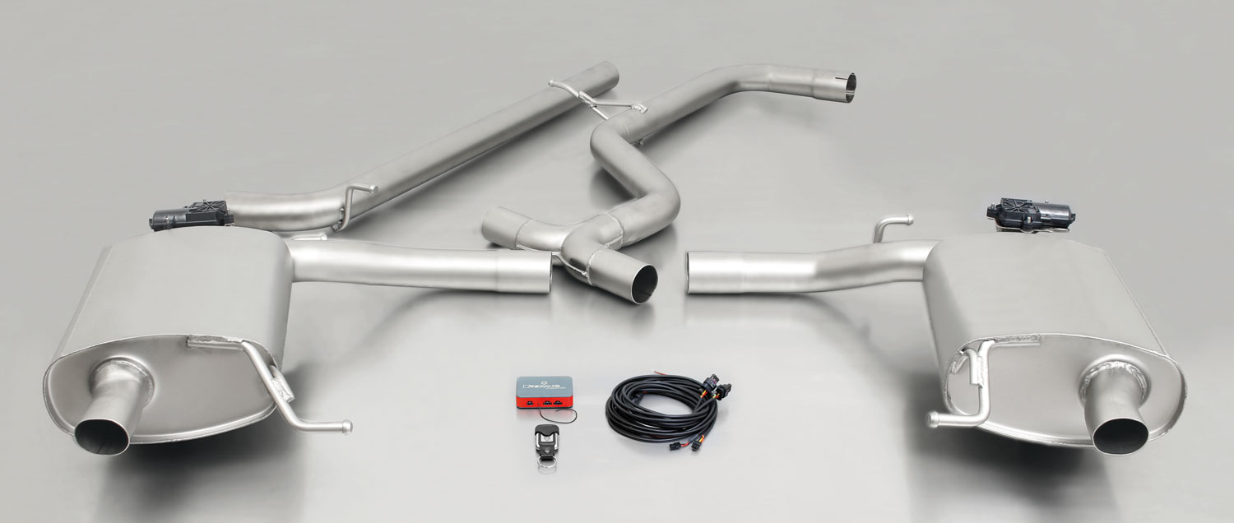

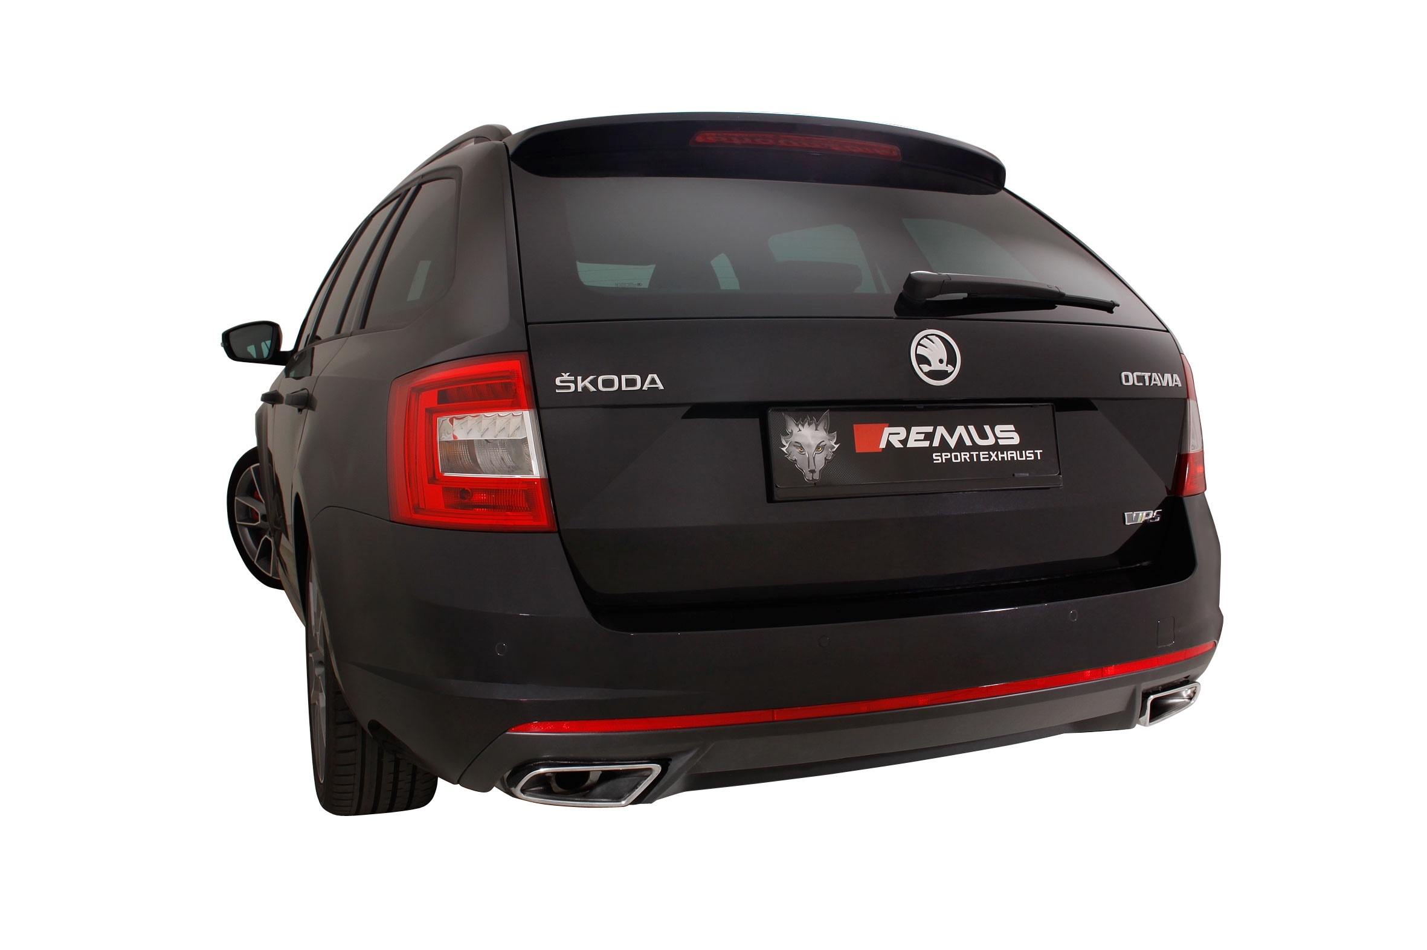

Car and engine specification
SKODA Octavia III RS/vRS sedan & station wagon, type 5E, 2013=>
2.0l TSI 162/169 kW
Part no. | Description | € RRP price excl. VAT
955113 1100 | RACING downpipe, tube Ø 70 mm, with sport catalytic convertor (200 CPSI), without homologation, can only be fitted in combination with the REMUS cat-back section | 874,--
Cat-back system incl. EEC homologation
806515 0300 | Stainless steel resonated cat-back section, with EEC homologation | 260,--
806515 0500LR | Stainless steel Sport exhaust left and right, fits into the original skirt using integrated tail pipes, with integrated valves, incl. EEC homologation in combination with the REMUS resonated cat-back section | 1.230,--
RACING Cat-back system without homologation
806015 1300 | Stainless steel RACING cat-back section, replaces front silencer, without homologation | 190,--
806015 0500LR | Stainless steel sport exhaust left and right featuring electronically controlled valves, fits into the original skirt using integrated tail pipes,  with integrated electrical valves, without homologation | 1.190,--
INFOBOX:
- Cat-back system only fits as a complete system!
- No cutting of original exhaust required!
- Cat-back-system with EEC homologation: 806515 0300 + 806515 0500LR
- RACING Turbo-back-system without homologation: 955113 1100 + 806015 1300 + 806015 0500LR
- RACING Cat-back-system without homologation: 806015 1300 + 806015 0500LR
- 806515 0500LR: It is not permissible to activate the valve on public roads as per the EU transport authority. The activation of the valve is carried out using the supplied remote control key fob. The sound controller and electrical actuator allow the valve to be operated in 4 different positions
- 806015 0500LR: The activation of the valve is carried out using the supplied remote control key fob. The sound controller and electrical actuator allow the valve to be operated in 4 different positions

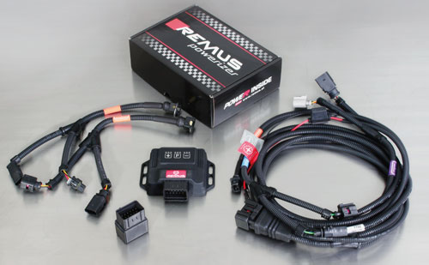

Under http://www.remus.eu/powerizer/ and http://www.remus.eu/remusresponder you will find the entire product range, prices and installation instructions.

REMUS Powerizer: More power, more economy and more fun.
- Up to 25 % more power
- Up to 20 % more torque
- Up to 1l/100 km fuel saving
- Fully adjustable power increase
- Simple DIY installation (Plug & Play)
REMUS POWERIZER: The performance figures represent the maximum achievable values. The actual performance output depends on the original tolerances of each engine. REMUS delivers the POWERIZER with the best possible setting for your vehicle type. You can adjust the performance according to your requirements as per the POWERIZER instructions

Legal references

1. Completion and registration of chip tuning in the car documents
Due to chip tuning, the operating license of the vehicle will terminate if the installation and registration of the POWERIZER is not carried out or immediately reported to an official approved testing facility. Please consider that driving a vehicle without the required operating license will cause legal penalties.

2. Vehicle insurance must be informed upon installing a POWERIZER
The installation of the POWERIZER can have influence on the insurance policy of your vehicle. You must inform the insurance company if you install a POWERIZER in your vehicle.

3. Effect of chip tuning on warranty and guarantee claims
a) When installing a POWERIZER, you will lose all guarantee claims regarding the engine against the vehicle manufacturer.
b) Installing a POWERIZER, can have influence on warranty claims against the seller of the vehicle.
c) REMUS excludes any claims regarding compensation for damages on the engine and drivetrain.

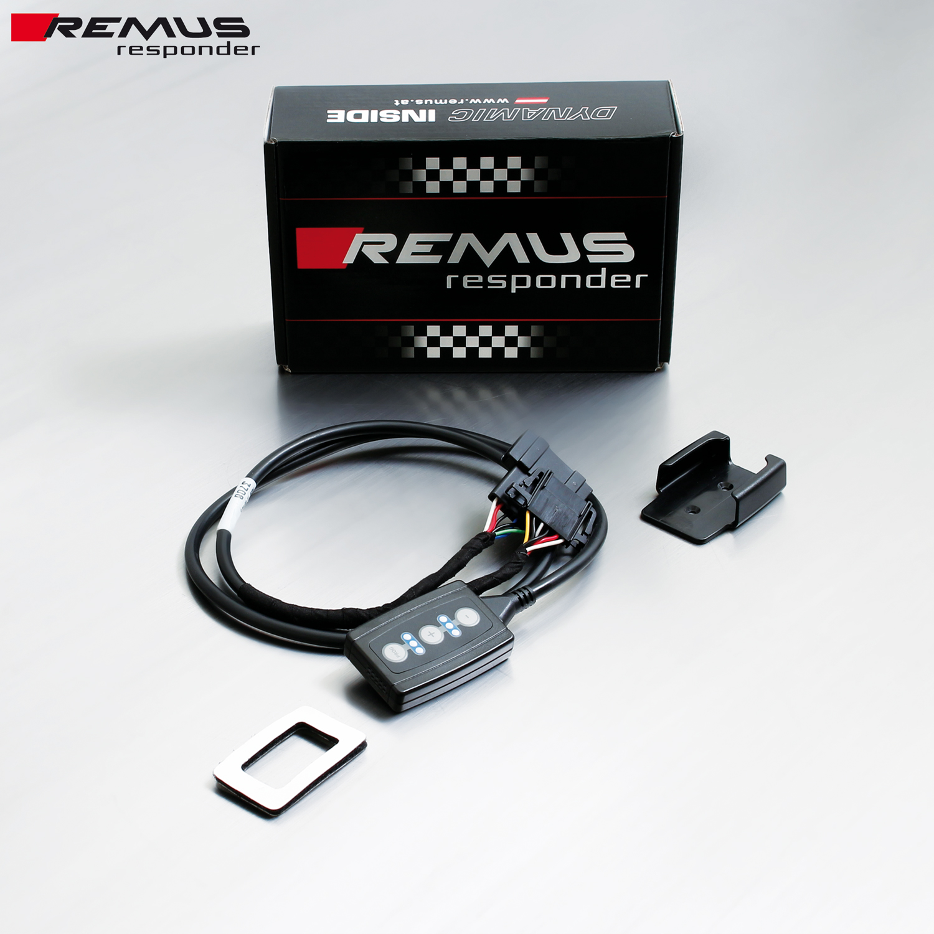

Under http://www.remus.eu/powerizer/ and http://www.remus.eu/remusresponder you will find the entire product range, prices and installation instructions.
REMUS RESPONDER:
Improved throttle response, more dynamic!
The REMUS Responder improves throttle response by means of modifying the accelerator pedal output signal. No more throttle delay and reduced lag during automatic shifting makes driving with the REMUS Responder more fun. The Responder attaches between the OEM pedal sensor and the OEM connector, ready to use in seconds due to plug & play technology. Sophisticated adjustable programming profiles can lead to improved fuel consumption and more efficiency. The 4 individual user selectable and adjustable performance settings allow drivers to select according to their own preferences.
The REMUS Responder totally eliminates the delay in modern electronic accelerator pedals!

