REMUS product information 17-2016

MERCEDES BENZ CLA 250 (260), C117, 2013=>

Dear REMUS Partner,

We are pleased to inform you that we have completed our next updated development:
REMUS Racing sport exhaust and non-resonated RACING front section for the
MB CLA 250 (260) FWD & 4matic, C117, 2013=>.

It would be a pleasure for us to receive your orders.

Stay tuned!
Your REMUS Team

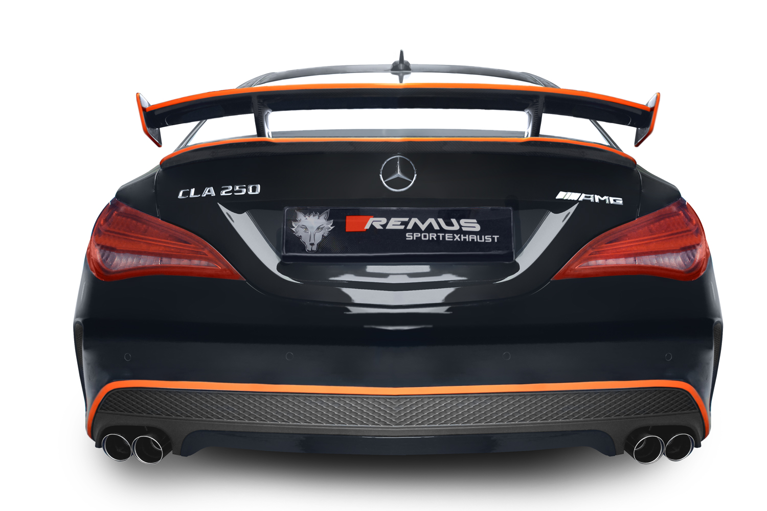

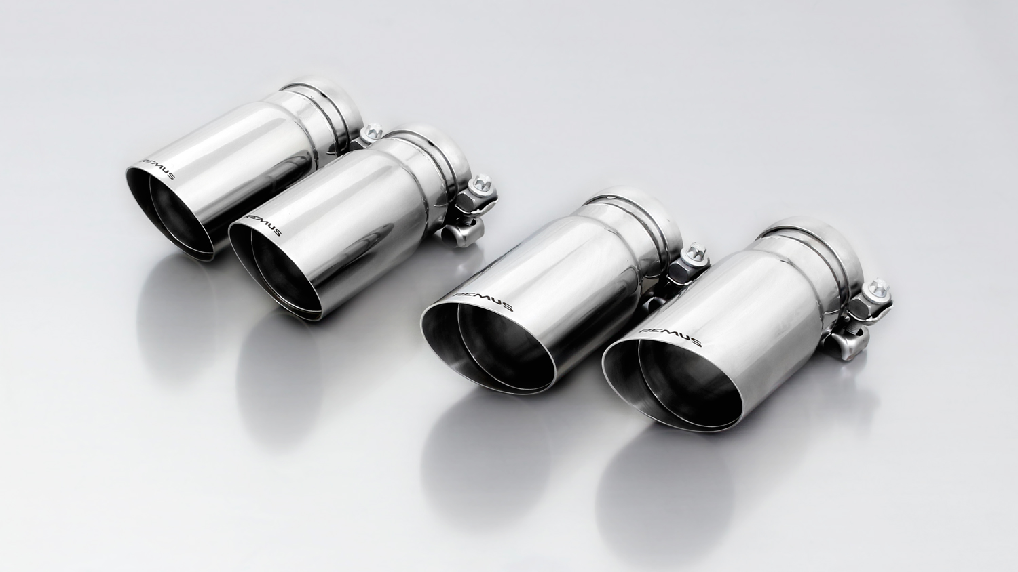
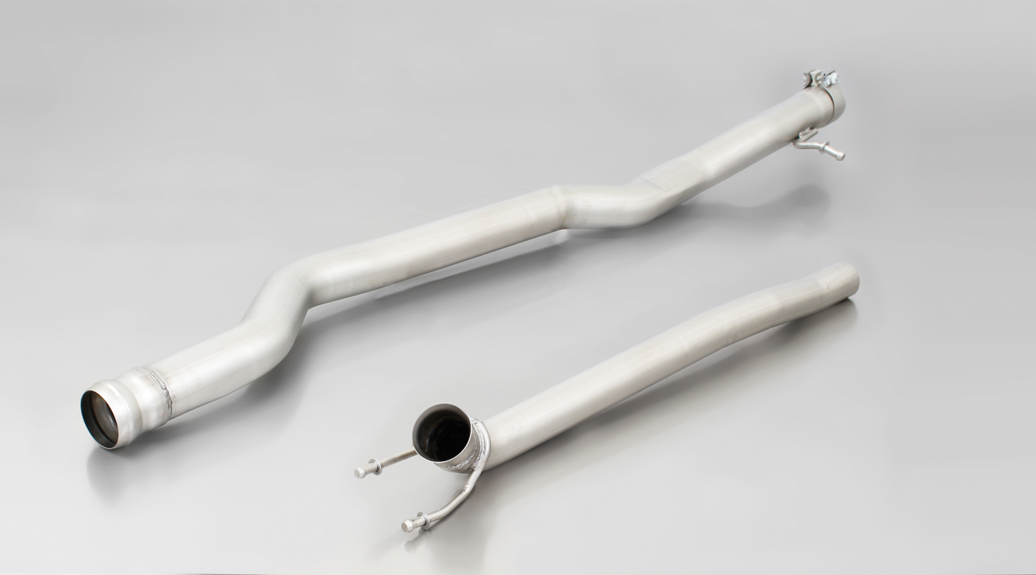
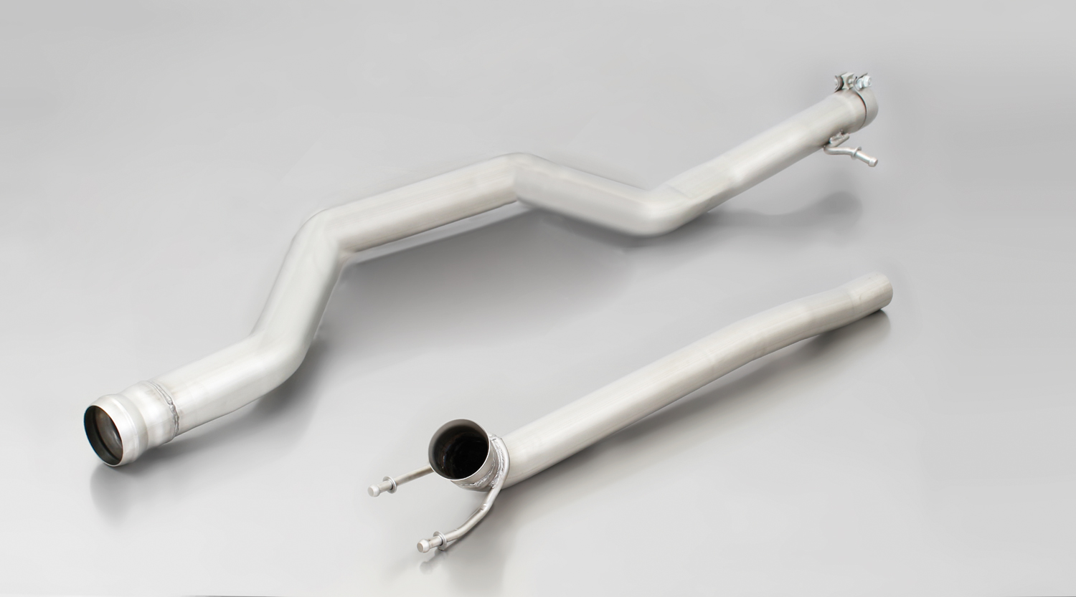
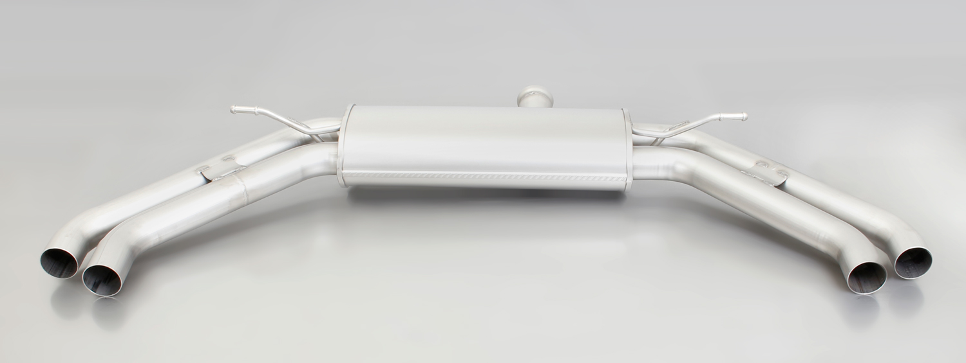
#03SSG: tail pipes Ø 76 mm angled/angled, straight cut, chromed

503513 1500

503513 1300

503613 1300

Car and engine specification
MB CLA 250 (260) FWD and 4matic, C117, 2013=>
2.0l 155 kW
Part no. | Description | € RRP price excl. VAT
503513 1300 | Stainless steel non-resonated racing cat-back front section for MB CLA 250 (260) 4matic, without homologation  Original Ø 60 mm  REMUS Ø 65 mm | 180,--
503613 1300 | Stainless steel non-resonated racing cat-back front section for MB CLA 250 (260) FWD, without homologation  Original Ø 60 mm  REMUS Ø 65 mm | 180,--
503513 1500 | Stainless steel racing sport exhaust, centered for L/R system (without tips), without homologation  Original Ø 60 mm  REMUS Ø 65 mm | 280,--
0046 03SSG | Tail pipe set L/R each 2 tail pipes Ø 76 mm angled/angled, straight cut, chromed with adjustable spherical clamp connection | 360,--
INFOBOX:
- Non-resonated RACING front section and RACING sport exhaust left/right with tail pipes only fits as a complete system!
- RACING without Homologation!
- No bumper modifications required!
- No cutting of the original exhaust system required except for cars with the underbody catalytic converter!
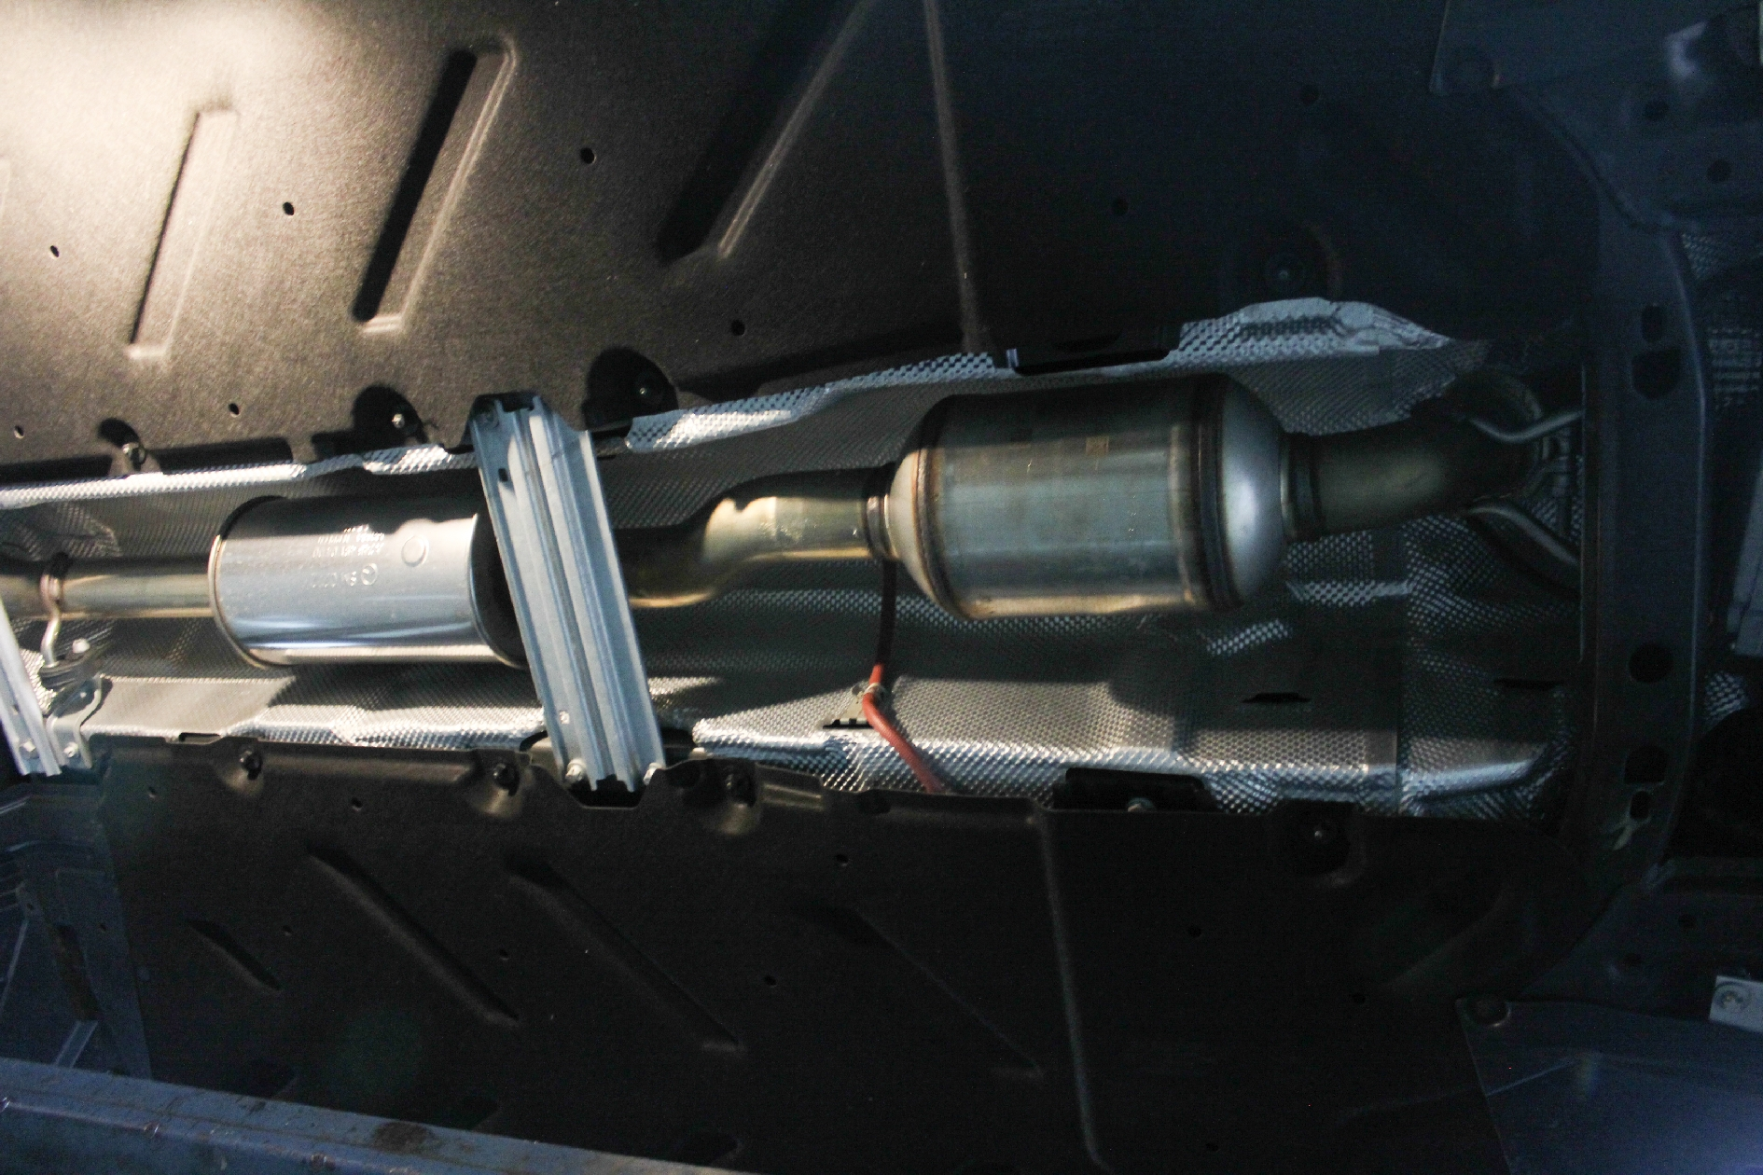
Underbody catalytic converter

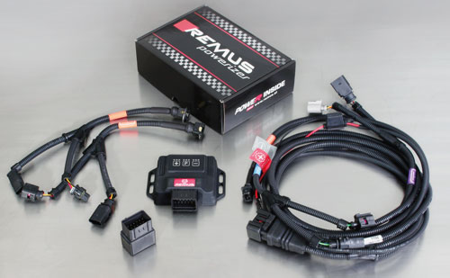

Under http://www.remus.eu/powerizer/ and http://www.remus.eu/remusresponder you will find the entire product range, prices and installation instructions.

REMUS Powerizer: More power, more economy and more fun.
- Up to 25 % more power
- Up to 20 % more torque
- Up to 1l/100 km fuel saving
- Fully adjustable power increase
- Simple DIY installation (Plug & Play)
REMUS POWERIZER: The performance figures represent the maximum achievable values. The actual performance output depends on the original tolerances of each engine. REMUS delivers the POWERIZER with the best possible setting for your vehicle type. You can adjust the performance according to your requirements as per the POWERIZER instructions

Legal references

1. Completion and registration of chip tuning in the car documents
Due to chip tuning, the operating license of the vehicle will terminate if the installation and registration of the POWERIZER is not carried out or immediately reported to an official approved testing facility. Please consider that driving a vehicle without the required operating license will cause legal penalties.

2. Vehicle insurance must be informed upon installing a POWERIZER
The installation of the POWERIZER can have influence on the insurance policy of your vehicle. You must inform the insurance company if you install a POWERIZER in your vehicle.

3. Effect of chip tuning on warranty and guarantee claims
a) When installing a POWERIZER, you will lose all guarantee claims regarding the engine against the vehicle manufacturer.
b) Installing a POWERIZER, can have influence on warranty claims against the seller of the vehicle.
c) REMUS excludes any claims regarding compensation for damages on the engine and drivetrain.

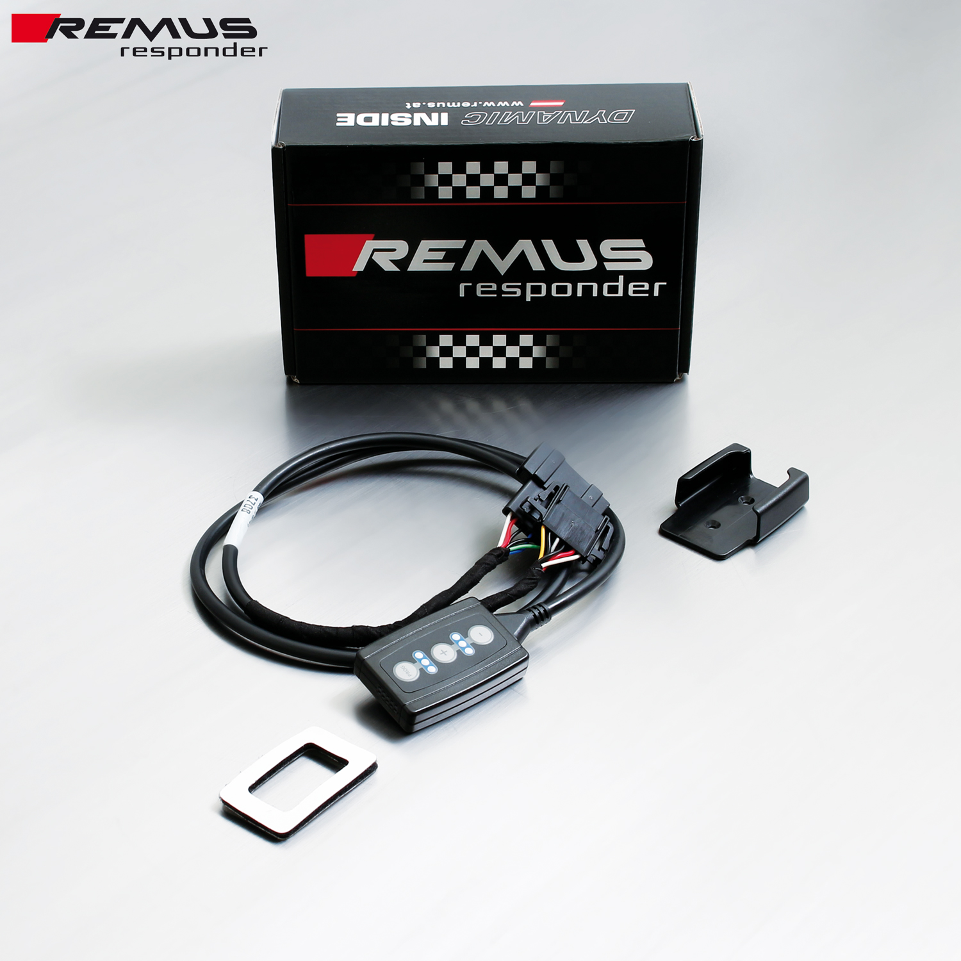

Under http://www.remus.eu/powerizer/ and http://www.remus.eu/remusresponder you will find the entire product range, prices and installation instructions.

REMUS RESPONDER:
Improved throttle response, more dynamic!
The REMUS Responder improves throttle response by means of modifying the accelerator pedal output signal. No more throttle delay and reduced lag during automatic shifting makes driving with the REMUS Responder more fun. The Responder attaches between the OEM pedal sensor and the OEM connector, ready to use in seconds due to plug & play technology. Sophisticated adjustable programming profiles can lead to improved fuel consumption and more efficiency. The 4 individual user selectable and adjustable performance settings allow drivers to select according to their own preferences.
The REMUS Responder totally eliminates the delay in modern electronic accelerator pedals!
