REMUS product information 12-2016

HONDA Civic Type R, type FK2, 2015=>

Dear REMUS Partner,

We are pleased to inform you that we have completed our next development:
REMUS cat-back system left/right with Carbon or Chromed tail pipes for the
HONDA Civic Type R, type FK2, 2015=> .

It would be a pleasure for us to receive your order.

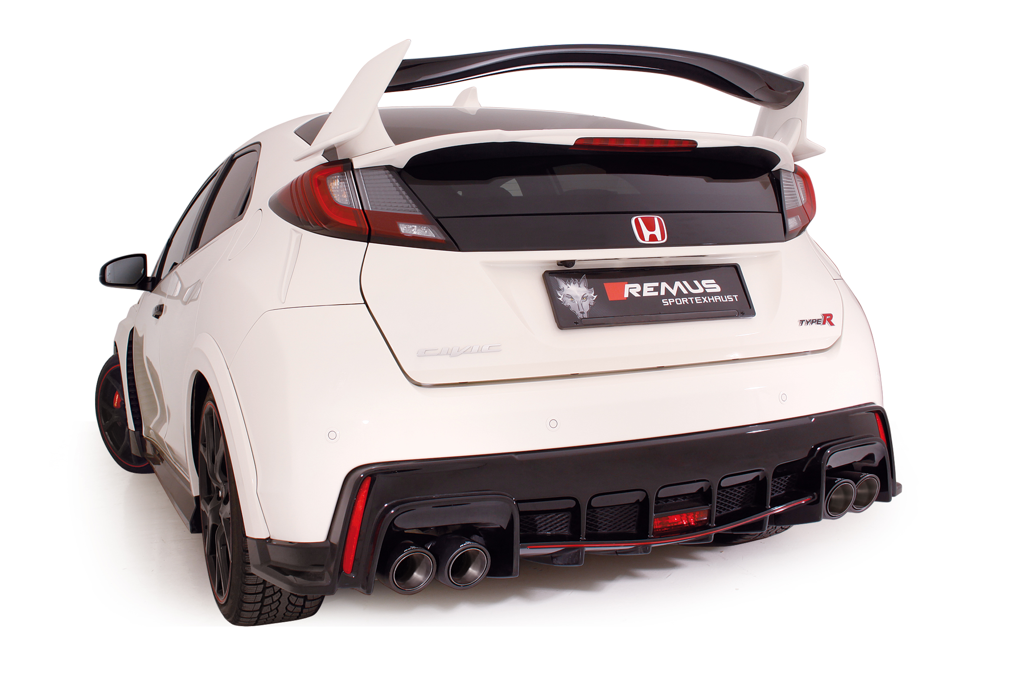
Stay tuned!
Your REMUS Team
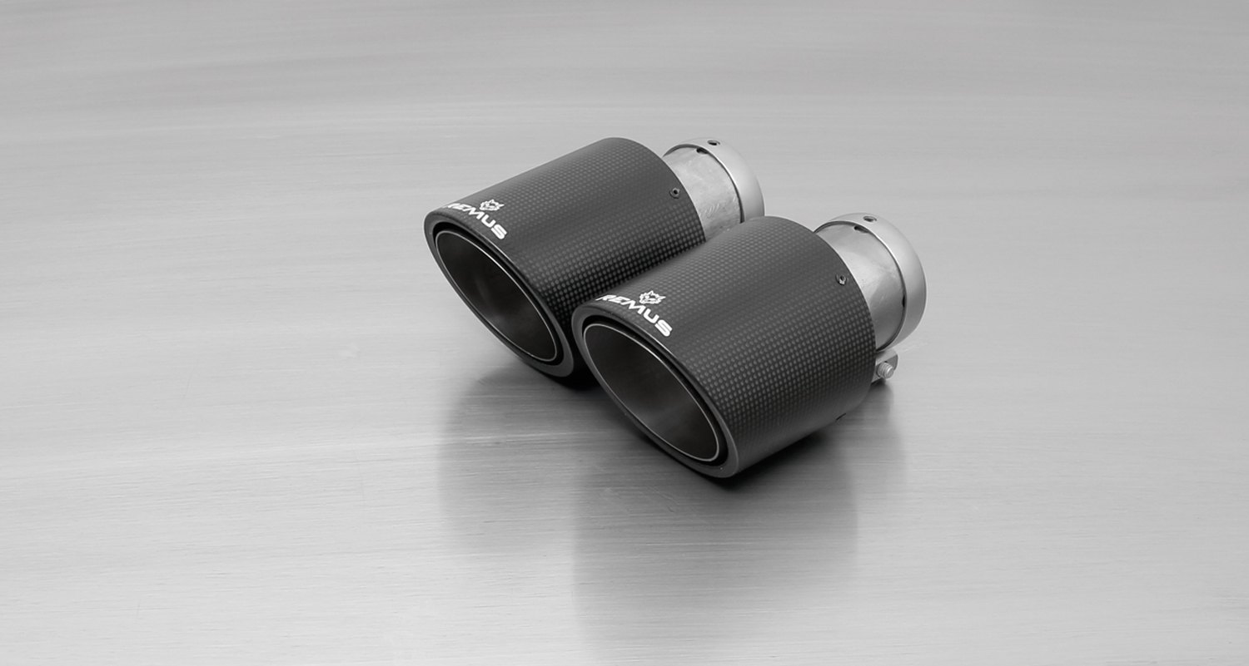
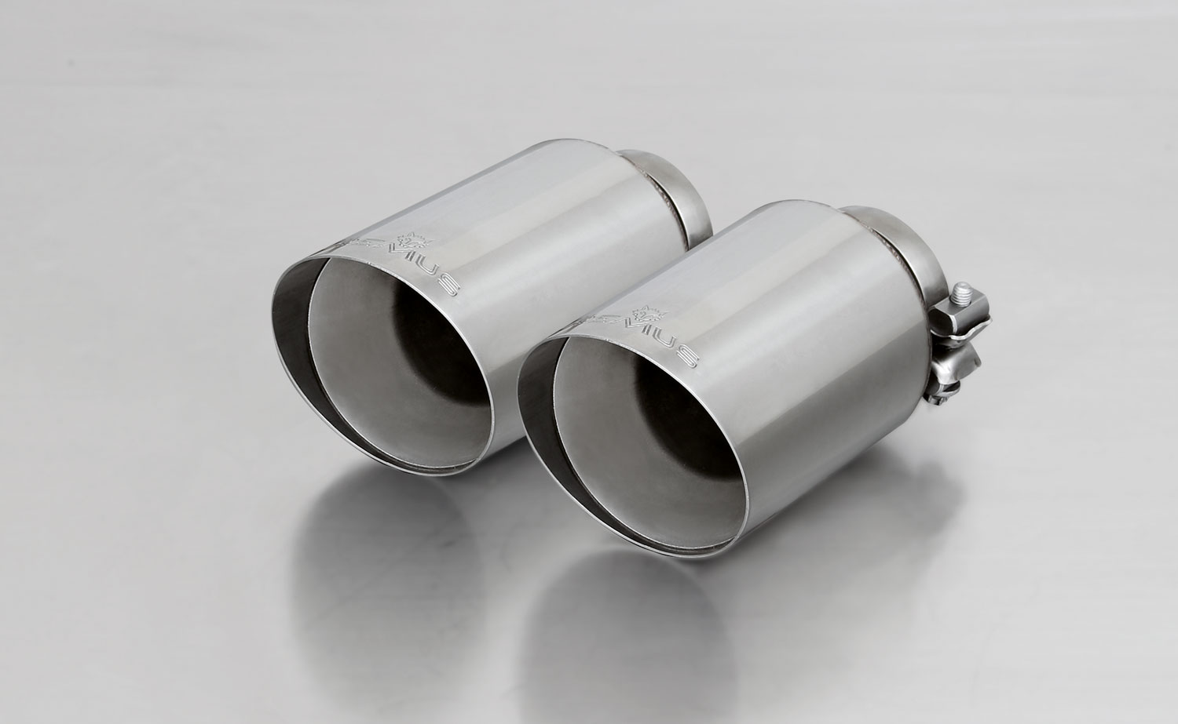
#70CS: Carbon tail pipes Ø 102 mm angled, Titanium internals

#70SG: tail pipes Ø 102 mm angled,
Straight cut, chromed
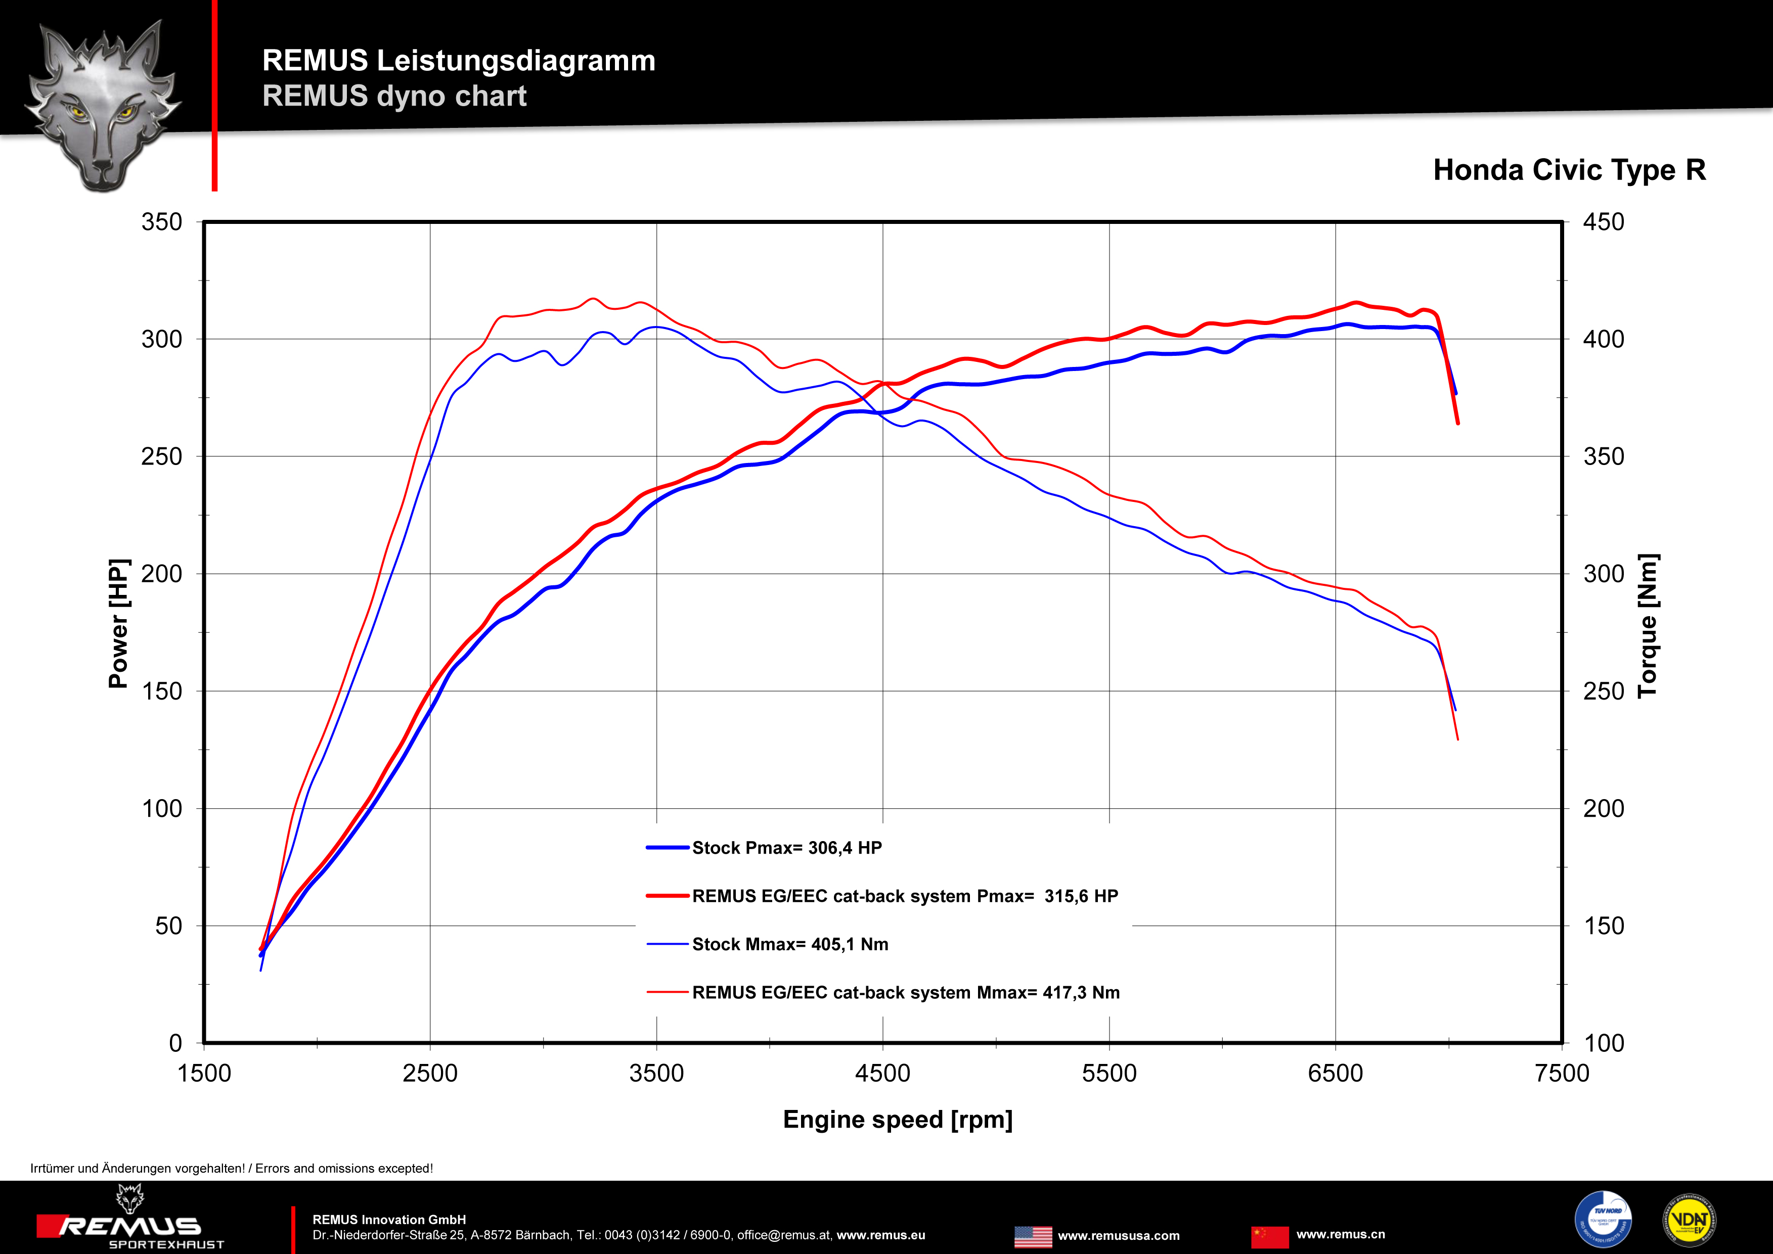

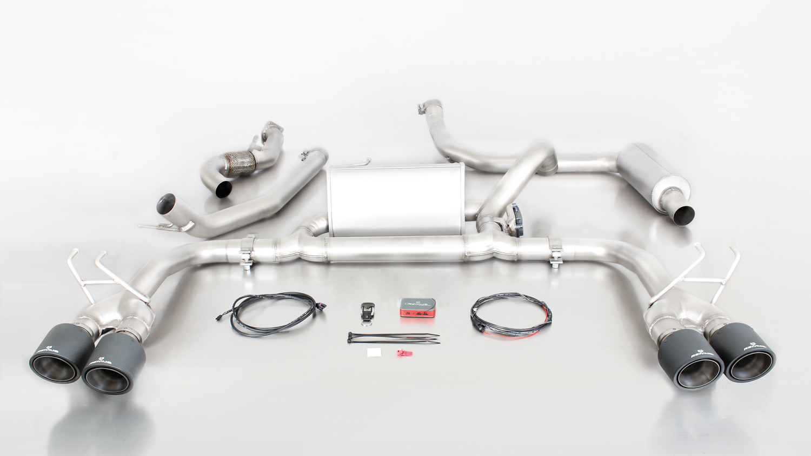
256015 1500 + 0446 70SG

Car and engine specification
HONDA Civic Type R, type FK2, 5 door, 2015=>
2.0l VTEC Turbo / Turbo GT 228 kW (K20C1)
Part no. | Description | € RRP price excl. VAT
256015 1500 | Stainless steel performance cat-back-system consisting of: Resonated cat-back section, sport exhaust centered for left/right system with integrated valve, with EEC homologation  Original tube Ø 60 mm  REMUS tube Ø 70 mm  A remote control unit is supplied for special applications in order to operate the valve in 4 different positions. | 1.270,--
choose from following tail pipe package:
0446 70SG | Tail pipe set L/R consisting of 4 tail pipes Ø 102 mm angled, straight cut, chromed, (length 145 mm) with adjustable spherical clamp connection | 280,--
0446 70CS | Tail pipe set L/R consisting of 4 Carbon tail pipes Ø 102 mm angled (length 145 mm), Titanium internals, with adjustable spherical clamp connection | 740,--
INFOBOX:
- Cat-back-system and tail pipe set only fit as a complete system!
- No vehicle modifications are required.

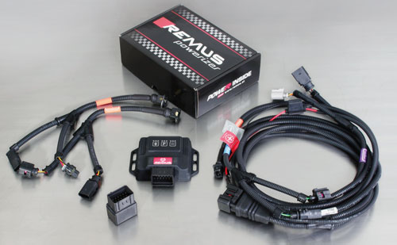

Under http://www.remus.eu/powerizer/ and http://www.remus.eu/remusresponder you will find the entire product range, prices and installation instructions.

REMUS Powerizer: More power, more economy and more fun.
- Up to 25 % more power
- Up to 20 % more torque
- Up to 1l/100 km fuel saving
- Fully adjustable power increase
- Simple DIY installation (Plug & Play)
REMUS POWERIZER: The performance figures represent the maximum achievable values. The actual performance output depends on the original tolerances of each engine. REMUS delivers the POWERIZER with the best possible setting for your vehicle type. You can adjust the performance according to your requirements as per the POWERIZER instructions

Legal references

1. Completion and registration of chip tuning in the car documents
Due to chip tuning, the operating license of the vehicle will terminate if the installation and registration of the POWERIZER is not carried out or immediately reported to an official approved testing facility. Please consider that driving a vehicle without the required operating license will cause legal penalties.

2. Vehicle insurance must be informed upon installing a POWERIZER
The installation of the POWERIZER can have influence on the insurance policy of your vehicle. You must inform the insurance company if you install a POWERIZER in your vehicle.

3. Effect of chip tuning on warranty and guarantee claims
a) When installing a POWERIZER, you will lose all guarantee claims regarding the engine against the vehicle manufacturer.
b) Installing a POWERIZER, can have influence on warranty claims against the seller of the vehicle.
c) REMUS excludes any claims regarding compensation for damages on the engine and drivetrain.

Under http://www.remus.eu/powerizer/ and http://www.remus.eu/remusresponder you will find the entire product range, prices and installation instructions.

REMUS RESPONDER:
Improved throttle response, more dynamic!
The REMUS Responder improves throttle response by means of modifying the accelerator pedal output signal. No more throttle delay and reduced lag during automatic shifting makes driving with the REMUS Responder more fun. The Responder attaches between the OEM pedal sensor and the OEM connector, ready to use in seconds due to plug & play technology. Sophisticated adjustable programming profiles can lead to improved fuel consumption and more efficiency. The 4 individual user selectable and adjustable performance settings allow drivers to select according to their own preferences.
The REMUS Responder totally eliminates the delay in modern electronic accelerator pedals!
