Product information 06/2017
VW Golf VII R Variant 4motion
VW Golf VII R Variant 4motion, Typ AU, 2016=>
2.0l TSI 221 kW (CJXC); 2.0l TSI 206 kW
REMUS Cat-back-system
- 100% stainless steel
- Powerful sound
- Performance and torque increase
- Light weight construction
+ 10,8 HP
+ 10,9 Nm
- 5,3 kg

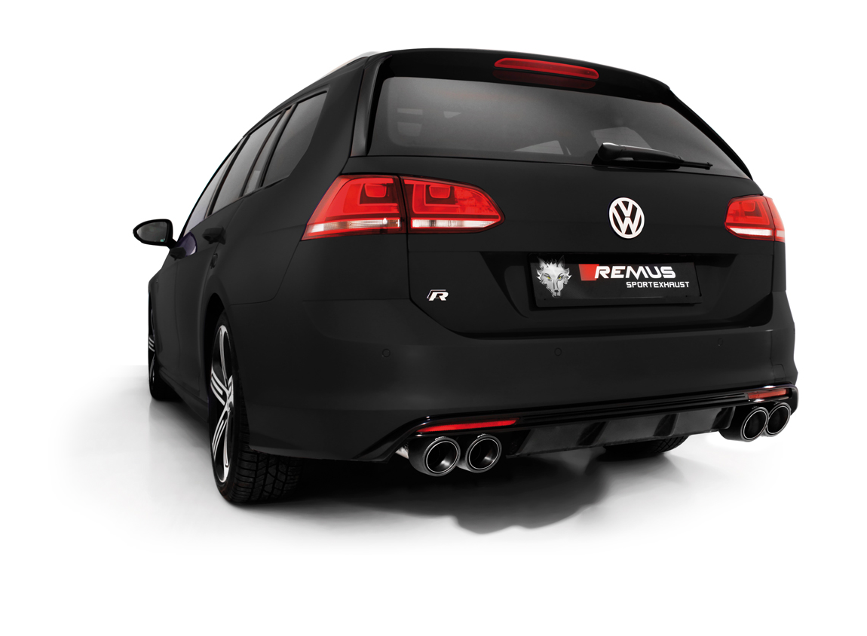

Car and engine specification
VW Golf VII R Variant 4motion, type AU, 2016=>
2.0l TSI 221 kW (CJXC); 2.0l TSI 206 kW
INFOBOX:
- RACING cat-back-system LR with remote controlled valves, without homologation:
956015 0500LR (Racing) + tail pipe set! No vehicle modifications are required!
Part no. | Description | € RRP price excl. VAT
956015 0500LR | Stainless steel RACING cat-back-system consisting of:  Resonated front section, y-pipe, RACING sport exhausts left & right (selectable tail pipes), with 2 integrated electrical valves, without homologation. Incl. REMUS sound controller  Original tube Ø 55 mm, REMUS tube Ø 70 mm  The activation of the valve is carried out using the included REMUS sound controller. The sound controller and electrical actuators allows the valve to be operated in 4 different positions. | 1.650,--
Choose from following tail pipe package:
0046 70SG | Stainless steel tail pipe set 4 tail pipes Ø 102 mm angled, straight cut, chromed, with adjustable spherical clamp connection | 296,--
0046 70S | Stainless steel tail pipe set 4 tail pipes Ø 102 mm angled, rolled edge, chromed, with adjustable spherical clamp connection | 340,--
0046 70CS | Carbon tail pipe set 4 tail pipes Ø 102 mm angled, Titanium internals, with adjustable spherical clamp connection | 840,--

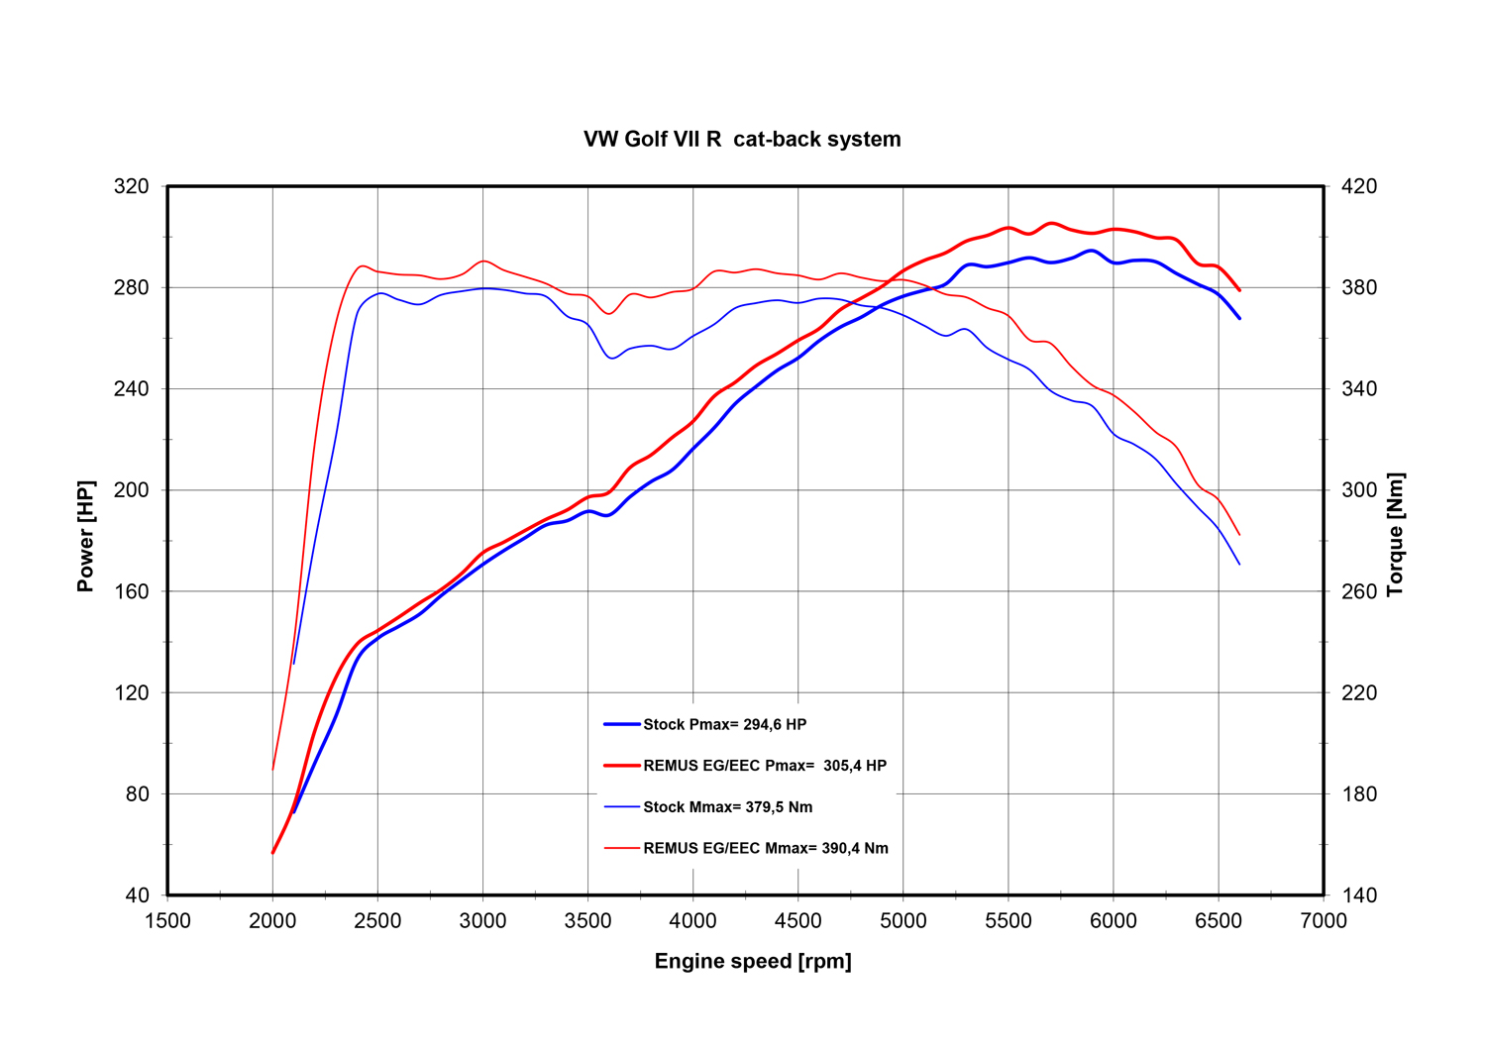

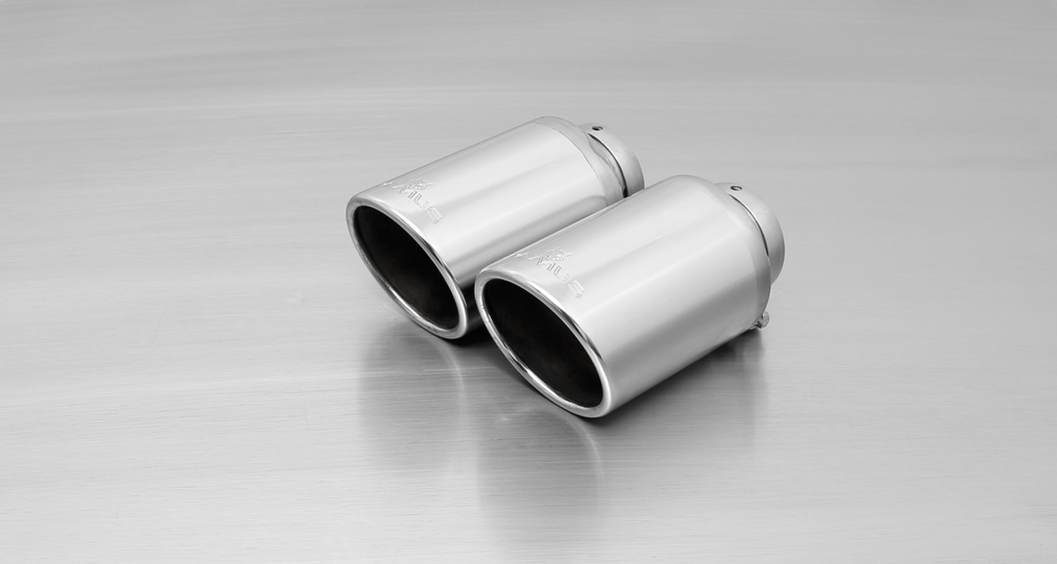
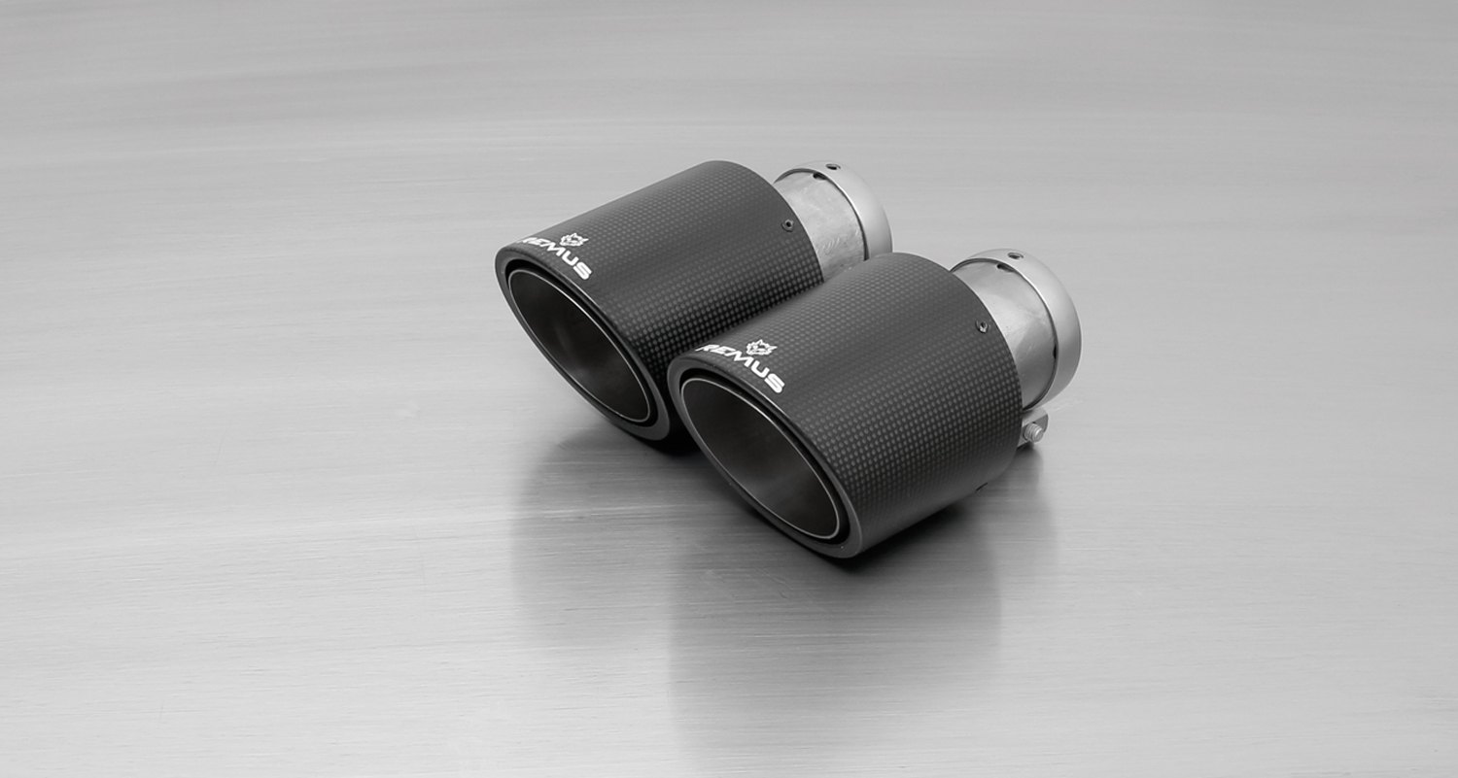
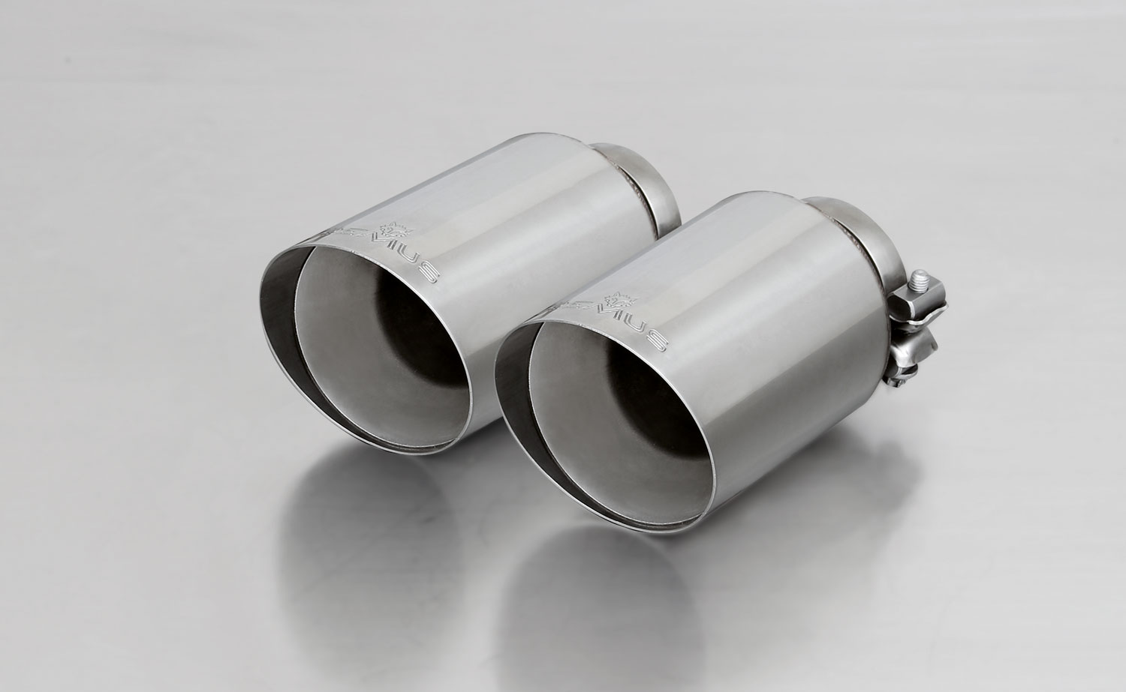

#70SG: tail pipes Ø 102 mm
angled, straight cut, chromed
#70S: tail pipes Ø 102 mm
angled, chromed

#70CS: Carbon tail pipes Ø 84 mm angled, Titanium internals

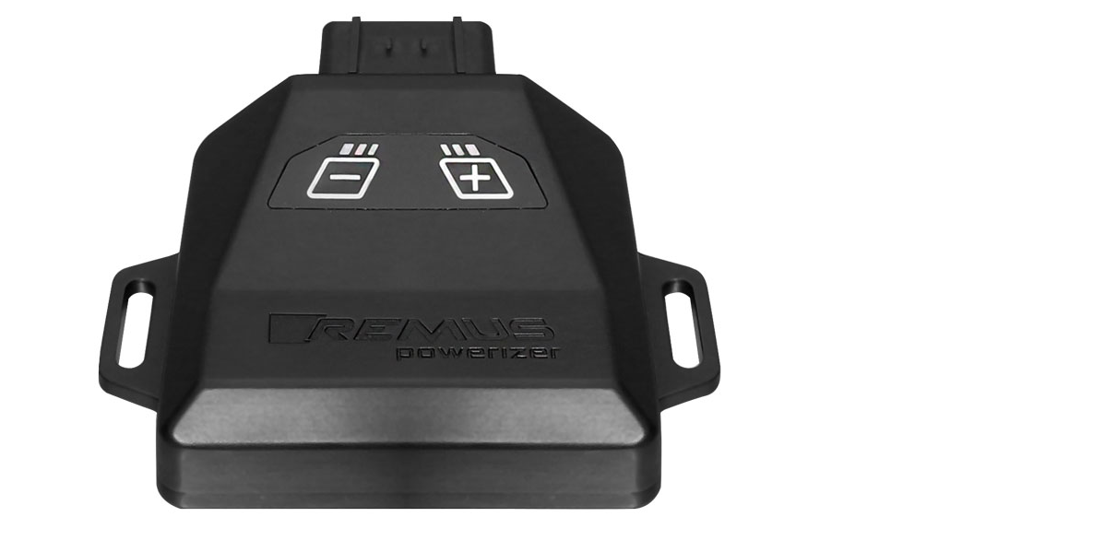
REMUS Powerizer
More power, more torque means more fun!
The perfectly matched electronics and advanced technology of the
REMUS Powerizer enhances Engine ECU mapping is optimized in
excess of 1000 times per second and ensures for a considerable and
noticeable power increase. The engine safety parameters (Check engine light) and engine management remains totally untouched to ensure that individual engine components are not overstrained.
Because of the plug & play concept, the REMUS Powerizer is installed in the engine compartment and connected to sensors such as intake manifold pressure sensor, boost pressure sensor, camshaft position sensor or fuel injection sensor. In real time, the incoming signals are processed, optimized and transmitted to the additional control unit. The Powerizer can be easily removed or decommissioned at any time using the supplied blind connector.
Due to the torque increase, the engine has more power at lower RPM which can lead to a reduction in fuel consumption. The power increase of the engine can easily be fine-tuned by means of seven preset levels via the keypad. The REMUS Powerizer is available for over 3300 petrol and diesel powered cars.
Furthermore, the latest Powerizer is also available for all vehicle engines with SENT technology. This newly developed multi-protocol technology combines analog and digital motor control the same time captures important analog signals of the engine management system which leads to increased engine performance. The capability to tune vehicles with SENT technology is an absolute highlight of the latest Powerizer.

- Up to 30% more power
- Up to 20% more torque
- Easy installation and removal (plug & play)
- Up to 1l/100 km fuel saving
- No vehicle modifications required
- 7 preset power levels

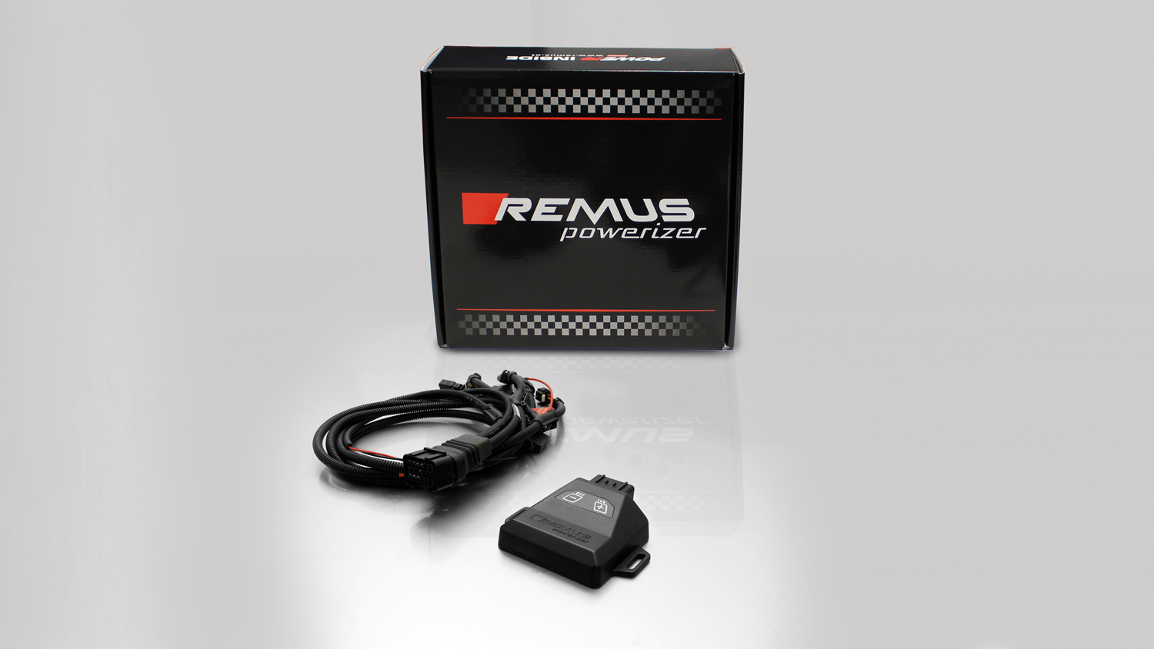

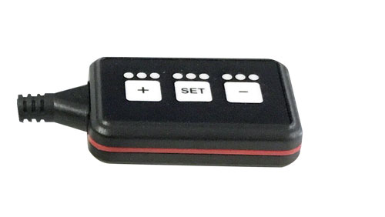
REMUS Responder

Improved throttle response for more driving dynamic!

The REMUS Responder improves throttle response and is the best power boost for
many electronically managed gas pedals. Results of up to 10% better acceleration are not uncommon and no annoying throttle delay and lag during take-off or in between manual / automatic shifts makes driving with the REMUS Responder much more dynamic.

The REMUS Responder attaches between the OEM gas pedal sensor and the OEM wiring loom and is ready to use in minutes due to plug & play technology.

The fully adjustable Responder settings can be adjusted in 20 different stages. The individual user-selectable and adjustable performance settings allow drivers to select according to their own preferences & road conditions.

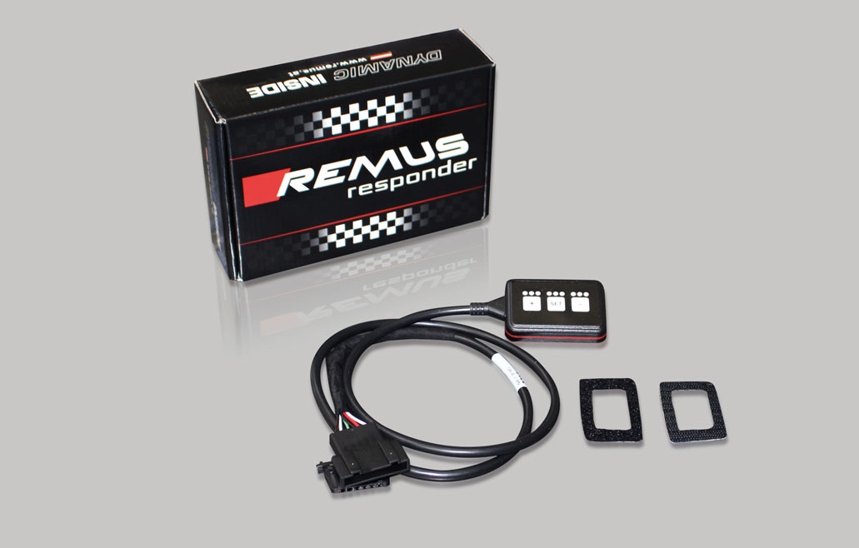

- Improves throttle response and lag during take-off and gear changes
- Quicker reaction times, more driving dynamic
- 20 individual user selectable performance settings
- Vehicle specific programming using OEM quality connectors
- Simple plug & play installation and removal without leaving traces

