REMUS product information 06-2015

MERCEDES BENZ CLA 45 AMG, C117, 2014=>

MERCEDES BENZ A 45 AMG, W176, 2013=>

Dear REMUS-Partner,

We are pleased to inform you that we have completed our next development
REMUS Cat-back system incl. front section and optional REMUS Sound Controller for the
Mercedes Benz CLA 45 AMG, C117, 2014=>
Mercedes Benz A 45 AMG, W176, 2013=>

It would be a pleasure for us to receive your order.

Stay tuned!
Your REMUS Team

Car and engine specification
Mercedes Benz CLA 45 AMG, C117, 2014=>
Mercedes Benz A 45 AMG, W176, 2013=>
2.0l 265 kW
Part no. | Description | € RRP price excl. VAT
504013 1500 | Stainless steel Cat-back system, centered including electronic controlled valve and non resonated front section, with homologation | 1.180,--
choose from following outlet tubes:
504013 1600 | Stainless steel outlet tubes for A 45 AMG incl. installation kit, suitable for the original exhaust outlets | 110,--
504513 1600 | Stainless steel outlet tubes for CLA 45 AMG incl. installation kit, suitable for the original exhaust outlets | 110,--
Optional: REMUS Sound Controller
STE 0002 | Sound Controller consisting of:  Electronic module incl. remote control for individual sound in 4 levels, no homologation | 290,--
ATTENTION:
- Cat-back system can only be installed using the required outlet tubes!

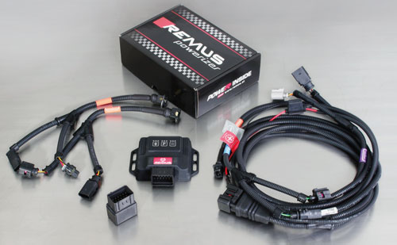

Part no. | Description | € RRP price excl. VAT
B917823 | REMUS POWERIZER for  MB CLA (C117) (2013-...) 45 AMG 2.0 360 HP 4MATIC  Original: 265 kW / 360 HP / 450 Nm  TUNED: 298 kW / 405 HP / 518 Nm / Vmax + - kmH | 499,--
B918426 | REMUS POWERIZER for  MB Class A (W176) (2012-...) 45 AMG 2.0 360 HP 4MATIC  Original: 265 kW / 360 HP / 450 Nm  TUNED: 298 kW / 405 HP / 518 Nm / Vmax + 0 kmH | 499,--
REMUS Powerizer: More power, more economy and more fun.
- Up to 25 % more power
- Up to 20 % more torque
- Up to 1l/100 km fuel saving
- Fully adjustable power increase
- Simple DIY installation (Plug & Play)
REMUS POWERIZER: The performance figures represent the maximum achievable values. The actual performance output depends on the original tolerances of each engine. REMUS delivers the POWERIZER with the best possible setting for your vehicle type. You can adjust the performance according to your requirements as per the POWERIZER instructions

Legal references

1. Completion and registration of chip tuning in the car documents

Due to chip tuning, the operating license of the vehicle will terminate if the installation and registration of the POWERIZER is not carried out or immediately reported to an official approved testing facility. Please consider that driving a vehicle without the required operating license will cause legal penalties.

2. Vehicle insurance must be informed upon installing a POWERIZER

The installation of the POWERIZER can have influence on the insurance policy of your vehicle. You must inform the insurance company if you install a POWERIZER in your vehicle.

3. Effect of chip tuning on warranty and guarantee claims

a) When installing a POWERIZER, you will lose all guarantee claims regarding the engine against the vehicle manufacturer.
b) Installing a POWERIZER, can have influence on warranty claims against the seller of the vehicle.
c) REMUS excludes any claims regarding compensation for damages on the engine and drivetrain.
.
c) REMUS schließt Ansprüche des Kunden auf Schadenersatz für etwaige Schäden an Motor und Antriebsstrang aus.

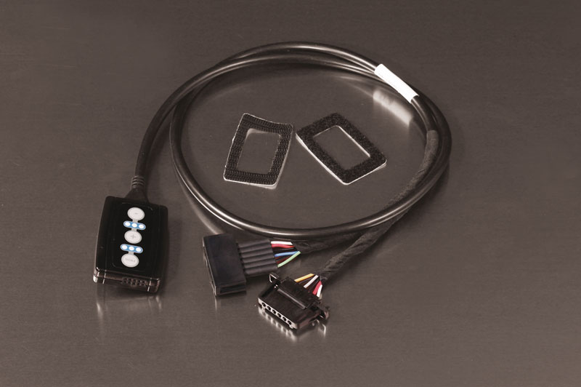

Part no. | Description | € RRP price excl. VAT
R903704 | REMUS Responder  Mercedes A-Klasse (W176) (2012-...) A 180 1595 cm³ 90 kW  Mercedes A-Klasse (W176) (2012-...) A 180 CDI 1461 cm³ 80 kW  Mercedes A-Klasse (W176) (2012-...) A 180 CDI 1796 cm³ 80 kW  Mercedes A-Klasse (W176) (2012-...) A 200 1595 cm³ 115 kW  Mercedes A-Klasse (W176) (2012-...) A 200 CDI 1796 cm³ 100 kW  Mercedes A-Klasse (W176) (2012-...) A 220 CDI 2143 cm³ 125 kW  Mercedes A-Klasse (W176) (2012-...) A 250 1991 cm³ 155 kW  Mercedes A-Klasse (W176) (2012-...) A 45 AMG 1991 cm³ 265 kW  Mercedes A-Klasse (W176) (2012-...) A 180 1595 cm³ 90 kW  Mercedes A-Klasse (W176) (2012-...) A 180 CDI 1461 cm³ 80 kW  Mercedes CLA-Klasse (C117)(2013-...) 180 BlueEFFICIENCY 1595 cm³ 90 kW  Mercedes CLA-Klasse (C117)(2013-...) CLA 180 1595 cm³ 115 kW  Mercedes CLA-Klasse (C117)(2013-...) CLA 200 1595 cm³ 115 kW  Mercedes CLA-Klasse (C117)(2013-...) CLA 200 CDI 1796 cm³ 100 kW  Mercedes CLA-Klasse (C117)(2013-...) CLA 220 CDI 2143 cm³ 125 kW  Mercedes CLA-Klasse (C117)(2013-...) CLA 250 1991 cm³ 155 kW  Mercedes CLA-Klasse (C117)(2013-...) CLA 45 AMG 1991 cm³ 265 kW | 167,--
REMUS RESPONDER:
Improved throttle response, more dynamic!
The REMUS Responder improves throttle response by means of modifying the accelerator pedal output signal. No more throttle delay and reduced lag during automatic shifting makes driving with the REMUS Responder more fun. The Responder attaches between the OEM pedal sensor and the OEM connector, ready to use in seconds due to plug & play technology. Sophisticated adjustable programming profiles can lead to improved fuel consumption and more efficiency. The 4 individual user selectable and adjustable performance settings allow drivers to select according to their own preferences.
The REMUS Responder totally eliminates the delay in modern electronic accelerator pedals!
