Product information 02/2017
VW Golf VII GTI Clubsport
VW Golf VII GTI Clubsport, type AU, from 2016
REMUS Turbo-back-system
- 100% stainless steel
- Powerful sound
- Performance and torque increase
- Light weight construction
+ 9,0 HP
+ 9,3 Nm
2.0l TSI 195 kW (CJXE)

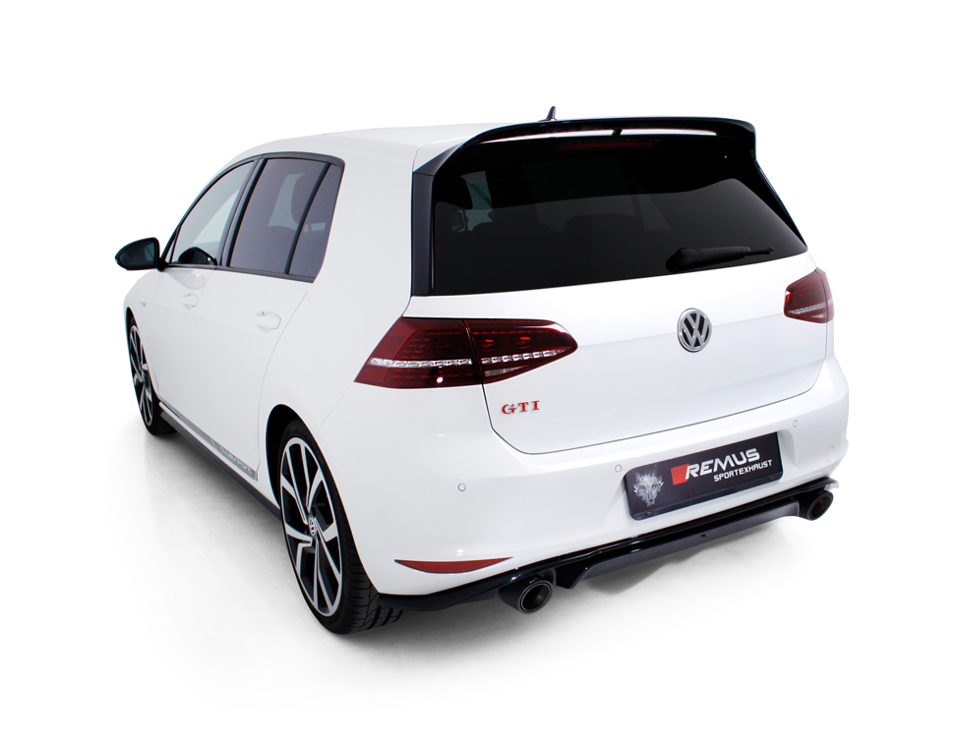

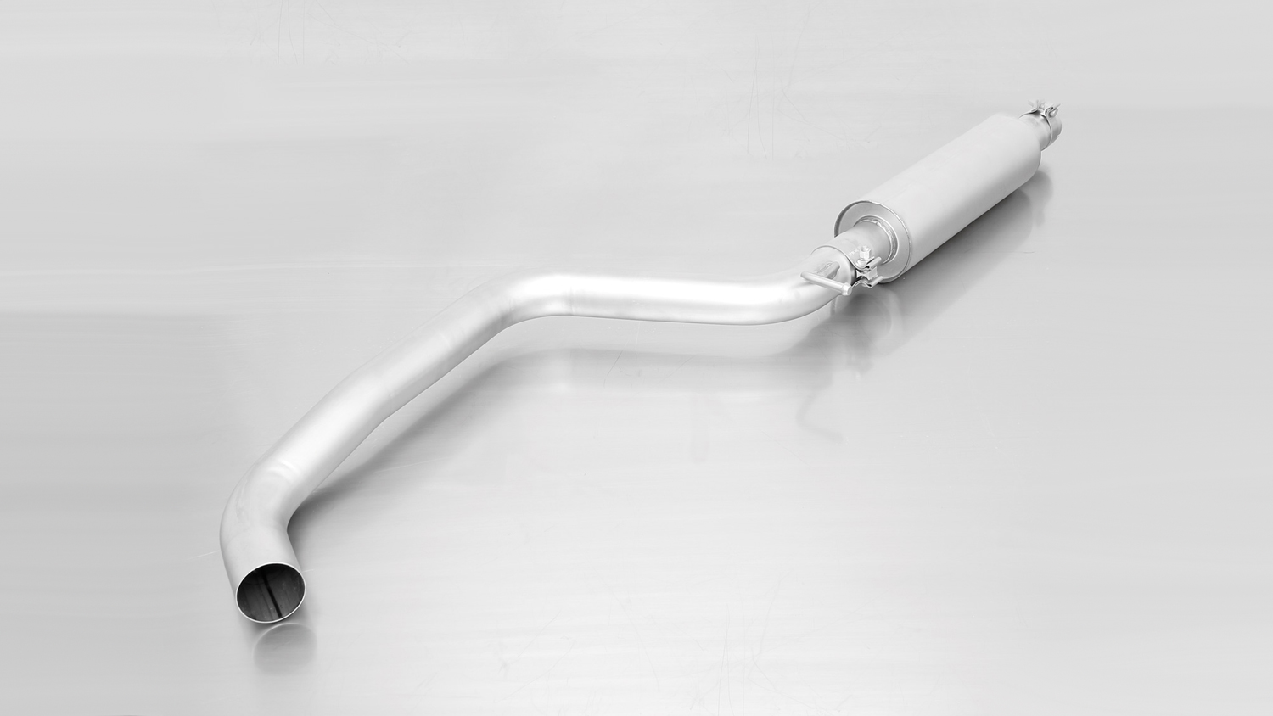
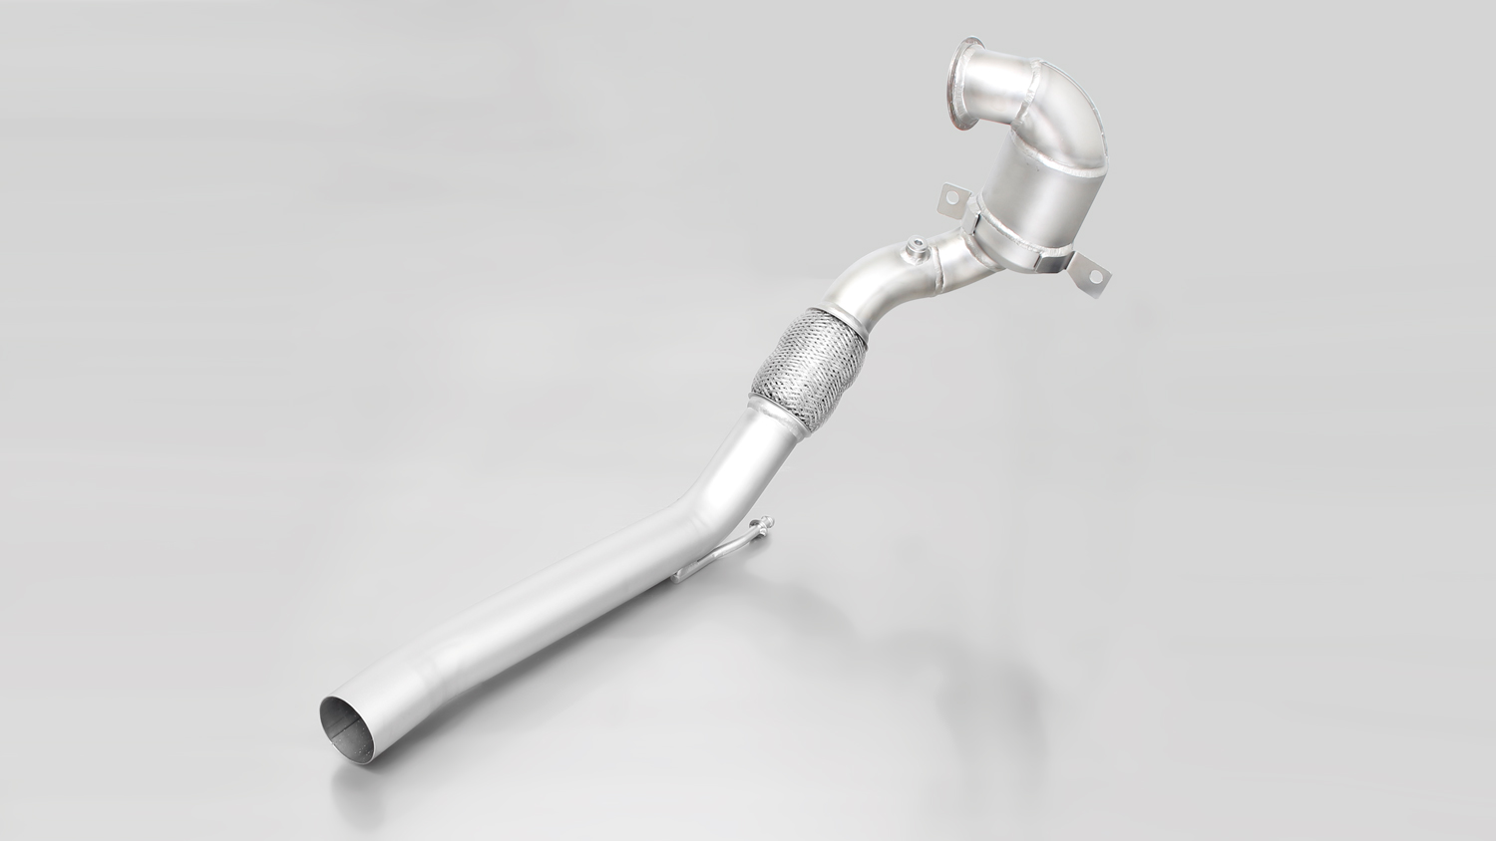

955113 1100

955213 0300

955213 0000
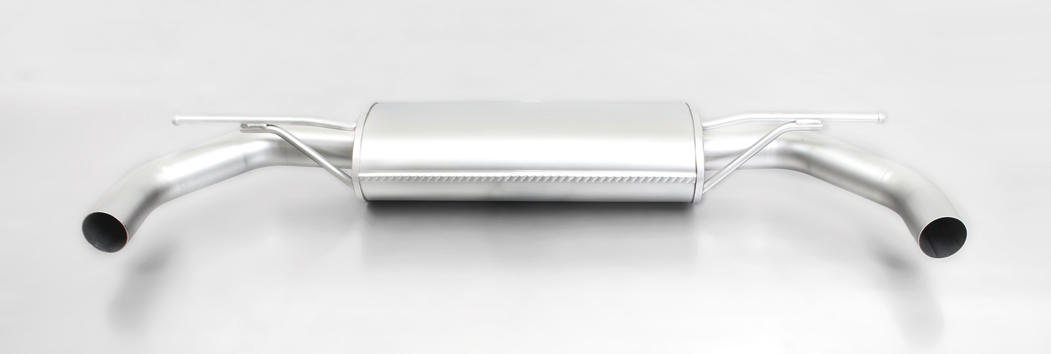

796014 1500
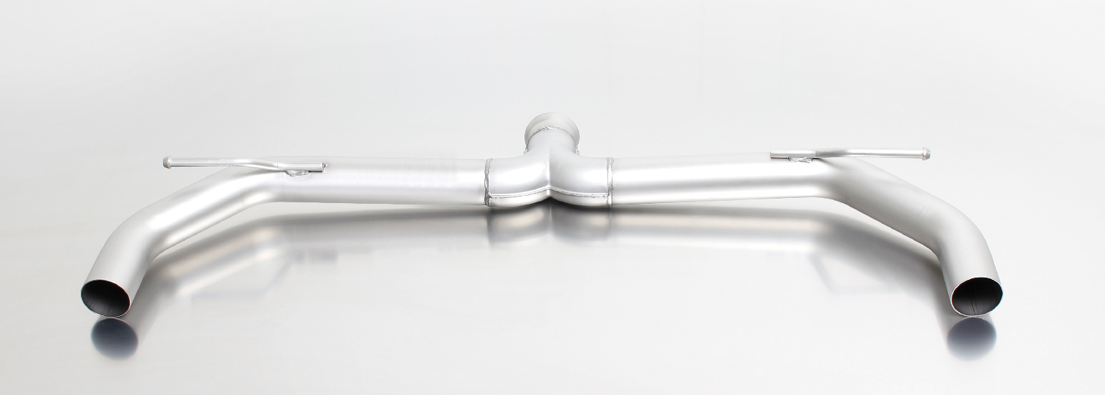

796014 1600

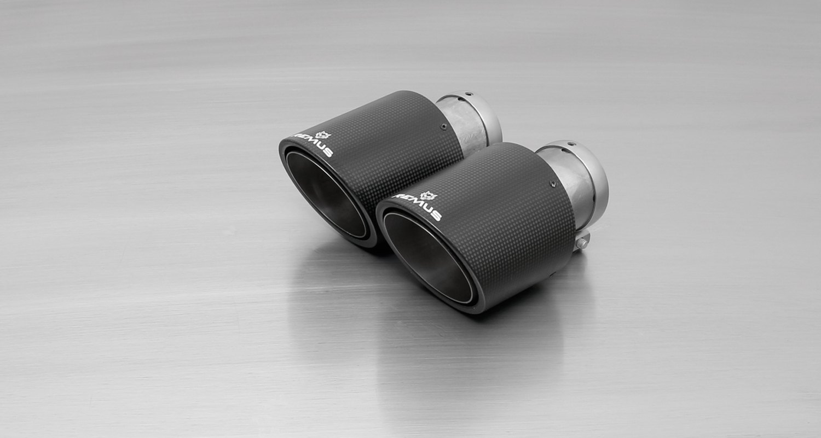
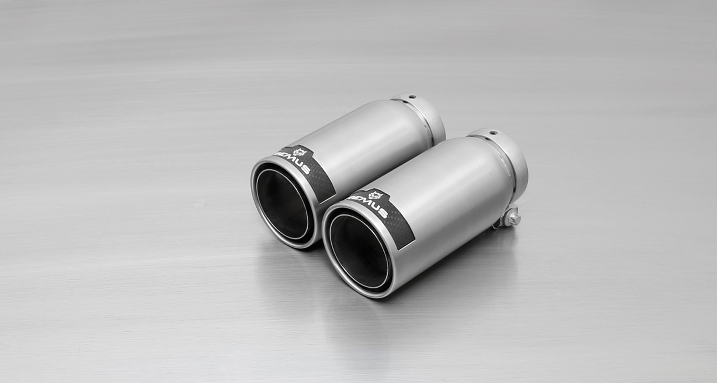
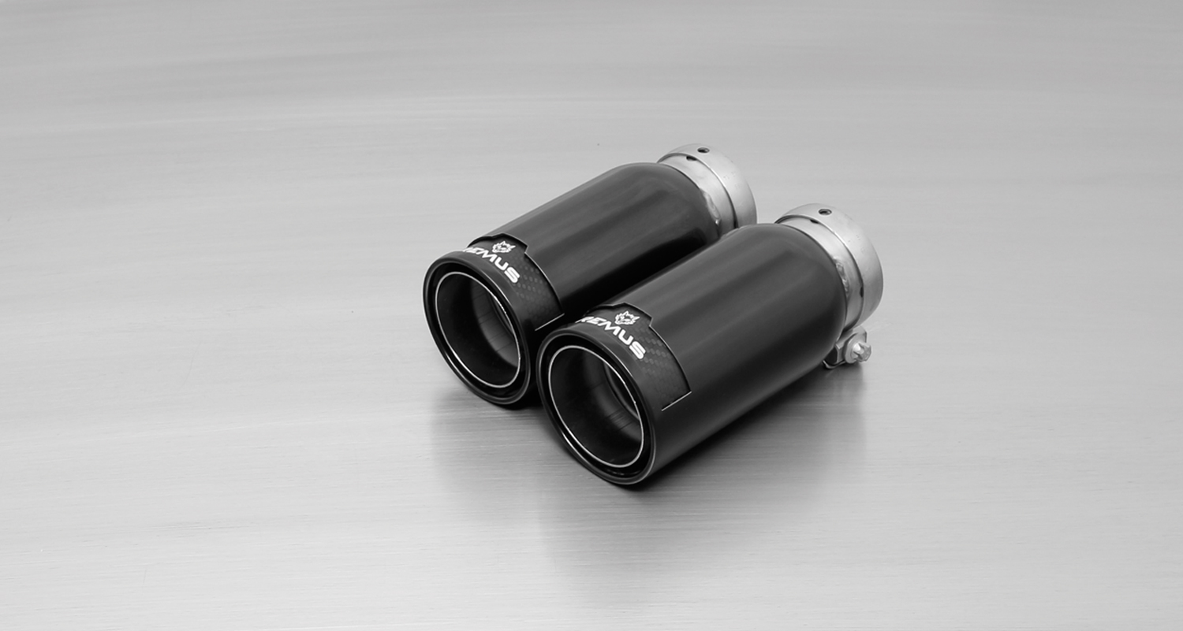
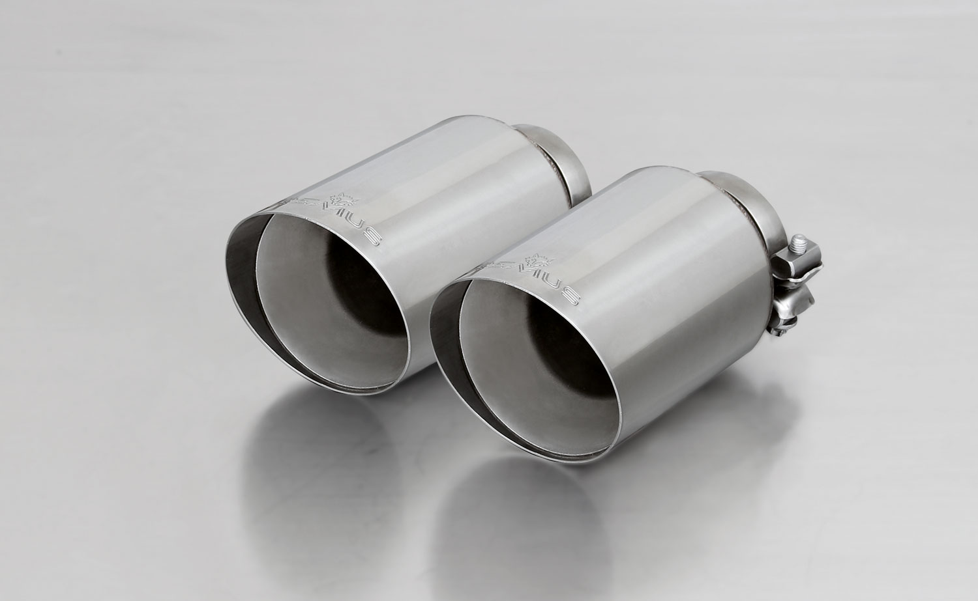
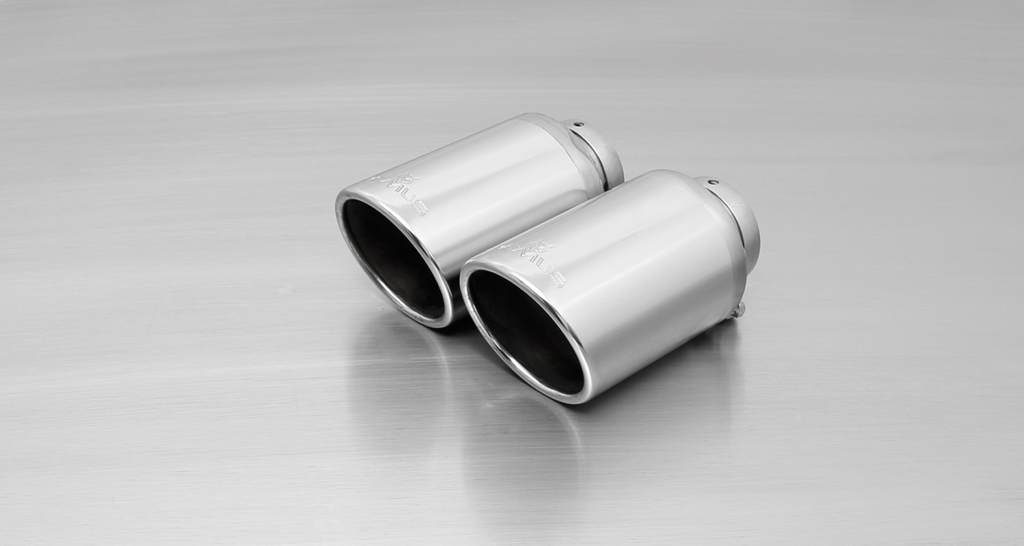
#70SG: tail pipes Ø 102 mm
angled, straight cut, chromed
#70CS: Carbon tail pipes Ø 84 mm angled, Titanium internals
#98C: tail pipes Ø 98 mm
Street Race, polished
#98CB: tail pipes Ø 98 mm
Street Race Black Chrome
#70S: tail pipes Ø 102 mm
angled, chromed

Car and engine specification
VW Golf VII GTI Clubsport, type AU, 2016=>
2.0l TSI 195 kW (CJXE)
INFOBOX:
- Cat-back-system L/R for original rear skirt: 955213 0300 + 955213 0000 + 796014 1500 resp. 796014 1600 (Racing) + tail pipe set! No vehicle modifications required!
- Turbo-back-system L/R for original rear skirt: 955113 1100 (Racing) + 955213 0300 + 955213 0000 + 796014 1500 resp. 796014 1600 (Racing) + tail pipe set! No vehicle modifications required!
- When installing REMUS down-pipes with and without the racing catalytic convertors, which are only suitable for closed road driving, it is important to note that ECU tuning is required to ensure that the engine runs and performs efficiently and to ensure that the CEL does not come on.
Part no. | Description | € RRP price excl. VAT
955113 1100 | Stainless steel RACING downpipe, tube Ø 70 mm, with sport catalytic convertor (200 CPSI), without homologation, can only be fitted in combination with the REMUS front silencer  Original tube Ø 65 mm / REMUS tube Ø 70 mm | 926,--
955213 0300 | Stainless steel resonated cat-back section, incl. EC homologation  Original tube Ø 65 mm / REMUS tube Ø 70 mm | 279,--
955213 0000 | Stainless steel connection tube for mounting the L/R sport exhaust or the non-resonated L/R RACING axle-back-systems | 59,--
Sport exhaust system L/R suitable for the original rear skirt, incl. EC homologation:
796014 1500 | Stainless steel sport exhaust centered for L/R system (without tail pipes), suitable for the original rear skirt, incl. EC homologation  Original tube Ø 65 mm / REMUS tube Ø 70 mm | 254,--
Alternative: Non-resonated L/R RACING axle-back system suitable for the original rear skirt, without homologation:
796014 1600 | Stainless steel non resonated L/R RACING axle-back-system (without tail pipes, without connecting tube), suitable for the original rear skirt, without homologation  Original tube Ø 65 mm / REMUS tube Ø 70 mm | 111,--
Choose from following tail pipe package:
0026 70SG | Stainless steel tail pipe set 2 tail pipes Ø 102 mm angled, straight cut, chromed, with adjustable spherical clamp connection | 148,--
0026 70S | Stainless steel tail pipe set 2 tail pipes Ø 102 mm angled, rolled edge, chromed, with adjustable spherical clamp connection | 170,--
0026 70CS | Carbon tail pipe set 2 tail pipes Ø 102 mm angled, Titanium internals, with adjustable spherical clamp connection | 420,--
0026 98C | Stainless steel tail pipe set 2 tail pipes Ø 98 mm Street Race, straight, carbon insert, with adjustable spherical clamp connection | 222,--
0026 98CB | Stainless steel tail pipe set 2 tail pipes Ø 98 mm Street Race Black Chrome, straight, carbon insert, with adjustable spherical clamp connection | 246,--

REMUS RACING

955113 1100

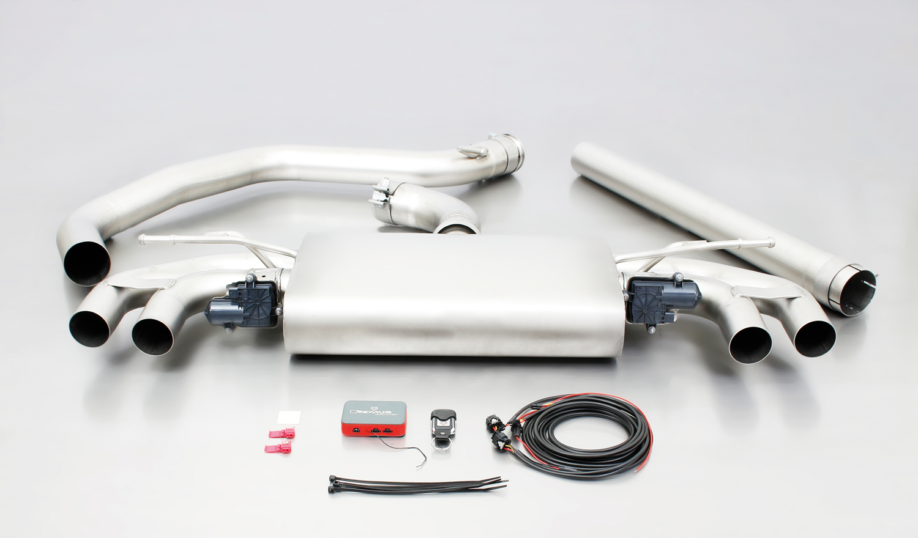

955113 1100
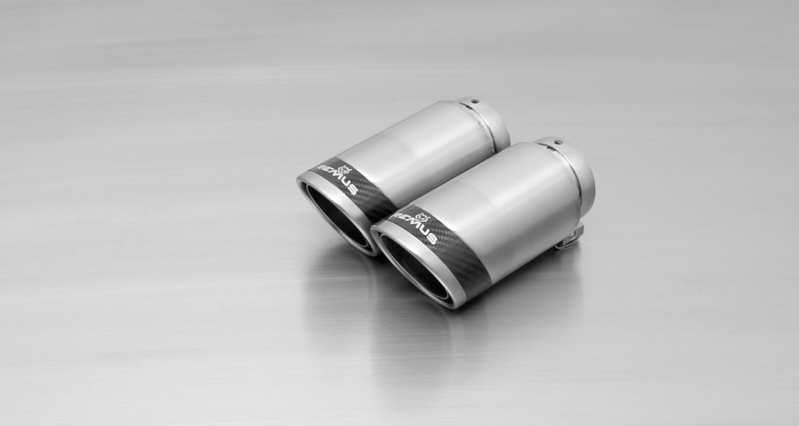
#83CS: tail pipes Ø 84 mm
Carbon Race, polished
#83C: tail pipes Ø 84 mm
Street Race, polished
#83CTS: Carbon-tail pipes
Ø 84 mm angled, Titanium internals

#83CB: tail pipes Ø 84 mm
Street Race Black Chrome
#55S: tail pipes Ø 84 mm
angled, chromed

951401 HES

952401 HES

Car and engine specification
VW Golf VII GTI Clubsport, type AU, 2016=>
2.0l TSI 195 kW (CJXE)
INFOBOX:
- RACING cat-back-system with remote controlled valves, without homologation: 955513 1500 + tail pipe set + 951401 HES resp. 952401 HES! No cutting of original exhaust required!
- RACING turbo-back-system with remote controlled valves, without homologation: 955113 1100 + 955513 1500 + tail pipe set + 951401 HES resp. 952401 HES! No cutting of original exhaust required!
- When installing REMUS down-pipes with and without the racing catalytic convertors, which are only suitable for closed road driving, it is important to note that ECU tuning is required to ensure that the engine runs and performs efficiently and to ensure that the CEL does not come on.
Part no. | Description | € RRP price excl. VAT
955113 1100 | Stainless steel RACING downpipe, tube Ø 70 mm, with sport catalytic convertor (200 CPSI), without homologation, can only be fitted in combination with the REMUS front silencer  Original tube Ø 65 mm / REMUS tube Ø 70 mm | 926,--
955513 1500 | Stainless steel RACING tube instead of front silencer, connection tube and sport exhaust centered for L/R system (without tail pipes), fits in combination with original and REMUS downpipe using the supplied adapters, REMUS tube Ø 76 mm, with 2 integrated electrical valves, without homologation  It is not permissible to activate the valve on public roads as per the EU transport authority. The activation of the valve is carried out using the included REMUS sound controller. The sound controller and electrical actuators allows the valve to be operated in 4 different positions. | 1.450,--
Choose from following tail pipe package:
0046 55S | Stainless steel tail pipe set 4 tail pipes Ø 84 mm angled, rolled edge, chromed, with adjustable spherical clamp connection | 320,--
0046 83C | Stainless steel tail pipe set 4 tail pipes Ø 84 mm Street Race, straight, carbon insert, with adjustable spherical clamp connection | 392,--
0046 83CS | Stainless steel tail pipe set 4 tail pipes Ø 84 mm Carbon Race, angled, carbon ring, with adjustable spherical clamp connection | 408,--
0046 83CB | Stainless steel tail pipe set 4 tail pipes Ø 84 mm Street Race Black Chrome, straight, carbon insert, with adjustable spherical clamp connection | 440,--
0046 83CTS | Carbon tail pipe set 4 tail pipes Ø 84 mm angled, Titanium internals, with adjustable spherical clamp connection | 780,--
Choose from following rear diffusors:
951401 HES | ABS rear diffusor left/right, carbon optic | 199,--
952401 HES | ABS rear diffusor left/right, satin black | 199,--

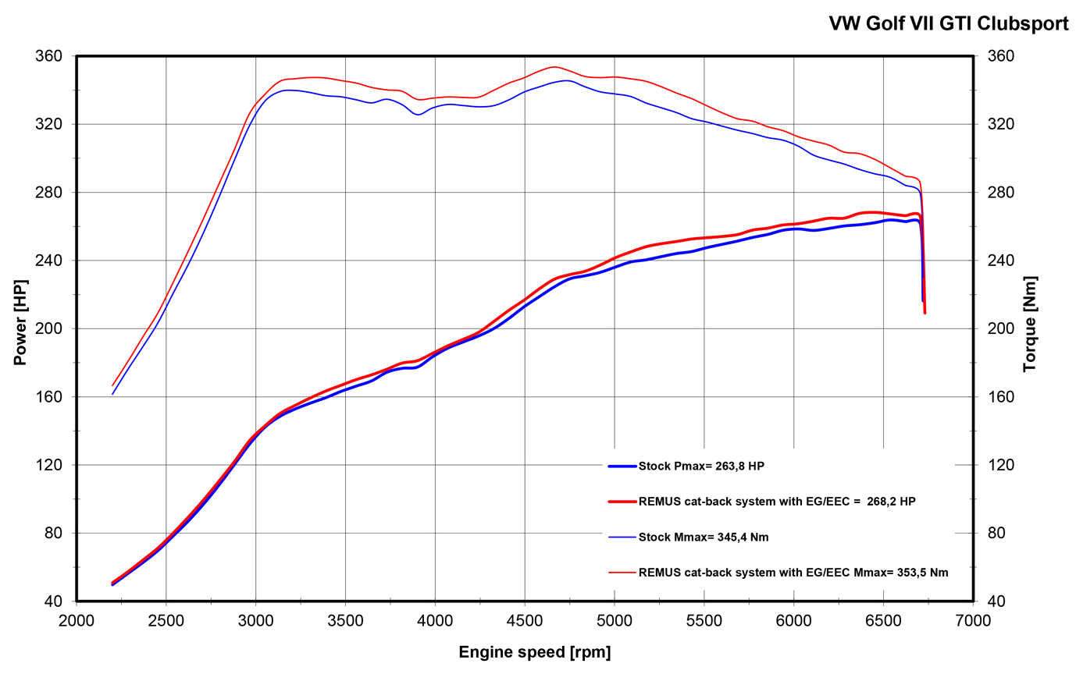

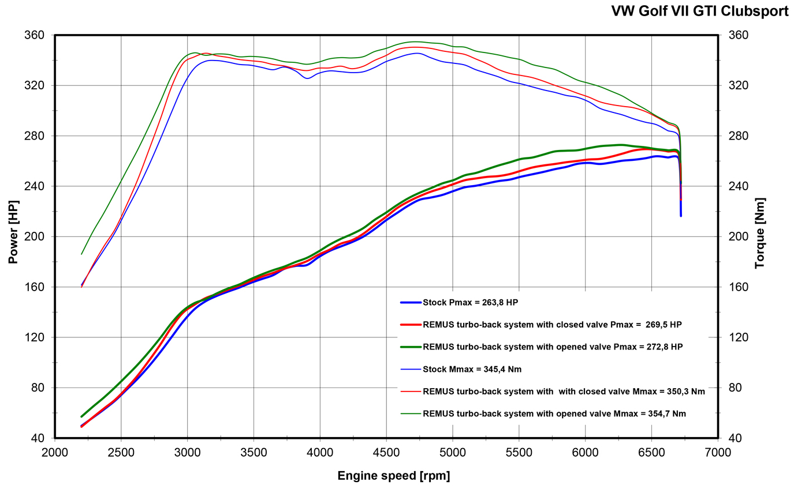

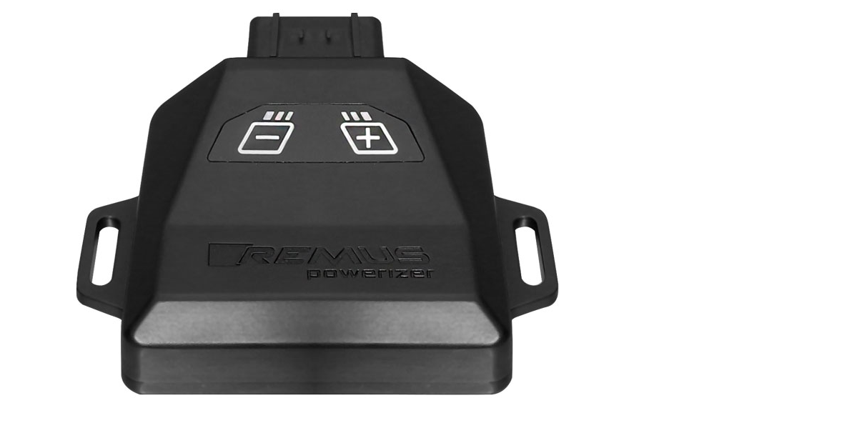
REMUS Powerizer
More power, more economy and more fun!
The electronics of the REMUS Powerizer enhances in real time
the engine management parameters. The engine mapping
is optimized in excess of 1000 times per second and ensures for a
considerable and noticeable power increase. The engine safety parameters and management remains totally original to ensure that individual engine components are not overstrained. Furthermore, the original mapping software remains totally untouched.
Due to the plug & play concept, the REMUS Powerizer is simple to install and can be easily removed or decommissioned using the supplied blind connector. Due to the torque increase, the engine has more power at lower RPM which leads to a reduction in fuel consumption. The power increase of the engine can be fine-tuned by means of seven preset levels. The REMUS Powerizer is available for over 3000 petrol and diesel powered cars.
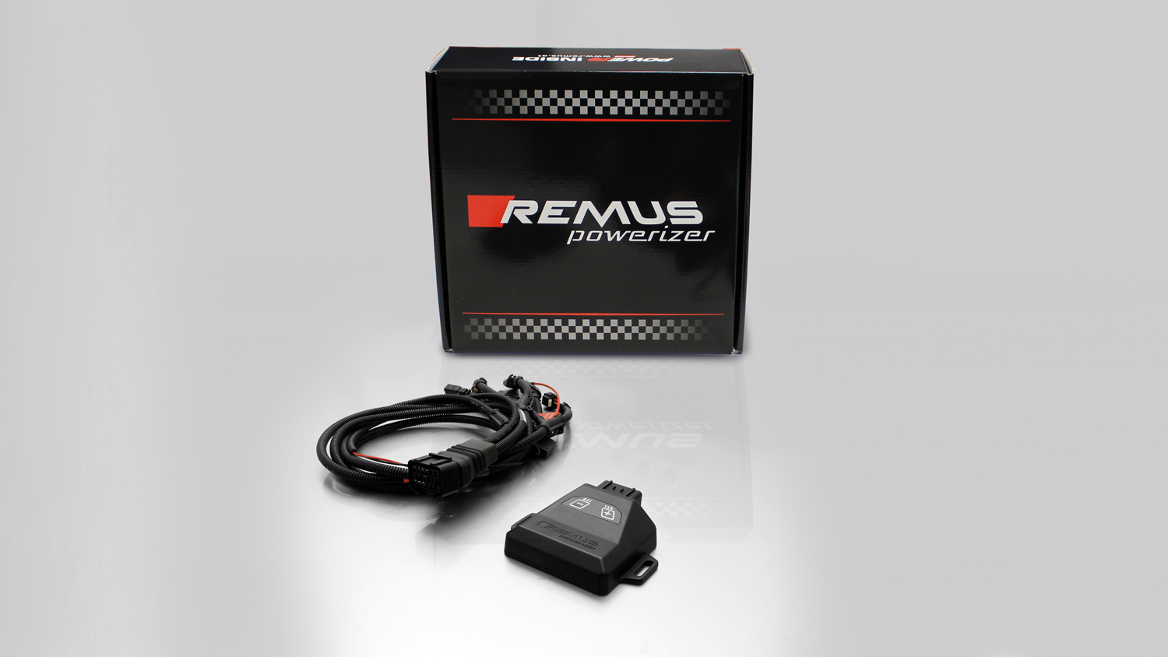

- Up to 25% more power
- Up to 20% more torque
- Easy installation and removal (plug & play)
- Up to 1l/100 km fuel saving
- No modifications on the ECU
- 7 preset power levels

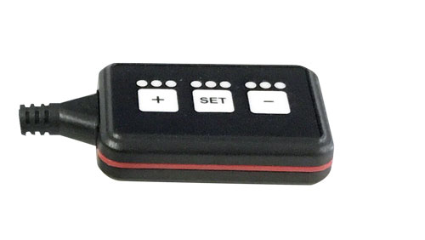
REMUS Responder

Improved throttle response, more dynamic!

Der REMUS ResponderThe REMUS Responder improves throttle response by means
of modifying the accelerator pedal output signal.

No more throttle delay and reduced lag during automatic shifting makes driving
with the REMUS Responder more fun. The Responder attaches between the
OEM pedal sensor and the OEM connector, ready to use in seconds due to plug & play technology.

Sophisticated adjustable programming profiles can lead to improved fuel consumption and
more efficiency. The four individual user selectable and adjustable performance settings
allow drivers to select according to their own preferences. The REMUS Responder totally eliminates the delay in modern electronic accelerator pedals!

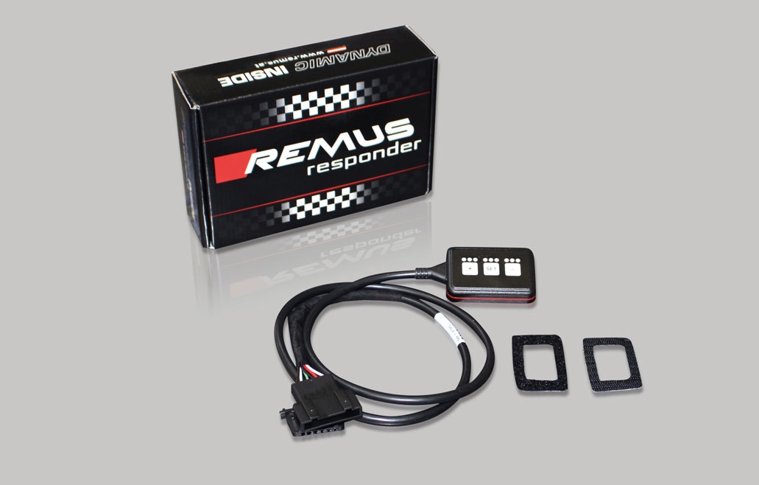

- Improved throttle response, reduced lag during gear changes
- Quicker reaction times, more dynamic without changing engine parameters
- 4 individual user selectable and adjustable performance settings
- Vehicle specific programming using OEM quality connectors
- Simple plug & play installation and easily removed without leaving traces

