REMUS product information 02-2015

REMUS tail pipe 83CTS

Dear REMUS-Partner,

We are pleased to inform you that we have completed our next development:
New tail pipes for REMUS “New Wolf” sport exhausts
#83CTS: Carbon tail pipes Ø 84 mm angled, Titanium internals,
with adjustable spherical clamp connection

It would be a pleasure for us to receive your order.

Stay tuned!
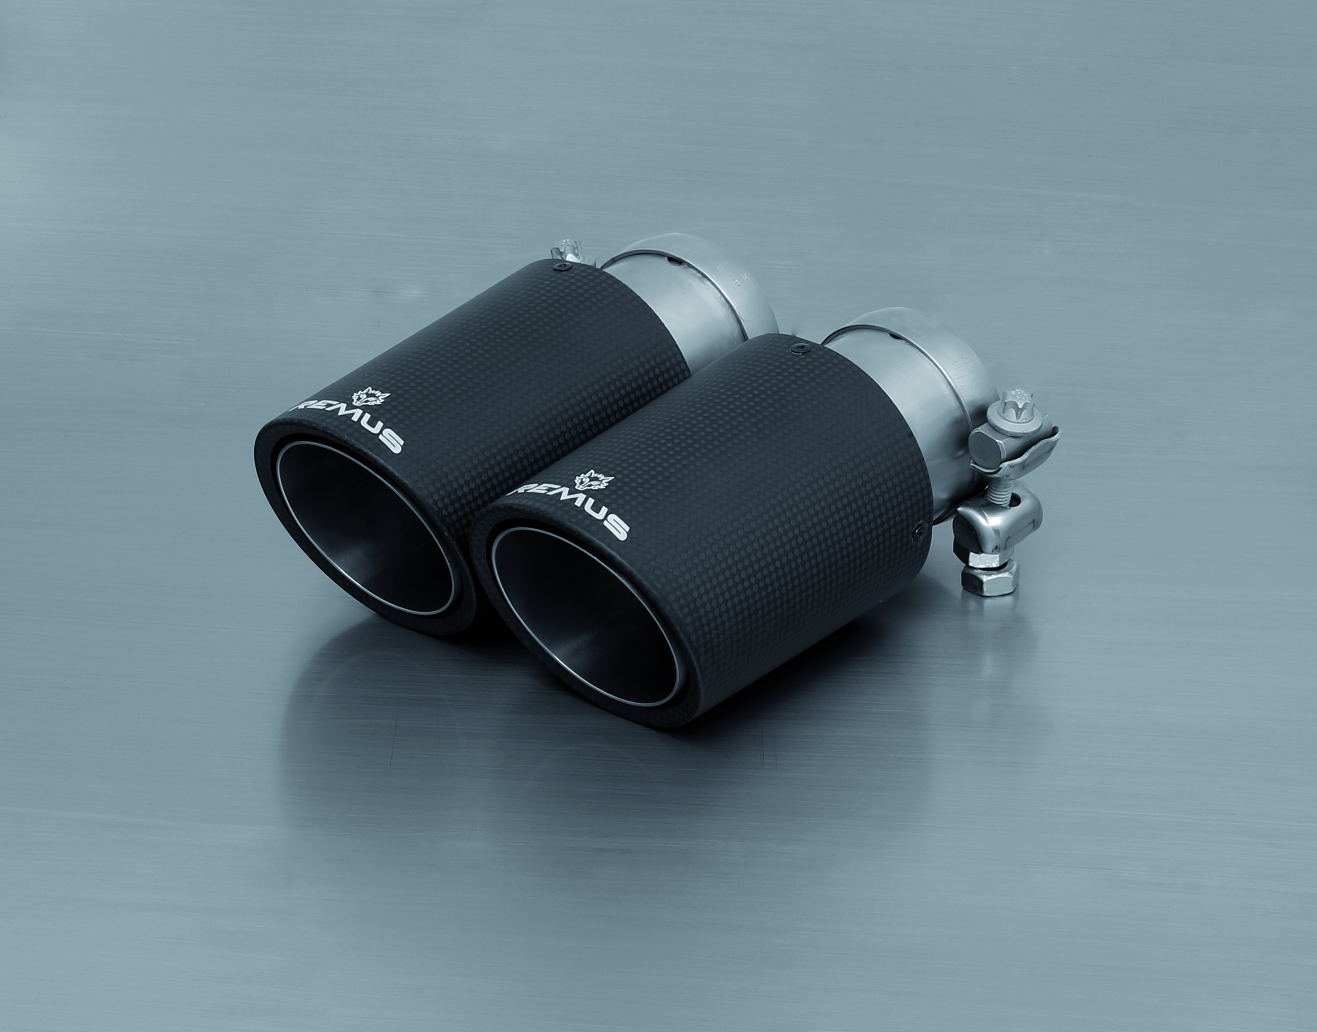
Your REMUS Team

#83CTS: Carbon tail pipe Ø 84 mm angled, Titanium internals

Info-Form

Fax +43 3142 6900-290, E-mail: thomas.brunner@remus.at
Part no. | Description | € RRP price excl. VAT
0026 83CTS | Tail pipe set 2 Carbon tail pipes Ø 84 mm angled, Titanium internals, with adjustable spherical clamp connection | 340,--
Application range:
BMW: 087087 0500; 089000 0500
0046 83CTS | Tail pipe set 4 Carbon tail pipes Ø 84 mm angled, Titanium internals, with adjustable spherical clamp connection | 680,--
Application range:
AUDI: 046513 0500
BMW: 088206 0500LR; 088906 0500LR; 089010 0500LR; 089107 0500LR; 089907 0500LR
VW: 955113 1500

