REMUS product information 30-2015

AUDI A3 Cabrio, type 8V, 2014=>

Dear REMUS-Partner,

We are pleased to inform you that we have completed our next development:
REMUS sport exhaust with selectable tail pipes for the
AUDI A3 Cabrio, type 8V, 2014=>.

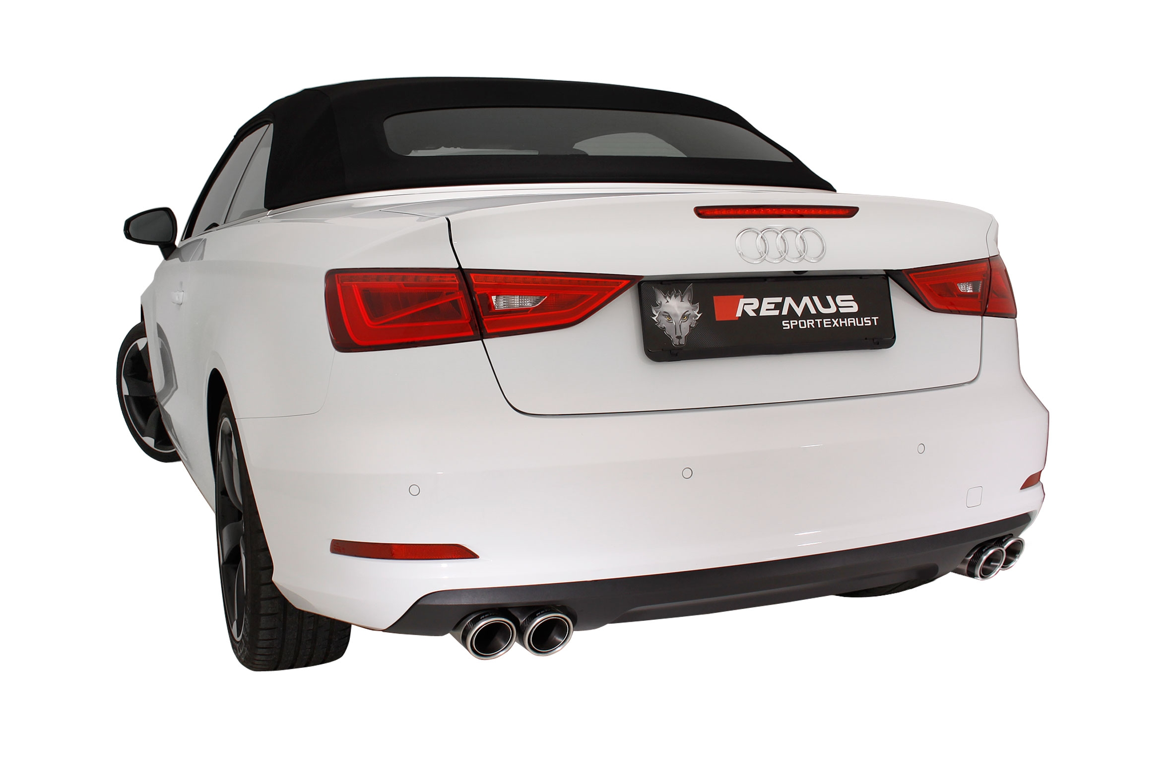
It would be a pleasure for us to receive your order.

Stay tuned!
Your REMUS Team

#83CS: tail pipe Ø 84 mm
Carbon Race, polished

#55S: tail pipe Ø 84 mm angled, chromed
#83C: tail pipe Ø 84 mm
Street Race, polished

#83CB: tail pipe Ø 84 mm
Street Race Black Chrome

Car and engine specification
AUDI A3 Cabrio, Type 8V, 2014=>
1.4l TFSI 92 kW; 1.4l TFSI 110 kW; 1.8l TFSI 132 kW
Part no. | Description | € 2016 RRP price excl. VAT
954312 0000 | Stainless steel racing tube without homologation, instead of front silencer, only for 1.4l TFSI | 158,--
954112 0000 | Stainless steel connection tube (multi-link axle) for mounting on 1.4l TFSI 92/110 kW | 56,--
955112 0000 | Stainless steel connection tube (multi-link axle) for mounting on 1.8l TFSI 132 kW | 56,--
045013 1500 | Sport exhaust centered for L/R system (without tail pipes),with EEC homologation | 286,--
choose from following tail pipe package:
0046 55S | Tail pipe set L/R consisting of 4 tail pipes Ø 84 mm angled, chromed, with adjustable spherical clamp connection | 300,--
0046 83C | Tail pipe set L/R consisting of 4 tail pipes Ø 84 mm Street Race, with adjustable spherical clamp connection | 340,--
0046 83CS | Tail pipe set L/R consisting of 4 tail pipes Ø 84 mm Carbon Race, with adjustable spherical clamp connection | 360,--
0046 83CB | Tail pipe set L/R consisting of 4 tail pipes Ø 84 mm Street Race Black Chrome, with adjustable spherical clamp connection | 388,--
ATTENTION:
- The sport exhaust can only be installed using the above mentioned tip sets!
- The sport exhausts are only mountable with connection tubes!
- The rear skirt must be trimmed as per the supplied template!
- Not suitable for S-Line models!

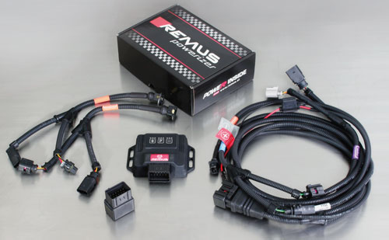

Under http://www.remus.eu/powerizer/ and http://www.remus.eu/remusresponder you will find the entire product range, prices and installation instructions.

REMUS Powerizer: More power, more economy and more fun.
- Up to 25 % more power
- Up to 20 % more torque
- Up to 1l/100 km fuel saving
- Fully adjustable power increase
- Simple DIY installation (Plug & Play)
REMUS POWERIZER: The performance figures represent the maximum achievable values. The actual performance output depends on the original tolerances of each engine. REMUS delivers the POWERIZER with the best possible setting for your vehicle type. You can adjust the performance according to your requirements as per the POWERIZER instructions

Legal references

1. Completion and registration of chip tuning in the car documents
Due to chip tuning, the operating license of the vehicle will terminate if the installation and registration of the POWERIZER is not carried out or immediately reported to an official approved testing facility. Please consider that driving a vehicle without the required operating license will cause legal penalties.

2. Vehicle insurance must be informed upon installing a POWERIZER
The installation of the POWERIZER can have influence on the insurance policy of your vehicle. You must inform the insurance company if you install a POWERIZER in your vehicle.

3. Effect of chip tuning on warranty and guarantee claims
a) When installing a POWERIZER, you will lose all guarantee claims regarding the engine against the vehicle manufacturer.
b) Installing a POWERIZER, can have influence on warranty claims against the seller of the vehicle.
c) REMUS excludes any claims regarding compensation for damages on the engine and drivetrain.

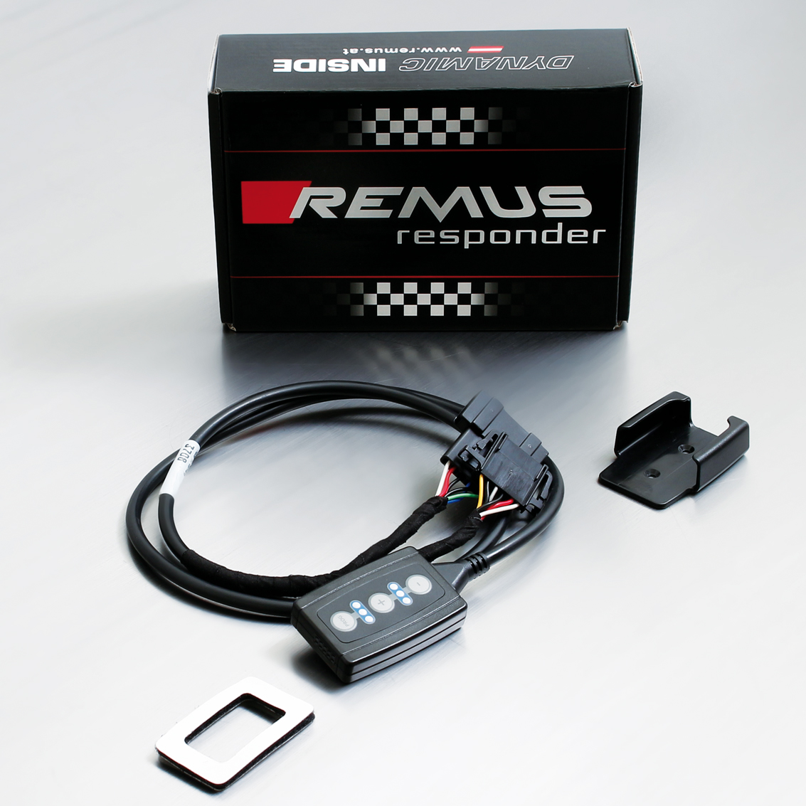

Under http://www.remus.eu/powerizer/ and http://www.remus.eu/remusresponder you will find the entire product range, prices and installation instructions.

REMUS RESPONDER:
Improved throttle response, more dynamic!
The REMUS Responder improves throttle response by means of modifying the accelerator pedal output signal. No more throttle delay and reduced lag during automatic shifting makes driving with the REMUS Responder more fun. The Responder attaches between the OEM pedal sensor and the OEM connector, ready to use in seconds due to plug & play technology. Sophisticated adjustable programming profiles can lead to improved fuel consumption and more efficiency. The 4 individual user selectable and adjustable performance settings allow drivers to select according to their own preferences.
The REMUS Responder totally eliminates the delay in modern electronic accelerator pedals!
