REMUS product information 09-2015 2015-05-07

AUDI S3 Quattro / S3 Quattro Sportback / S3 Quattro Sedan, type 8V, 2013=>

Dear REMUS-Partner,

We are pleased to inform you that we have completed our next development
REMUS racing downpipe, racing tube, EEC approved racing front silencer,
EEC approved sport exhaust left/right with selectable tail pipes for
AUDI S3 Quattro / S3 Quattro Sportback / S3 Quattro Sedan, type 8V, 2013=>.

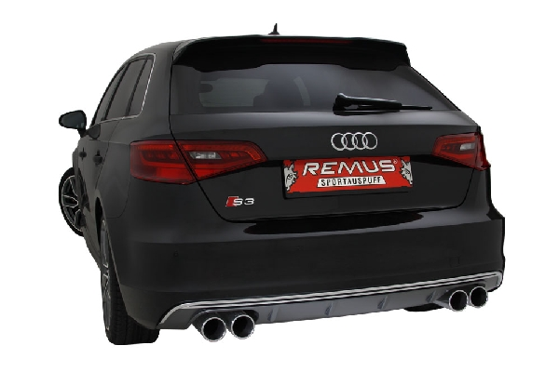
It would be a pleasure for us to receive your order.

Stay tuned!
Your REMUS Team
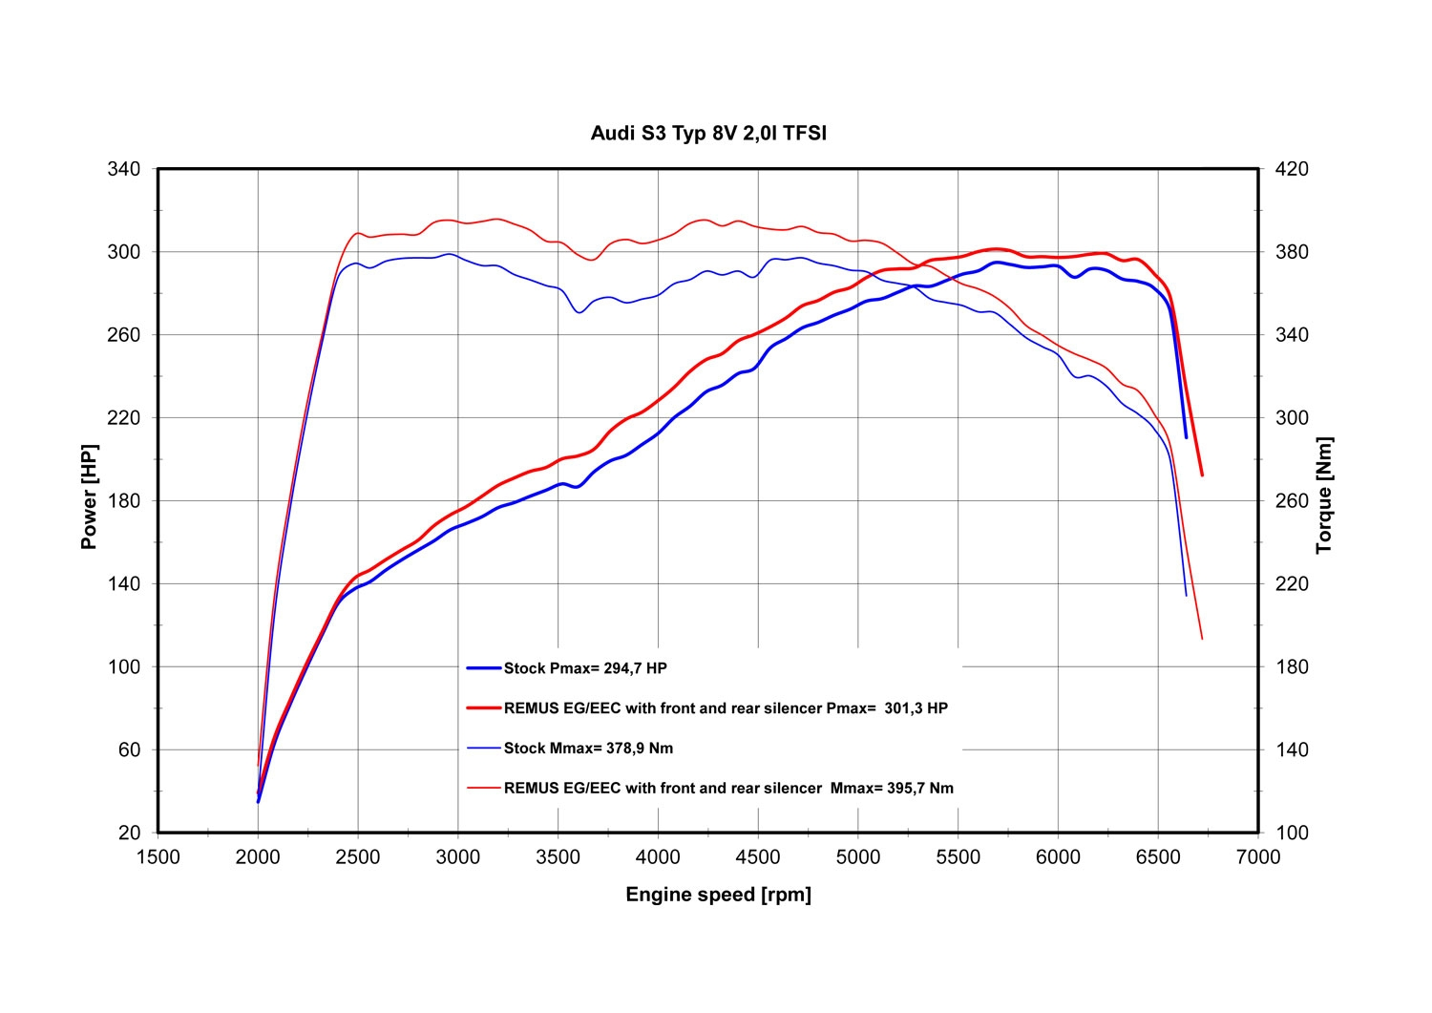

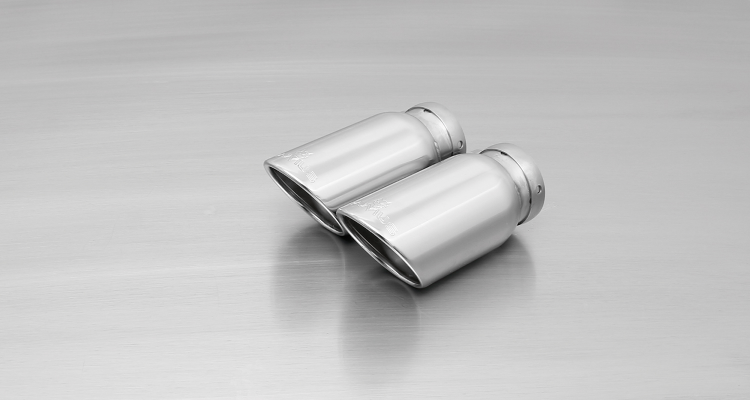
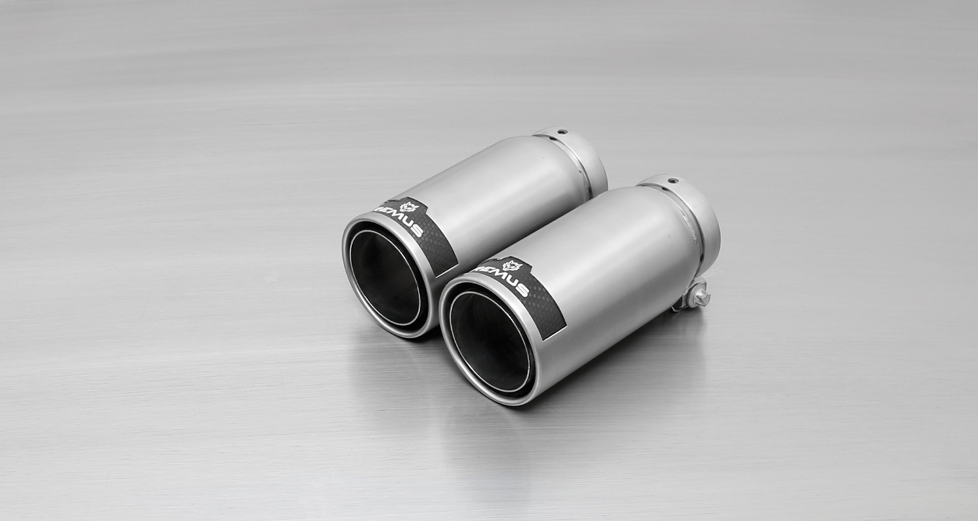
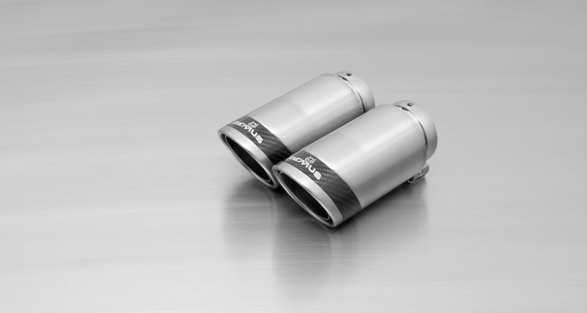
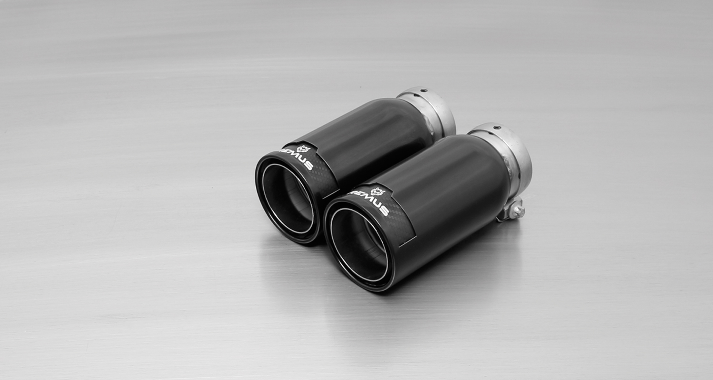
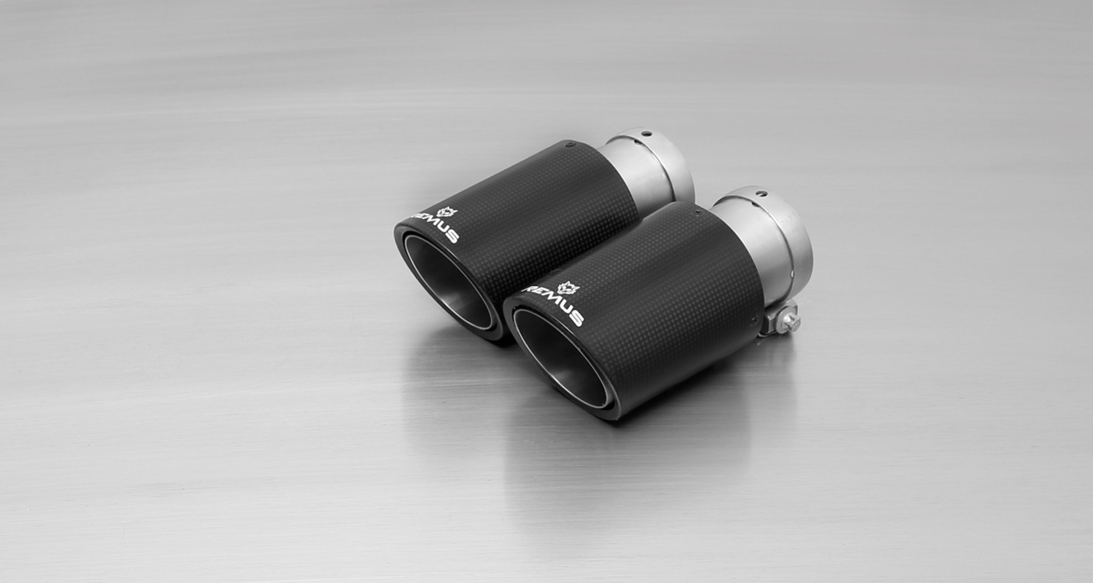
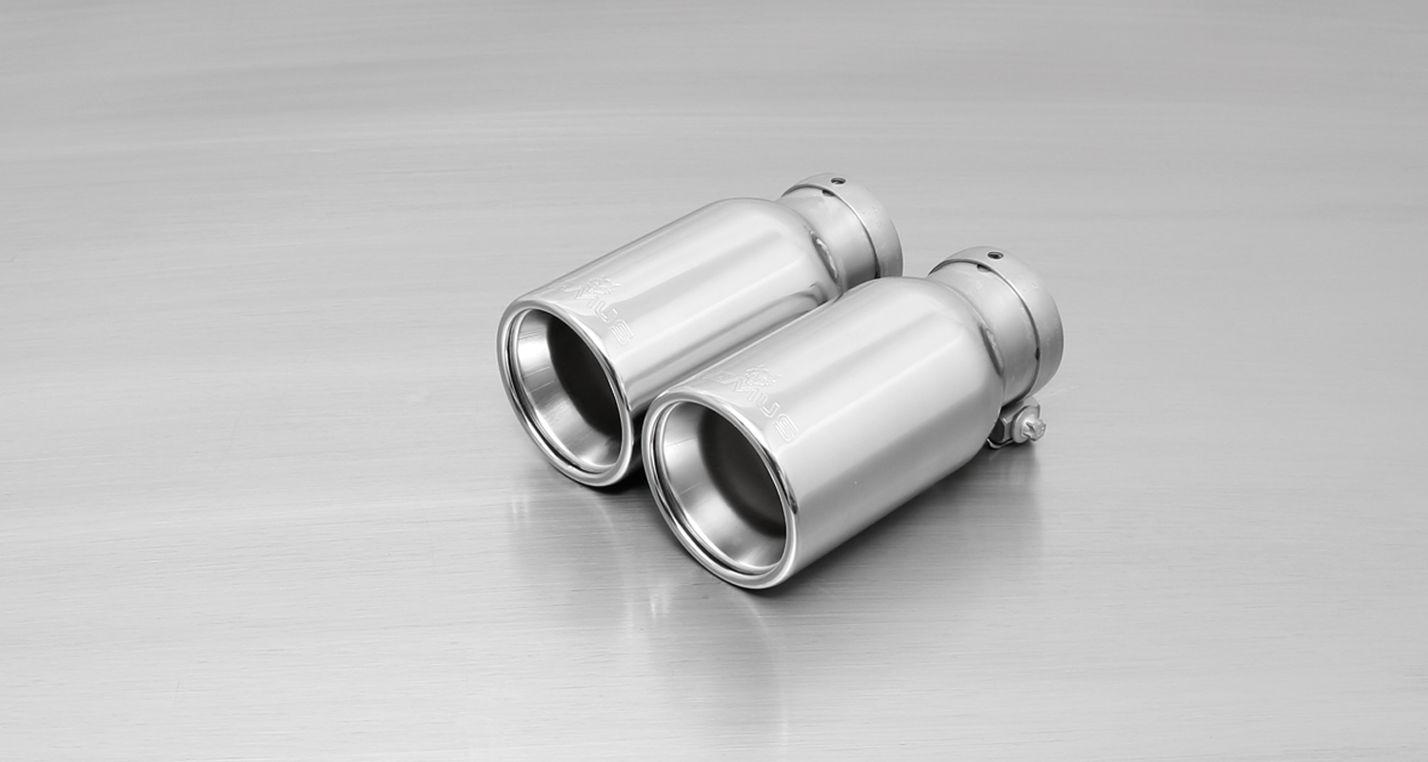
#83CB: tail pipes Ø 84 mm
Street Race Black Chrome
#55S: tail pipes Ø 84 mm angled, chromed
#83C: tail pipes Ø 84 mm
Street Race, polishe
#83CS: tail pipes Ø 84 mm
Carbon Race, polished
#83CTS: 2 Carbon-tail pipes Ø 84 mm angled, Titanium internals

#05: tail pipes Ø 90 mm, chromed

Car and engine specification
AUDI S3 Quattro, type 8V, 2013=>
AUDI S3 Sportback Quattro, type 8V, 2013=>
2.0l TFSI 221 kW (CJXC)
Part no. | Description | € RRP price excl. VAT
956014 1100 | Stainless steel RACING downpipe with sport catalytic convertor (200 CPSI), Ø 76 mm tube, without homologation (Can only be installed together with REMUS front silencer or racing tube) | 917,--
046513 0300 | Stainless steel front silencer, with EEC homologation | 236,--
046513 0000 | Stainless steel RACING tube without homologation, instead of front silencer | 85,50
046813 1500 | Stainless steel sport exhaust centered for L/R system, with 2 integrated electrical valves (without tail pipes), with EEC homologation | 770,--
choose from following tail pipe package:
0046 55S | Tail pipe set L/R consisting of 4 tail pipes Ø 84 mm angled, chromed, with adjustable spherical clamp connection | 300,--
0046 05 | Tail pipe set L/R consisting of 4 tail pipes Ø 90 mm, chromed, with adjustable spherical clamp connection | 300,--
0046 83C | Tail pipe set L/R consisting of 4 tail pipes Ø 84 mm Street Race, with adjustable spherical clamp connection | 340,--
0046 83CS | Tail pipe set L/R consisting of 4 tail pipes Ø 84 mm Carbon Race, with adjustable spherical clamp connection | 360,--
0046 83CB | Tail pipe set L/R consisting of 4 tail pipes Ø 84 mm Street Race Black Chrome, with adjustable spherical clamp connection | 388,--
0046 83CTS | Tail pipe set L/R consisting of 4 Carbon tail pipes Ø 84 mm angled, Titanium internals, with adjustable spherical clamp connection | 680,--
ATTENTION:
- Sport exhaust can only be installed using the above mentioned tail pipes!
- 046813 1500 replaces 046513 0500 which will be available as long as stock lasts!

Car and engine specification
AUDI S3 Sedan Quattro, type 8V, 2014=>
2.0l TFSI 221 kW (CJXC)
Part no. | Description | € RRP price excl. VAT
956014 1100 | Stainless steel RACING downpipe with sport catalytic convertor (200 CPSI), Ø 76 mm tube, without homologation (Can only be installed together with REMUS front silencer or racing tube) | 917,--
046513 0300 | Stainless steel front silencer, with EEC homologation | 236,--
046513 0000 | Stainless steel RACING tube without homologation, instead of front silencer | 85,50
047014 1500 | Stainless steel sport exhaust centered for L/R system, with 2 integrated electrical valves (without tail pipes), with EEC homologation | 770,--
choose from following tail pipe package:
0046 55S | Tail pipe set L/R consisting of 4 tail pipes Ø 84 mm angled, chromed, with adjustable spherical clamp connection | 300,--
0046 05 | Tail pipe set L/R consisting of 4 tail pipes Ø 90 mm, chromed, with adjustable spherical clamp connection | 300,--
0046 83C | Tail pipe set L/R consisting of 4 tail pipes Ø 84 mm Street Race, with adjustable spherical clamp connection | 340,--
0046 83CS | Tail pipe set L/R consisting of 4 tail pipes Ø 84 mm Carbon Race, with adjustable spherical clamp connection | 360,--
0046 83CB | Tail pipe set L/R consisting of 4 tail pipes Ø 84 mm Street Race Black Chrome, with adjustable spherical clamp connection | 388,--
0046 83CTS | Tail pipe set L/R consisting of 4 Carbon tail pipes Ø 84 mm angled, Titanium internals, with adjustable spherical clamp connection | 680,--
ATTENTION:
- Sport exhaust can only be installed using the above mentioned tail pipes!

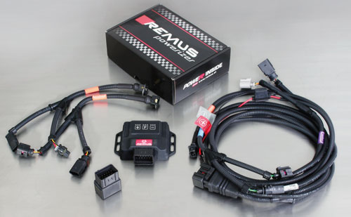

Part no. | Description | € RRP price excl. VAT
B918421 | REMUS POWERIZER for  Audi A3 (8V) (2012-...)S3 2.0 TFSI 300 HP aut.  Original: 221 kW / 300 HP / 380 Nm  TUNED: 260 kW / 353 HP / 455 Nm / Vmax + 0 kmH | 499,--
B917567 | REMUS POWERIZER for  Audi A3 (8V) (2012-...)S3 2.0 TFSI 300 HP man.  Original: 221 kW / 300 HP / 380 Nm  TUNED: 260 kW / 353 HP / 455 Nm / Vmax + 0 kmH | 499,--
REMUS Powerizer: More power, more economy and more fun.
- Up to 25 % more power
- Up to 20 % more torque
- Up to 1l/100 km fuel saving
- Fully adjustable power increase
- Simple DIY installation (Plug & Play)
REMUS POWERIZER: The performance figures represent the maximum achievable values. The actual performance output depends on the original tolerances of each engine. REMUS delivers the POWERIZER with the best possible setting for your vehicle type. You can adjust the performance according to your requirements as per the POWERIZER instructions

Legal references

1. Completion and registration of chip tuning in the car documents
Due to chip tuning, the operating license of the vehicle will terminate if the installation and registration of the POWERIZER is not carried out or immediately reported to an official approved testing facility. Please consider that driving a vehicle without the required operating license will cause legal penalties.

2. Vehicle insurance must be informed upon installing a POWERIZER
The installation of the POWERIZER can have influence on the insurance policy of your vehicle. You must inform the insurance company if you install a POWERIZER in your vehicle.

3. Effect of chip tuning on warranty and guarantee claims
a) When installing a POWERIZER, you will lose all guarantee claims regarding the engine against the vehicle manufacturer.
b) Installing a POWERIZER, can have influence on warranty claims against the seller of the vehicle.
c) REMUS excludes any claims regarding compensation for damages on the engine and drivetrain.

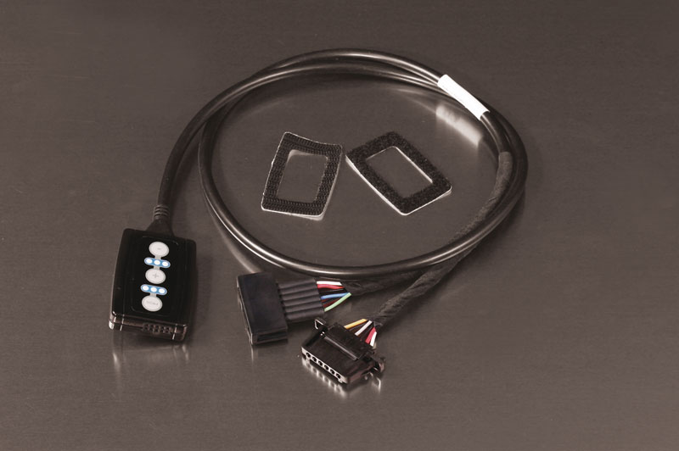

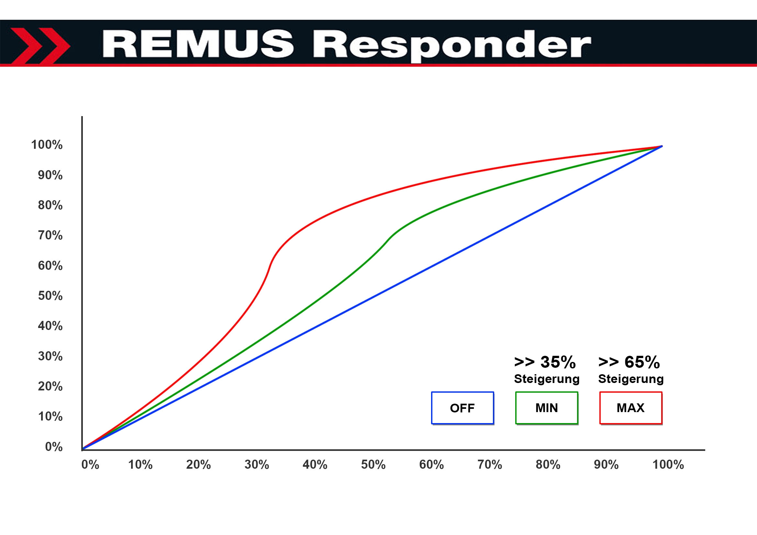
Part no. | Description | € RRP price excl. VAT
R903712 | REMUS Responder  AUDI A3 (8V) (2012-...); 1.2L TFSI; 77 kW  AUDI A3 (8V) (2012-...); 1.4L TFSI; 92 kW  AUDI A3 (8V) (2012-...); 1.4L TFSI; 90 kW  AUDI A3 (8V) (2012-...); 1.4L TFSI COD; 103 kW  AUDI A3 (8V) (2012-...); 1.6L TDI; 77 kW  AUDI A3 (8V) (2012-...); 1.6L TDI ultra; 81 kW  AUDI A3 (8V) (2012-...); 1.8L TFSI; 132 kW  AUDI A3 (8V) (2012-...); 2.0L TDI; 110 kW  AUDI A3 (8V) (2012-...); 2.0L TDI; 135 kW  AUDI A3 (8V) (2012-...); 2.0L TFSI S3; 221 kW | 167,--
REMUS RESPONDER:
Improved throttle response, more dynamic!
The REMUS Responder improves throttle response by means of modifying the accelerator pedal output signal. No more throttle delay and reduced lag during automatic shifting makes driving with the REMUS Responder more fun. The Responder attaches between the OEM pedal sensor and the OEM connector, ready to use in seconds due to plug & play technology. Sophisticated adjustable programming profiles can lead to improved fuel consumption and more efficiency. The 4 individual user selectable and adjustable performance settings allow drivers to select according to their own preferences.
The REMUS Responder totally eliminates the delay in modern electronic accelerator pedals!

