REMUS product information 08-2015

BMW 6 Series E63 Coupé / E64 Cabrio, 2004=>

Dear REMUS-Partner,

We are pleased to inform you that we have completed our next development
REMUS sport exhaust left / right with selectable tail pipes for the
BMW 6 Series E63 Coupé/E64 Cabrio, 2004=>.

It would be a pleasure for us to receive your order.
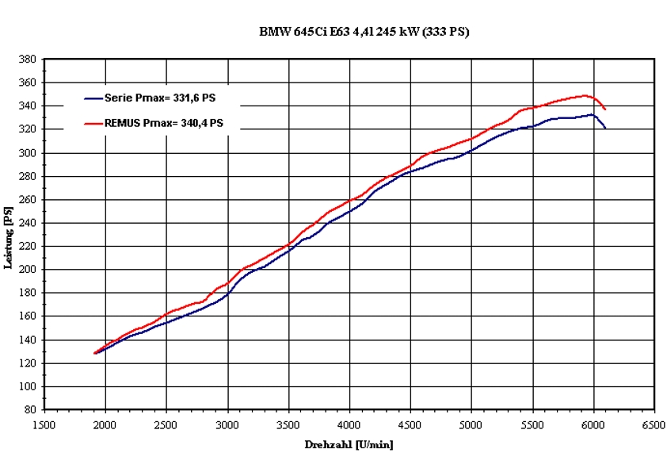
Stay tuned!
Your REMUS Team

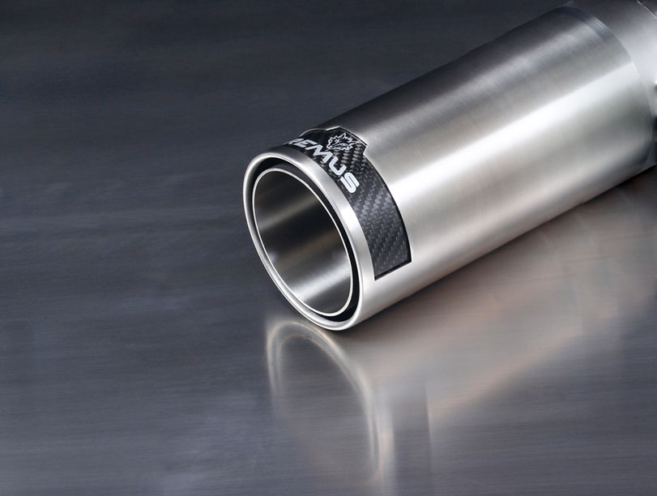
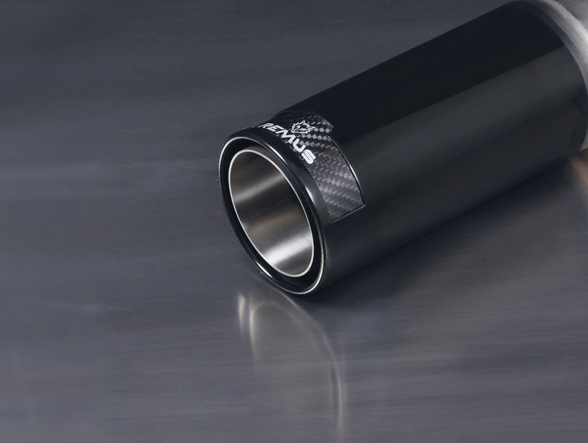
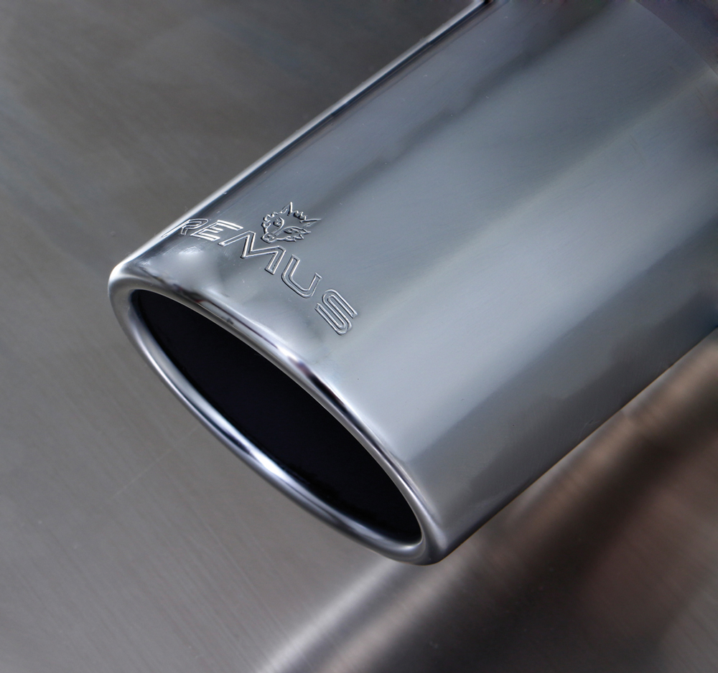
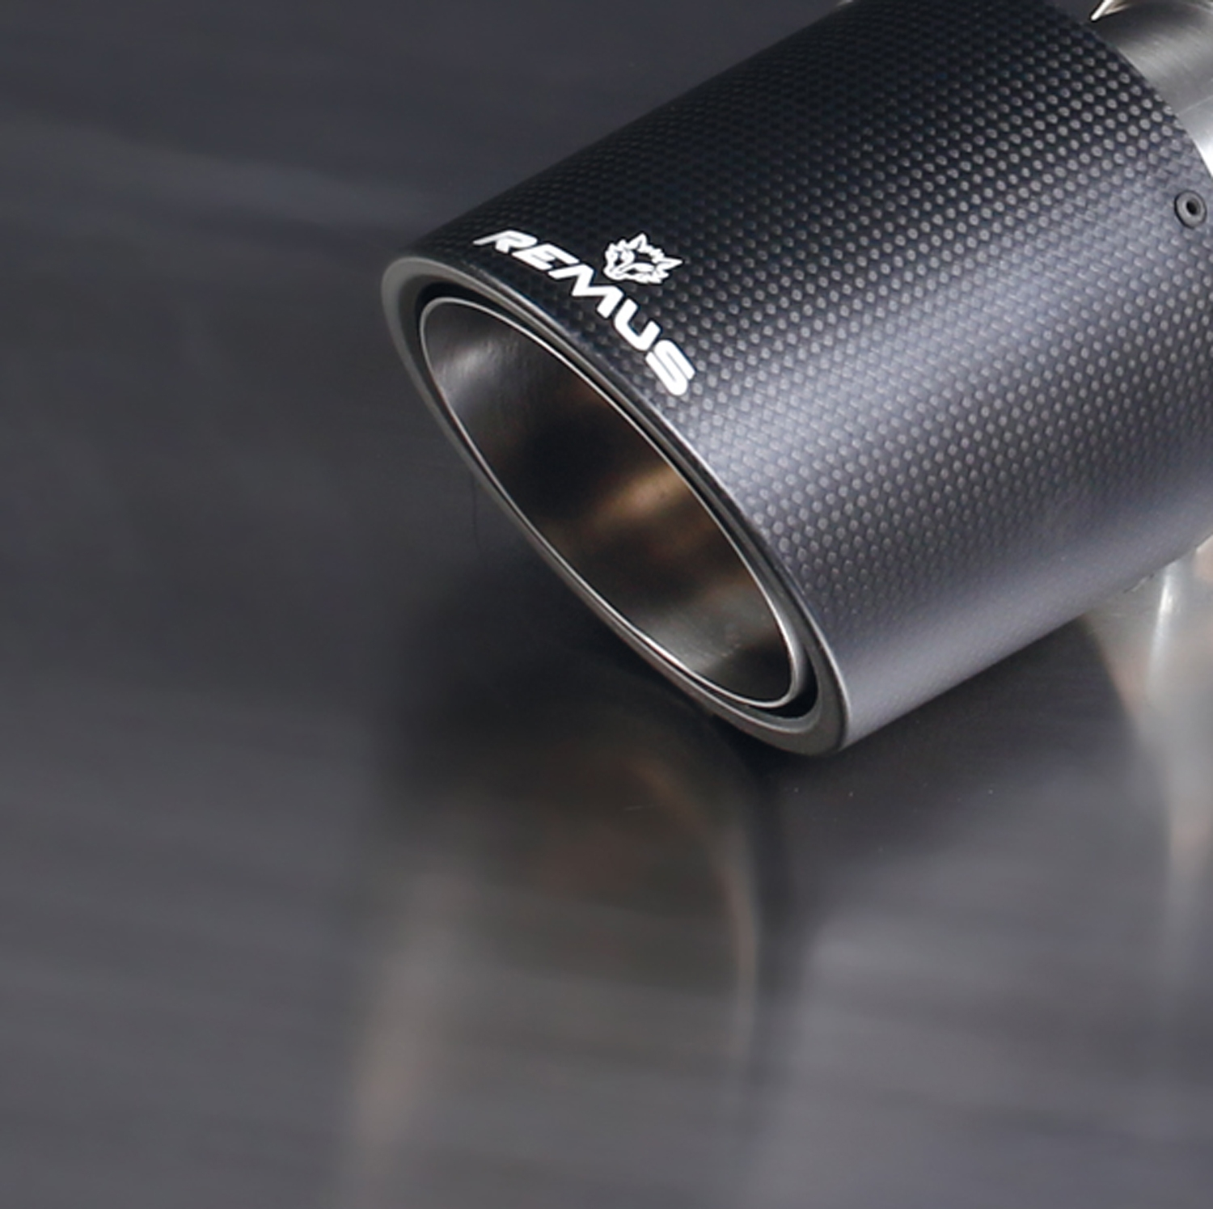
#70CS: L/R each 1 Carbon tail pipe
Ø 102 mm angled, Titanium internals

#70S: L/R each 1 tail pipe
Ø 102 mm angled, chromed

#98CB: L/R each 1 tail pipe Ø 98 mm
Street Race Black Chrome
#98C: L/R each 1 tail pipe Ø 98 mm
Street Race

Car and engine specification
BMW 6er E63 Coupé
BMW 6er E64 Cabrio
645CI 4.4l 245 kW, 2004=>; 650CI 4.8l 270 kW, 2006=>
Part no. | Description | € RRP price excl. VAT
089204 0500LR | Stainless steel sport exhaust left and sport exhaust right (without tail pipes), with EEC homologation | 660,--
choose from following tail pipe package:
0026 70S | Tail pipe set L/R consisting of 2 tail pipes Ø 102 mm angled, chromed, with adjustable spherical clamp connection | 160,--
0026 70CS | Tail pipe set L/R consisting of 2 Carbon tail pipes Ø 102 mm angled, Titanium internals, with adjustable spherical clamp connection | 370,--
0026 98C | Tail pipe set L/R consisting of 2 tail pipes Ø 98 mm Street Race, with adjustable spherical clamp connection | 196,--
0026 98CB | Tail pipe set L/R consisting of 2 tail pipes Ø 98 mm Street Race Black Chrome, with adjustable spherical clamp connection | 220,--
ATTENTION:
- Not for M sport option!
- 089204 0500LR replaces 089204 0598CL and 089204 0598CR.
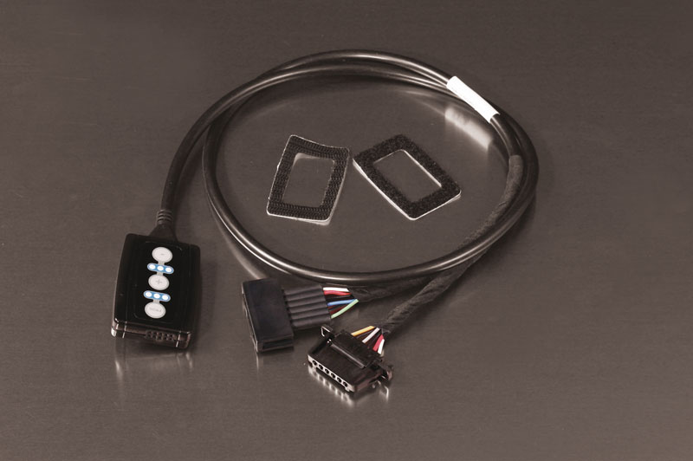

Part no. | Description | € RRP price excl. VAT
R903702 | REMUS Responder  BMW 6 Series (E63, E64) (2003-2010) 630i 200 kW  BMW 6 Series (E63, E64) (2003-2010) 630i 190 kW  BMW 6 Series (E63, E64) (2003-2010) 635d 210 kW  BMW 6 Series (E63, E64) (2003-2010) 645Ci 245 kW  BMW 6 Series (E63, E64) (2003-2010) 650i 270 kW  BMW 6 Series (E63, E64) (2003-2010) M6 373 kW | 167,--
REMUS RESPONDER:
Improved throttle response, more dynamic!
The REMUS Responder improves throttle response by means of modifying the accelerator pedal output signal. No more throttle delay and reduced lag during automatic shifting makes driving with the REMUS Responder more fun. The Responder attaches between the OEM pedal sensor and the OEM connector, ready to use in seconds due to plug & play technology. Sophisticated adjustable programming profiles can lead to improved fuel consumption and more efficiency. The 4 individual user selectable and adjustable performance settings allow drivers to select according to their own preferences.
The REMUS Responder totally eliminates the delay in modern electronic accelerator pedals!
